Meusburger Georg GmbH & Co KG
Kesselstr. 42, 6960 Wolfurt, Austria

Meusburger sets standards with the smartFILL single nozzles from PSG

The expert in standard components Meusburger now has the smartFILL single nozzles from PSG in range. Best part quality and a wide range of applications make the smartFILL hot runner single nozzle the poster child of PSG. By using this nozzle the melt is tempered homogeneously to the injected part guaranteeing highest quality of parts. With the easily interchangeable nozzle tips, different types of gating are possible which makes the smartFILL nozzles suitable for a wide range of applications and all common thermoplastics with and without fillers.

Innovative heating technology
The innovative heating technology provides an optimal heat transfer into the plastic used. A differentiated power distribution guarantees a homogeneous temperature profile on the entire nozzle length. Both the heater and the thermocouple can be changed easily and quickly thanks to the intelligent clip lock.

Streamlined melt channel with high-quality surface
The streamlined melt channel enables optimal melt exchange by preventing dead spots in the melt flow. It also ensures a low shear stress of the melt as well as good colour changing qualities.

Different gate types
The highly wear-resistant nozzle tips are easily exchangeable and can be used for different materials and applications such as direct gating or gating to sub-manifold. The nozzle length always remains the same even with different gating types.

Easy nozzle installation
The installation of the single nozzle is quick and easy – the high strength and corrosion resistant nozzle body is inserted in the cavity plate and fixed by the clamping plate and/or the locating ring.

Torpedo for optimal flow properties
The partitioning and re-merging of the melt takes place in the hot zone of the nozzle. This reduces the development of flow lines and thus serves to improve the optical and mechanical quality of the parts.

Easy configuration in the Meusburger web shop
With the hot runner nozzles configurator, the appropriate nozzle and tip type can be selected quickly and easily using a number of parameters. The CAD data of the configured single nozzle including installation spaces are immediately available for download.

Picture credits: Photo (Meusburger)
Caption: Meusburger sets standards with the smartFILL single nozzles from PSG

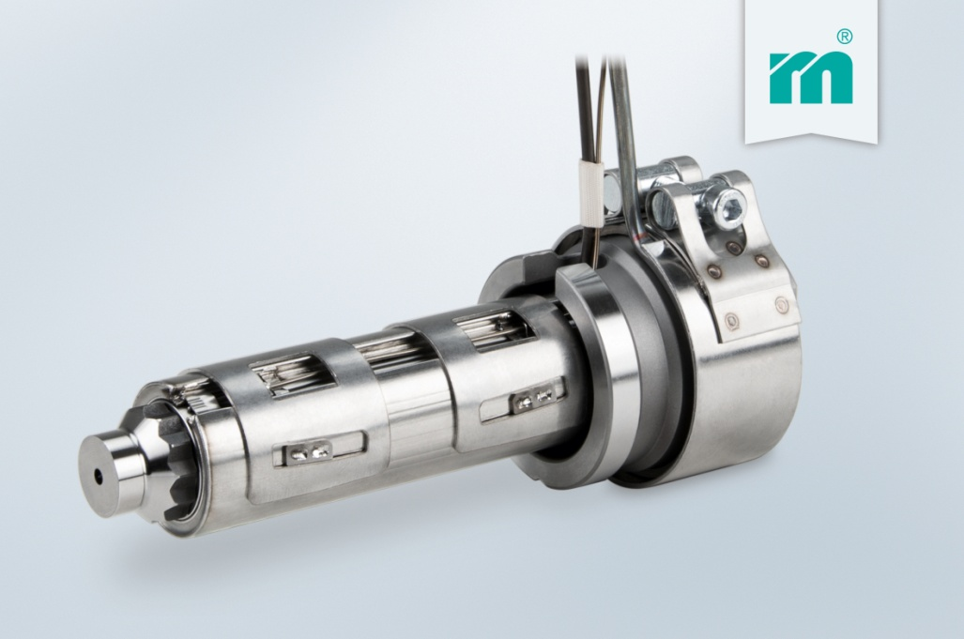

Meusburger Group – Setting Standards

The Meusburger Group is the leading international manufacturer of high-quality standard parts, hot runner and control systems and selected items in workshop equipment. More than 17,500 customers all over the world make use of the numerous advantages of standardisation and benefit from the company's over 50 years of experience in working with steel. The permanent availability of products makes the Meusburger Group the reliable and global partner for die, mould, jigs and fixtures construction.

Further information:
Meusburger Georg GmbH & Co KG
Communication / Public relations
Lia Klimmer
Phone: + 43 5574 6706-1446
Email: presse@meusburger.compresse@meusburger.com
http://www.meusburger.com/en/press-releases

