Meusburger Georg GmbH & Co KG
Kesselstr. 42, 6960 Wolfurt, Austria

NEW at Meusburger – Compact and ready-to-use pilot unit

The new E 5655 Pilot unit from Meusburger is used for the precise centring of the metal strip within the stamping die. Through the compact and ready-to-use design of the pilot unit the die maker saves not only time but also costs in design and assembly.

Due to the standardised pilot pins with an inlet chamfer of 40° no adjustment effort is required. They are made of high-speed steel 1.3343 which is characterised by high wear resistance. In order to prevent the lifting of the metal strip during the stamping process, the slug is wiped off with the bush. The contact pressure can be adjusted quickly and easily by means of three different system compression springs which are included in the delivery. A simple removal is guaranteed through identical installation diameters of the bush head and the pilot pin head. The appropriate CAD data can be easily and quickly downloaded in the online shop with only a few clicks. The new pilot unit is available from stock in diameters 5 and 8 mm.

Picture credits: Photo (Meusburger),
Captions: NEW at Meusburger – Compact and ready-to-use pilot unit

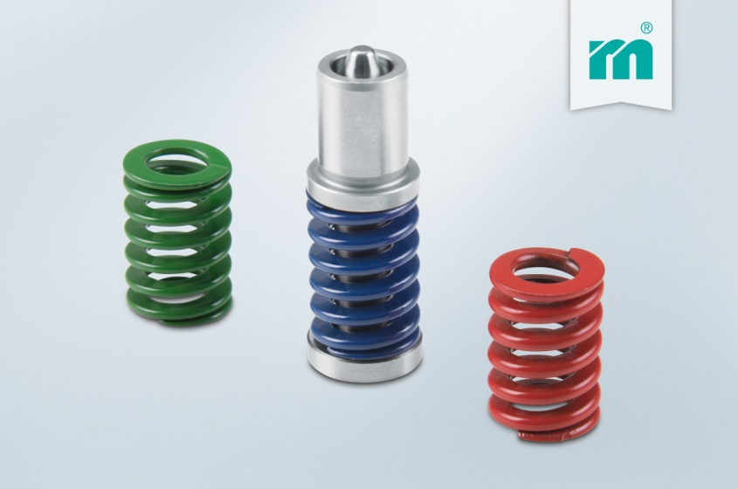

Meusburger – Setting Standards
Meusburger is the leading manufacturer of high-precision standard parts. More than 17,000 customers all over the world make use of the numerous advantages of standardisation and benefit from the company's over 50 years of experience in working with steel. Offering an extensive range of standard parts, combined with high-grade products in the field of workshop equipment, Meusburger is the reliable global partner for making dies, moulds, jigs and fixtures.

Further information:
Meusburger Georg GmbH & Co KG
Communication / Public relations
Phone: + 43 5574 6706-0
Email: press@meusburger.com
www.meusburger.com/press-releases

