Meusburger Georg GmbH & Co KG
Kesselstr. 42, 6960 Wolfurt, Austria

More safety in the operation thanks to the IsoTemp® high temperature hose

The new E 2187 IsoTemp® high temperature hoses from Meusburger combine tried and trusted technology with an innovative silicone sheath. This offers protection against burns as well as against abrasion or damages to the metal sheath. Therefore there is no risk of injuries from protruding wires. The special construction provides for high durability and maximum flexibility.

The IsoTemp® high temperature hose from Meusburger can be used at temperatures of up to 200°C with water, oil, air as well as vapour. All components that come in contact with the medium are made of stainless steel in order to prevent the formation of corrosion and thus prevent the clogging of the hose line. The union nut can either be mounted with a coupler or screwed directly onto the mould. Thanks to the FDA compliant silicone sheath, the hose is also very well suited for use in cleanrooms. The high flexibility is demonstrated by the very small bending radius of 50 mm. The IsoTemp® high temperature hose is available from Meusburger in red and blue versions in graduated lengths of 300 mm to 2500 mm from stock. Upon request the hoses are also available in special lengths.
The Meusburger product range also includes the E 21872 High temperature hose without silicone sheath.

Picture credits: Photo (Meusburger)
Caption: More safety in the operation thanks to the IsoTemp® high temperature hose

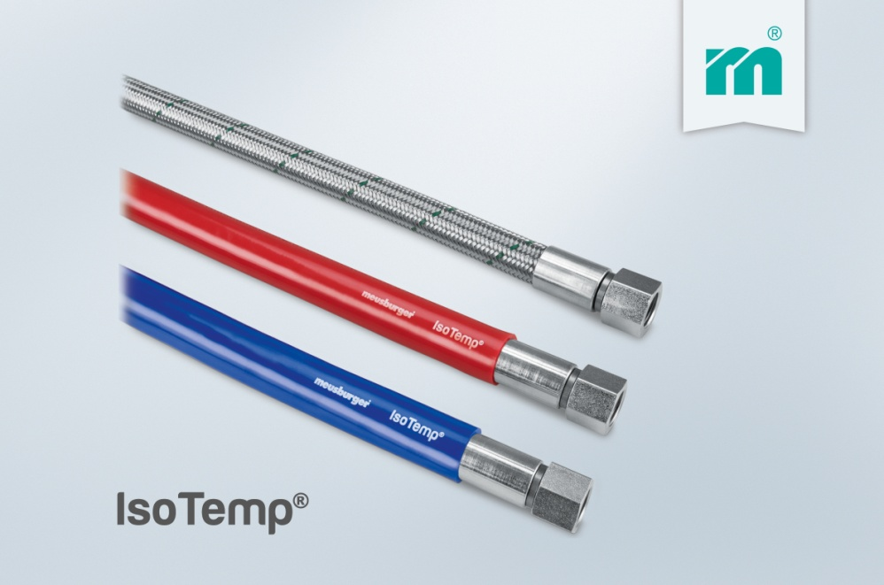

Meusburger Group – Setting Standards
The Meusburger Group is the leading international manufacturer of high-quality standard parts, hot runner and control systems and selected items in workshop equipment. More than 17,500 customers all over the world make use of the numerous advantages of standardisation and benefit from the company's over 50 years of experience in working with steel. The permanent availability of products makes the Meusburger Group the reliable and global partner for die, mould, jigs and fixtures construction.

Further information:
Meusburger Georg GmbH & Co KG
Communication / Public relations
Lia Klimmer
Phone: + 43 5574 6706-1446
Email: presse@meusburger.compresse@meusburger.com
http://www.meusburger.com/en/press/press.html

