Meusburger Georg GmbH & Co KG
Kesselstr. 42, 6960 Wolfurt, Austria

NEW from Meusburger: HFC rough milling cutters

The new high-feed milling cutters WZF 11512 and WZF 11522, or HFC milling cutters for short (HFC stands for High Feed Cutting), are mainly used for roughing. This procedure is particularly economical, as very high cutting speeds and feed rates can be reached. In addition, these milling cutters guarantee higher process reliability through a controlled wear process without cutting edge breakage.

The high-feed milling cutters are made of solid carbide with TiAIN coating and suitable for many different applications. This includes not only soft but also hardened steel up to 63 HRC. For example, the HFC milling cutters in a softer application material are optimal for clearing inclined pins or introducing pockets for cable slots which require a deep milling groove. For hardened steels, the main area of application is the 2-axis roughing of surfaces and contours.
Meuburger offers 2 different variations: a long (WZF 11512) and an extra long version (WZF 11522), both with diameters of 3-16 mm. All HFC milling cutters with a diameter of 5 mm feature internal cooling. The cutting data for the respective diameters and materials can be found quickly and easily at our site http://cuttingdata.meusburger.com.

Picture credits: Photo (Meusburger)
Caption: NEW from Meusburger: HFC rough milling cutters

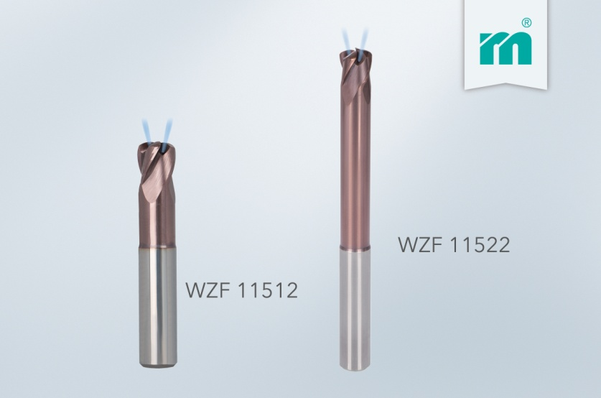

Meusburger Group – Setting Standards
The Meusburger Group is the leading international manufacturer of high-quality standard parts, hot runner and control systems and selected items in workshop equipment. More than 17,500 customers all over the world make use of the numerous advantages of standardisation and benefit from the company's over 50 years of experience in working with steel. The permanent availability of products makes the Meusburger Group the reliable and global partner for die, mould, and jigs and fixtures construction.

Further information:
Meusburger Georg GmbH & Co KG
Communication / Public relations
Lia Klimmer
Phone: +43 5574 6706-1446
Email: presse@meusburger.com
http://www.meusburger.com/en/press/press.html

