Meusburger Georg GmbH & Co KG
Kesselstr. 42, 6960 Wolfurt, Austria

New from Meusburger: E 1307 Fine centring unit, flat for high-precision centring of inserts

The new E 1307 Fine centring unit, flat from Meusburger features minimal installation space which provides for maximum space utilisation within the insert. Through the DLC coated centring elements available with or without fixing holes the designer enjoys maximum flexibility during design, and the wear is reduced to a minimum.

The best way to compensate the thermal expansion between the inserts and the cavity plate with milled pocket is to place the centring element directly at the cavity. However, designers often have to cope with very little space available for introducing the cavity when designing the inserts. To achieve exact centring of the individual inserts, Meusburger set themselves the goal of developing a centring element that is as small as possible but still equipped with technical refinements: the E 1307 Fine centring unit, flat. The product features compact design with defined installation positions, which prevents incorrect mounting of the respective centring parts. The hardened and DLC-coated fine centring unit ensures minimal wear and is ideal for use in cleanrooms. The large chamfer on the contact surface of the centring parts allows the introduction of corner radii for better hardening results on the insert and at the same time facilitates assembly. In addition, the withdrawal thread facilitates disassembly. The fine centring unit, flat is available in 2 versions with 2 sizes each: the E 13076 with mounting holes as ready-to-use variant and the E 13070 without mounting holes for individual adjustment to the required dimensions on a specific insert. The data is available in the online shop and with just a few clicks ready for download and export to the respective CAD system.

Picture credits: Photo (Meusburger)
Caption: New from Meusburger: E 1307 Fine centring unit, flat for high-precision centring of inserts
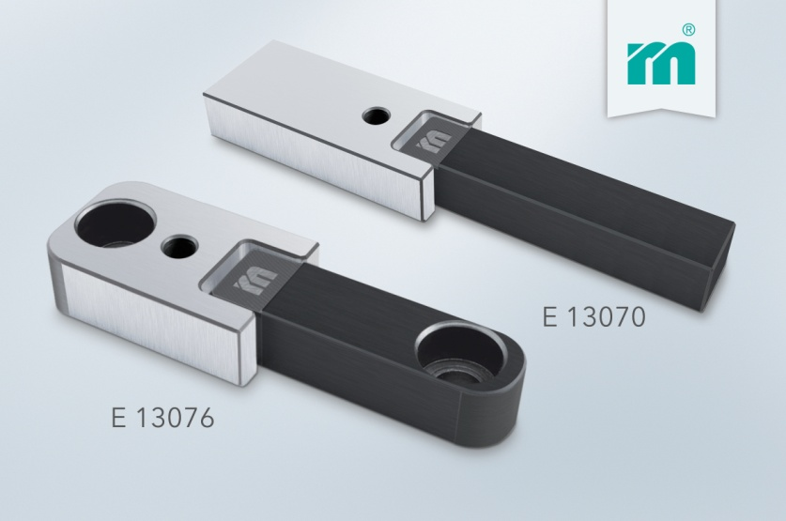

Meusburger Group – Setting Standards

The Meusburger Group is the leading international manufacturer of high-quality standard parts, hot runner and control systems and selected items in workshop equipment. More than 17,500 customers all over the world make use of the numerous advantages of standardisation and benefit from the company's over 50 years of experience in working with steel. The permanent availability of products makes the Meusburger Group the reliable and global partner for die, mould, and jigs and fixtures construction.

Further information:
Meusburger Georg GmbH & Co KG
Communication / Public relations
Lia Klimmer
Phone: + 43 5574 6706-1446
Email: presse@meusburger.compresse@meusburger.com
http://www.meusburger.com/en/press/press.html

