

Version 1.0

Contents

1. Foreword 4

2. General information 5

2.1. Title 5

2.2. Customer 5

2.3. Contacts 5

2.4. Target 5

2.5. Liabilities 5

2.6. Delivery date / Schedule 5

2.7. Deviations 5

2.8. Mould validations 5

2.8.1. Mould function test 5

2.8.2. Mould validation 5

2.9. Mould delivery 5

2.10. Mould transport 5

2.10.1. Transport insurance 5

2.10.2. Delivery note 5

2.11. Machine parameters 6

3. Mould design 7

3.1. Design implementation 7

3.2. Design approval 7

3.3. Design documents 8

3.3.1. After completion of the design 8

3.3.2. Before delivery of the mould 8

3.3.3. After completion of the project 8

3.3.4. Media for the data exchange 9

4. Mould base 10

4.1. General information 10

4.2. Materials 10

4.3. Standard parts 11

4.4. Mould bases 11

4.4.1. Lever slots 11

4.4.2. Edges 13

4.4.3. Threaded holes 13

4.4.4. Marking 13

4.5. Inserts 14

4.6. Change mould inserts 14

4.7. Marking stamps 14

4.7.1. Date stamps 14

4.7.2. Product labelling 14

4.8. Ventilation 15

5. Guiding and centring 15

5.1. Guiding 15

5.1.1. Standard guiding system 15

5.1.2. Ejector set guiding 15

5.1.3. Support pillars with guiding function 16

5.1.4. Flat guiding unit 16

5.2. Centring 17

5.2.1. Top and side locks 17

5.2.2. Fine centring unit 17

5.2.3. Centring unit 17

6. Sprues 18

6.1. Sprue type 18

6.2. Sprue design 18

6.2.1. Sprue bush 18

6.2.2. Sprue retainer 18

6.2.3. Sprue cone 18

6.2.4. Sprue channel 18

6.2.5. Sprue tunnel 19

6.2.6. Sprue adjusters 19

7. Hot runner system 20

7.1. General information 20

7.2. Hot runner design 20

7.3. Hot runner label 20

7.4. Hot runner electrical system 20

7.4.1. Placement of the connector housing 20

7.4.2. Plug assignment on the hot runner 20

7.4.3. Assignment sequence 21

8. Slides 23

8.1. Mechanically actuated slides 23

8.1.1. Standardised slide systems 23

8.2. Hydraulically actuated slides 24

9. Demoulding 25

9.1. Ejectors 25

9.2. Hydraulically operated ejector retaining plates 25

9.3. Thread insert and ejector rod 26

9.3.1. Thread insert 26

9.3.2. Ejector rod 26

9.4. Position monitoring and securing 26

9.4.1. End position control 26

9.4.2. Push back pins and push back unit 27

9.4.3. Ejector set lock 27

9.5. 3-plate moulds 27

10. Hydraulic system 29

10.1. Hydraulic connectors 29

10.2. Hydraulic cylinders 29

11. Temperature regulation components 31

11.1. Layout of the cooling circuits 31

11.1.1. Diameter of the cooling circuits 31

11.1.2. Spacing of the cooling circuits to each other 31

11.1.3. Marking the cooling circuits 31

11.2. Adapting the cooling circuits 31

11.2.1. Water coolant 31

11.2.2. Heat transfer oil coolant 31

11.2.3. Core cooling 31

11.2.4. Fittings 31

11.2.5. Temperature regulation pipe extension 32

11.3. Mould hosing 32

11.3.1. Couplers 32

11.3.2. Coolant hoses 34

11.3.3. Manifolds 34

11.4. Sealing plugs and screw plugs 35

11.5. O-rings 35

12. Process monitoring 37

12.1. Cycle counter 37

12.2. Cavity pressure sensors 37

12.3. Thermocouples 38

12.4. Logic distributors 38

12.5. Electrical connections 38

13. Mould specifications 39

13.1. Dimensions and weight 39

13.2. Mould centre of gravity 39

13.3. Securing the mould 39

13.3.1. Screw holes 39

13.3.2. Insulation boards 40

13.4. Required mould opening strokes 41

13.5. Mould centring 41

13.6. Mould transport and securing 41

13.6.1. Mould support rails 41

13.6.2. Transport lock 41

13.6.3. Lifting points 42

13.7. Mould labelling 42

13.7.1. Label 42

13.7.2. Status indicator plate 42

# Foreword

This document is considered the basis for the mould design and production.

Passages marked in turquoise can be filled out accordingly.

|  |  |  |  |  |
| --- | --- | --- | --- | --- |
| **Nominal size** | **Fitting** | **Coolant** | **Temperature** | **Pressure** |
| Ø XY | XY | XY | XY | XY |

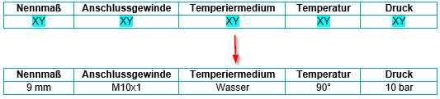

|  |  |  |  |  |
| --- | --- | --- | --- | --- |
| **Nominal size** | **Fitting** | **Coolant** | **Temperature** | **Pressure** |
| 9 mm | M10x1 | Water | 90° | 10 bar |

In tables, the first column can be marked to indicate which product or which combination option is used.

**Example:**

Combination of DLC coated E 1002 guide pillar with E 1100 guide bush.

The rest of the rows or columns can be removed.

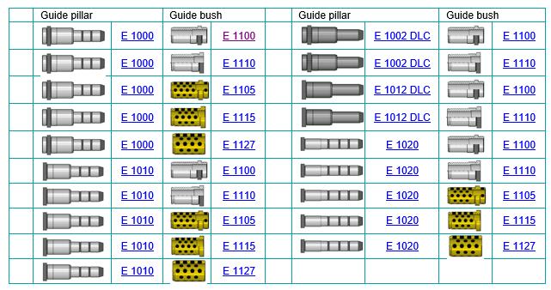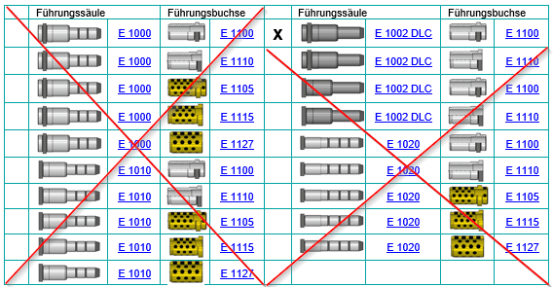

Passages and points that are not generally required can simply be deleted or supplemented. The table of contents must be updated accordingly at the end.

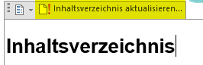



This symbol provides useful overviews about downloading and printing regarding the respective topic

# General information

## Title

XY

## Customer

XY

## Contacts

XY

## Target

XY

## Liabilities

XY

## Delivery date / Schedule

XY

## Deviations

XY

## Mould validations

### Mould function test

XY

### Mould validation

XY

## Mould delivery

XY

## Mould transport

### Transport insurance

XY

### Delivery note

XY

## Machine parameters

|  |  |
| --- | --- |
| **Manufacturer** | XY |
| **Type** | XY |
| **Tie-bar spacing** | XY |
| **Tie-bar diameter** | Ø XY |
| **Max. permissible mould weight** | XY |
| **Min. installation height** | XY |
| **Max. installation height** | XY |
| **Diameter of fixed-half locating ring** | XY |
| **Diameter of moving-half locating ring** | XY |

# Mould design

Fundamentally, the mould design should be maintenance friendly.

Upon final payment, the client obtains ownership to the design and intellectual property rights, provided these are not protected by patent.

The design release is broken down into

* Pt. 1 Mould pre-design/function (for steel release/order)
* Pt. 2 Design release of the complete 3D design, including temperature regulation

## Design implementation

* The drawings or data released by the client for the individual project steps are considered the basis for the order. Associated 3D CAD item models may only be used while taking the dimensions and tolerances specified in the drawing into consideration.
* The authorised mould maker is solely responsible for the data conversion in their CAD system. The mould maker is liable for possible conversion errors.
* It is not permitted to assign the order further to third parties: only after consultation with and written approval from the company XY.
* The origin/basis of the entire mould design is the 3D CAD mould item model (file name). It contains the shrinkage, draft angles, adjustments, etc. All adjustments and changes are first made to the mould item model and derived from this into the individual components. There is always a current mould item model available in the project. Old versions are saved for documentation purposes.
* The mould item model is used to create a control drawing containing the dimensional situations of the item designation with shrinkage.
* The entire mould design is built using 3D CAD solid models based on the mould item model.
* All mould components exist as separate 3D CAD models.
* The mould ventilation is part of the mould design.
* A detailed drawing is created of each component. The drawings are associated with the 3D CAD models, which means the drawing views are automatically updated - if there are model changes. Changes are documented in the title block by the change index and are documented by a change data sheet if there are more major changes.
* Alternatively, the 3D CAD models can be coloured in according to the colour table standard.
* The old design status is to be saved before making changes/adjustments.



[**CAD colour table standards to download and print**](https://www.meusburger.com/DE/AT/media/DOC_PRO_FLY_CAD-Farbtabellenstandards_IN.pdf)

## Design approval

Before starting the construction, the client must submit the mould design. If the design is not yet complete, a pre-draft must at least be available, which is adopted in a design meeting with the project manager from the company XY.

The mould design adopted by the company XY does not release the manufacturer from its responsibility to create a fully functional mould ready for serial production.

The design must be approved by the following parties:

|  |  |  |  |  |
| --- | --- | --- | --- | --- |
| **Department** | **Name** | **Function** | **Date** | **Signature** |
| Mould manufacturer |  |  |  |  |
| Company: XY Development/Sales |  | Project manager |  |  |
| Company: XY Mould Technology |  | Mould technology manager |  |  |
| Company: XY Production |  | Production manager |  |  |

## Design documents

### After completion of the design

The following documents are to be handed over to the client in paper form and as a PDF format:

* Module drawings depicting the complete mould base:
  + Top view of fixed half and moving half
  + Cross-sections showing all relevant details, such as gating, hot runner, inserts, temperature regulation, etc.
  + Exploded view (if available)
  + The drawings must contain the dimensions, the mould weight and the item numbers of the parts list
* The parts list contains all items and all steel grades with the material numbers, strength and hardness in HRC as well as the suppliers
* Hot runner drawing, including wiring

Upon the client’s request, additional documents are to be provided at any point in the project.

### Before delivery of the mould

* Complete set of drawings, which was used for the mould production
* Parts list
* Hot runner drawing
* Hot runner assignment plan
* Connection plan / pin assignment for hot runner system
* Temperature control plan
* Flow chart / functional diagram of hydraulic core pullers

### After completion of the project

The client receives the complete design documents in paper form and as data sets.

This includes:

* 3D CAD data in CAD format or STEP format specifying the software, software version and the service pack
  + - All item CAD data, which was used as the basis to implement the project, including electrodes
    - All mould items with shrinkage, draft angles, adjustments, etc.
    - Fixed half and moving half output as a separate assembly
  + 2D-CAD in DXF and PDF format
* Parts list
* Hot runner drawing
* Hot runner pin assignment plan
* Connection plan / pin assignment for hot runner system
* Representation of the cooling circuits
* Flow chart / functional diagrams of hydraulically actuated components
* Electrodes
  + - Electrodes for the mould production are parts of the mould and must be fully handed over to the company XY by request. All electrodes are to be listed in a parts list with serial no., cavity designation, spark gap and for the item to be used. Electrodes are to be stored and only disposed of following written approval by the company XY.

In general:

* + All 2D/3D CAD data are to be clearly designated (e.g. moving half, fixed half, slide, etc.)
  + All components have the mould coordinate system as a reference
  + Current actual dimensions to guarantee a spare parts production without subsequent rework or press-in work

### Media for the data exchange

* USB flash drive or cloud

In general:

* Labelling with the client’s information: Project no., mould no., item designation, item no., table of contents

# Mould base

## General information

|  |  |
| --- | --- |
| **Number of cavities** | XY |
| **Material** | XY |
| **Fillers** | XY |
| **Shrinkage** | XY |
| **Part weight** | XY |
| **Gating** | XY |
| **Hot runner** | Yes/no |

## Materials

The material for the individual components can be found in the mould specification and is to be entered in the following list as confirmation. The Meusburger material selection wizard on <http://material.meusburger.com>

can be used as an assistant when selecting the material.



|  |  |  |  |  |  |
| --- | --- | --- | --- | --- | --- |
| **No.** | **Item no.** | **Designation** | **Material** | **Heat treatment** | **Hardness in HRC** |
| 1 | F 10-F 40 | Fixed-half clamp plate |  |  |  |
| 2 | F 60 | Backing plate |  |  |  |
| 3 | F 50, F 53 F 55 | Fixed-half cavity plate |  |  |  |
| 4 | [NF …](https://ecom.meusburger.com/e_menu/index.asp?set_gruppe=11) | Fixed-half inserts |  |  |  |
| 5 |  | Heat-stressed inserts |  |  |  |
| 6 | [NF …](https://ecom.meusburger.com/e_menu/index.asp?set_gruppe=11) | Moving-half inserts |  |  |  |
| 7 | F 50, F 55 | Moving-half cavity plate |  |  |  |
| 8 | F 60 | Moving-half backing plate |  |  |  |
| 9 | F 80 | Ejector retaining plate |  |  |  |
| 10 | F 85 | Ejector base plate |  |  |  |
| 11 | F (10) 15-F 45 | Moving-half clamp plate |  |  |  |
| 12 |  | Additional mould base plates |  |  |  |

For 2-component moulds with an index plate, the following points are added:

|  |  |  |  |  |
| --- | --- | --- | --- | --- |
| **No.** | **Designation** | **Material** | **Heat treatment** | **Hardness in HRC** |
| 13 | Index plate |  |  |  |
| 14 | Separate index shaft |  |  |  |

## Standard parts

Standard parts are preferably to be used according to the Meusburger standard. The standard parts must be purchased from manufacturers who are also represented in the countries of the production locations. The supply sources must be evident from the parts list.

## Mould bases

F-plates from Meusburger should preferably be used for the mould base. This guarantees a quick reaction time when procuring spare parts.

This also guarantees a consistent product quality, which allows for a trouble-free exchange.

All cavity plates are provided with lever slots to ensure easy disassembly.

Meusburger F-plates already have these lever slots as a standard feature.



[**Overview of the inside dimensions to download and print**](https://ecom.meusburger.com/files/info/bohrbild.pdf)

The following depicts the different designs.

### Lever slots

**Lever slots for F-lengthwise mould type**

[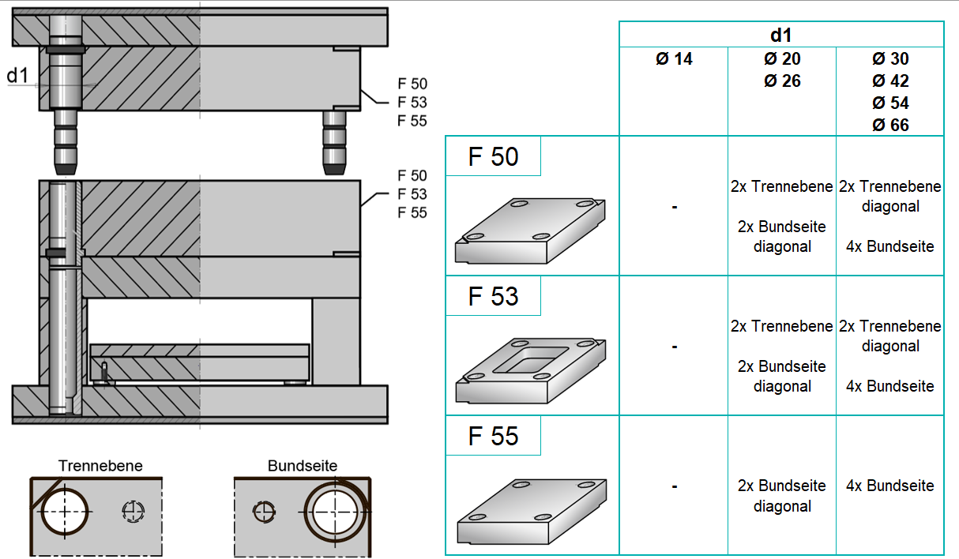](https://ecom.meusburger.com/fpl_menu/index.asp?rnd=60308)

**Lever slots for F-crosswise mould type**

[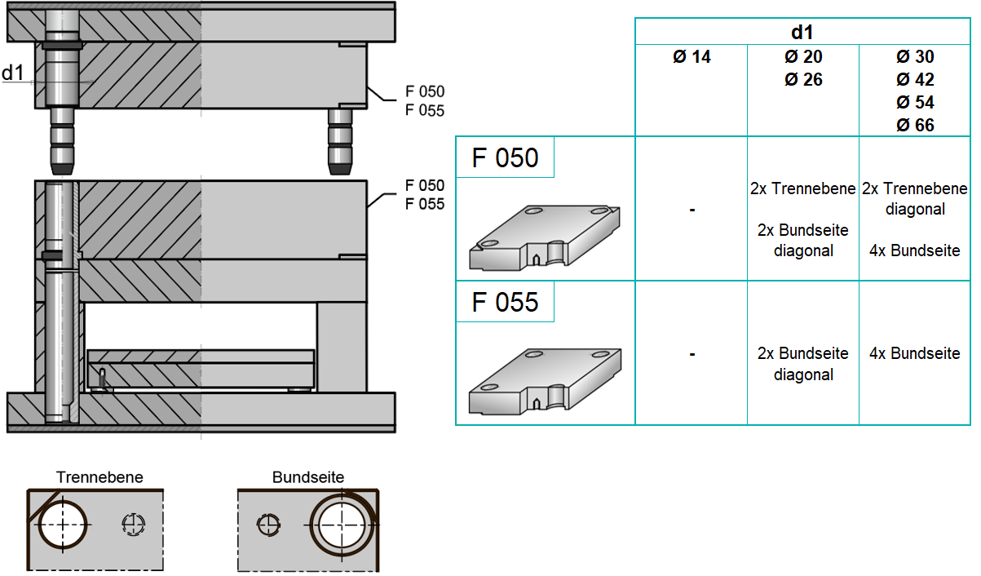](https://ecom.meusburger.com/fpq_menu/index.asp?rnd=60809)

**Lever slots for FB-sliding core mould type**

[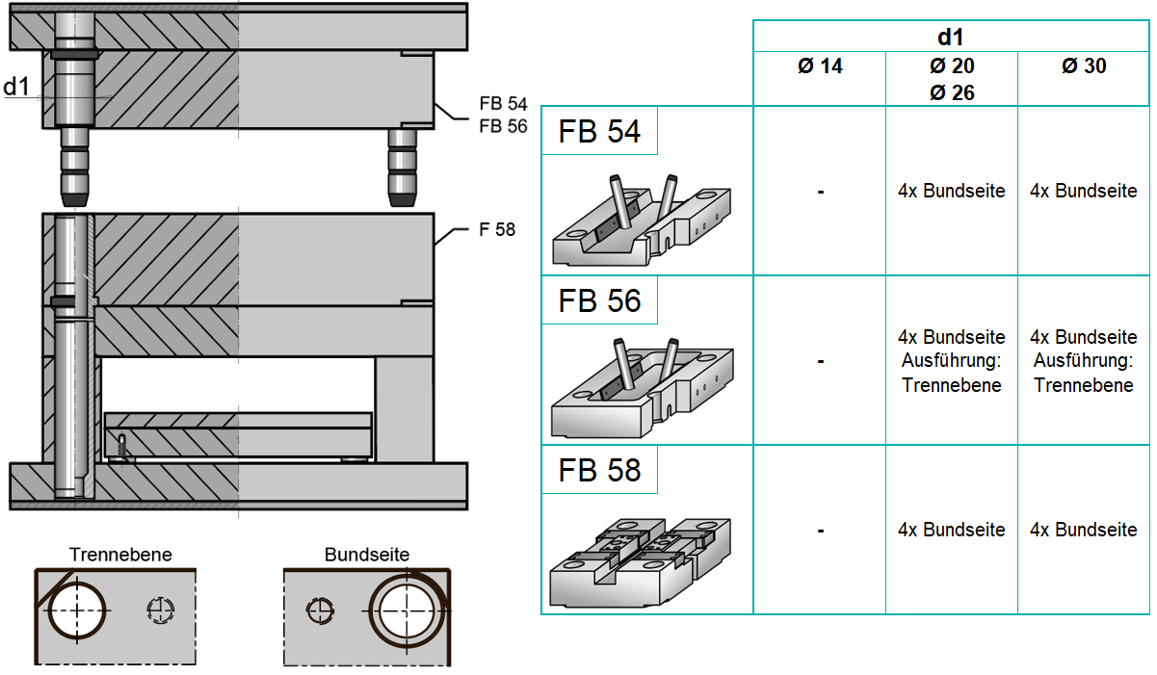](https://ecom.meusburger.com/fbl_menu/index.asp?rnd=4257)

**Lever slots for FW-change mould type**

[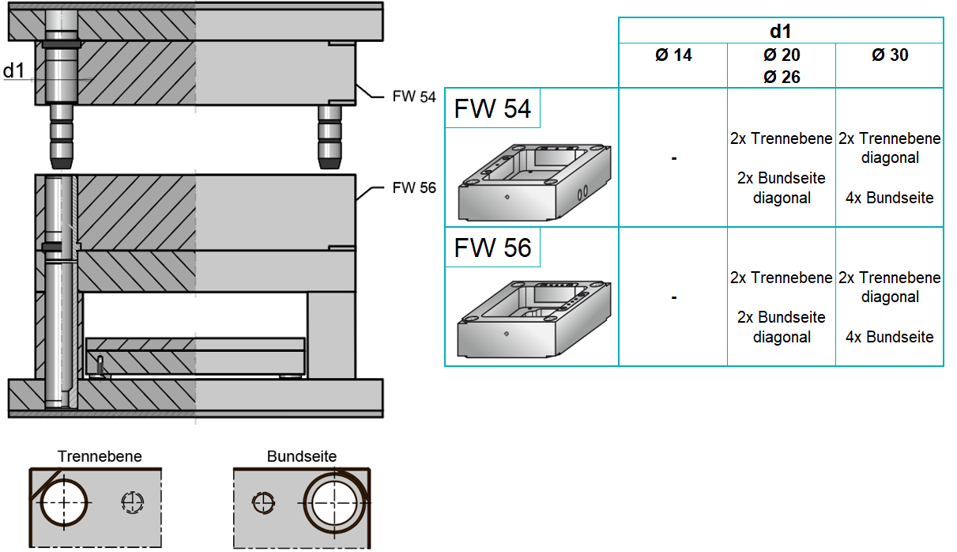](https://ecom.meusburger.com/fw_menu/index.asp?rnd=11985)

### Edges

The edges are generally to be broken or bevelled at the mould plates.

### Threaded holes

Transport and mounting threads are used for all individual parts and assemblies with a weight over XY kg.

### Marking

Mould plates are generally to be provided with a plate numbering (stroke rate) and material identification on top, starting with the fixed-half clamping plate, fixed-half cavity plate, etc.

All attachments must be marked with the XY mould number (transport and mould protection, ejector rods, location rings, etc.).

View from above View from below



## Inserts

Complex shaping part geometries are to be designed as a separate insert.

## Change mould inserts

Change mould inserts are to be designed so that a replacement is possible in the assembled state on the injection moulding machine via the split line face by loosening the hexagon socket screws. Pull-off threads or withdrawal threads are to be used for disassembly.

## Marking stamps

Labels in the cavity are generally to be designed as an insert, if possible. This can be screwed in from behind if it is not associated with a variant change. In case of an accidental twisting of the arrow insert, marking stamps with latching function are to be used.

|  |
| --- |
| **Diameter** |
| Ø XY |



[**Overview of the marking stamps to download and print**](https://ecom.meusburger.com/files/pdf/e/schrifteinsaetze_uebersicht_info.pdf)

### Date stamps

|  |  |  |  |  |  |  |  |
| --- | --- | --- | --- | --- | --- | --- | --- |
|  |  |  |  |  |  |  |  |
|  |  | Standard | WFH* | Short | Short, with latching function | Multi-stamp with latching function | Die casting |
|  | Day |  |  | [E 2423](https://ecom.meusburger.com/e/index.asp?id=1818) |  |  |  |
| [E 2431](https://ecom.meusburger.com/e/index.asp?id=1820) |
|  | Week |  |  | [E 2421](https://ecom.meusburger.com/e/index.asp?id=1816) |  |  |  |
|  | Month | [E 2400](https://ecom.meusburger.com/e/index.asp?id=291&rnd=46023) | [E 24005](https://ecom.meusburger.com/e/index.asp?id=1127) | [E 2420](https://ecom.meusburger.com/e/index.asp?id=301) | [E 2420 R](https://ecom.meusburger.com/e/index.asp?id=1967) | [E 2420 MR](https://ecom.meusburger.com/e/index.asp?id=2197) | [E 24760](https://ecom.meusburger.com/e/index.asp?id=1652) |
| [E 2440](https://ecom.meusburger.com/e/index.asp?id=310) |
|  | Year | [E 2404](https://ecom.meusburger.com/e/index.asp?id=294) | [E 24045](https://ecom.meusburger.com/e/index.asp?id=1129) | [E 2424](https://ecom.meusburger.com/e/index.asp?id=303) | [E 2424 R](https://ecom.meusburger.com/e/index.asp?id=1969) |  |
| [E 2444](https://ecom.meusburger.com/e/index.asp?id=312) |
|  | Quarter | [E 2405](https://ecom.meusburger.com/e/index.asp?id=295) |  | [E 2425](https://ecom.meusburger.com/e/index.asp?id=304) |  |  |  |
|  | Shift | [E 2408](https://ecom.meusburger.com/e/index.asp?id=298) |  | [E 2428](https://ecom.meusburger.com/e/index.asp?id=307) |  |  |  |
|  | 0-9 | [E 2402](https://ecom.meusburger.com/e/index.asp?id=293) | [E 24025](https://ecom.meusburger.com/e/index.asp?id=1128) | [E 2422](https://ecom.meusburger.com/e/index.asp?id=302) | [E 2422 R](https://ecom.meusburger.com/e/index.asp?id=1968) |  |  |
|  | A-M | [E 2406](https://ecom.meusburger.com/e/index.asp?id=296) | [E 24065](https://ecom.meusburger.com/e/index.asp?id=1131) | [E 2426](https://ecom.meusburger.com/e/index.asp?id=305) |  |  |  |
|  | N-Z | [E 2407](https://ecom.meusburger.com/e/index.asp?id=297) |  | [E 2427](https://ecom.meusburger.com/e/index.asp?id=306) |  |  |  |
|  | Blank | [E 2409](https://ecom.meusburger.com/e/index.asp?id=299) | [E 24095](https://ecom.meusburger.com/e/index.asp?id=1134) | [E 2429](https://ecom.meusburger.com/e/index.asp?id=308) | [E 2429 R](https://ecom.meusburger.com/e/index.asp?id=1970) |  |  |
| [E 2449](https://ecom.meusburger.com/e/index.asp?id=317) |

*WFH... with fixed height

### Product labelling

|  |  |  |  |  |  |  |  |  |  |
| --- | --- | --- | --- | --- | --- | --- | --- | --- | --- |
|  |  |  |  |  |  |  |  |  |  |
|  |  | 01-PET | 02-PE-HD | 03-PVC | 04-PE-LD | 05-PP | 06-PS | 07-O | blank |
|  | Recycling | [E 2460/../01](https://ecom.meusburger.com/e/index.asp?id=1338) | [E 2460/../02](https://ecom.meusburger.com/e/index.asp?id=1338) | [E 2460/../03](https://ecom.meusburger.com/e/index.asp?id=1338) | [E 2460/../04](https://ecom.meusburger.com/e/index.asp?id=1338) | [E 2460/../05](https://ecom.meusburger.com/e/index.asp?id=1338) | [E 2460/../06](https://ecom.meusburger.com/e/index.asp?id=1338) | [E 2460/../07](https://ecom.meusburger.com/e/index.asp?id=1338) | [E 2465/../RC](https://ecom.meusburger.com/e/index.asp?id=1339) |

|  |  |  |
| --- | --- | --- |
| Certifications | | |
|  |  | [E 2465/../LM](https://ecom.meusburger.com/e/index.asp?id=1339) |
|  |  | [E 2465/../CE](https://ecom.meusburger.com/e/index.asp?id=1339) |

## Ventilation

A ventilation groove is to be incorporated all around the cavity and to the outer edge of the mould. A ventilation groove or an ejector for venting is to be incorporated at the end of the flow path. In the area of weld lines, a ventilation via ejector ([E 1770](https://ecom.meusburger.com/e/index.asp?id=2309&eg=7)) is to be provided. Corresponding ventilation must also be provided for mould cores and slides.

# Guiding and centring

## Guiding

Guide pillars and bushes as well as flat guides between fixed and moving mould halves are used for pre-centring.

A 3:1 system is to be chosen to ensure the mould is assembled correctly. Guide pillars with DLC coating are preferably used.



[**Overview of the guides to download and print**](https://ecom.meusburger.com/files/pdf/e/form_auswahlhilfe-DLC.pdf)

### Standard guiding system

|  |  |
| --- | --- |
| **Guiding diameter pillar** | **3-1 System for anti-twist protection** |
| Ø XY | Yes / No |

|  |  |  |  |  |  |  |  |  |  |
| --- | --- | --- | --- | --- | --- | --- | --- | --- | --- |
|  | Guide pillar | | Guide bush | |  | Guide pillar | | Guide bush | |
|  |  | [E 1000](https://ecom.meusburger.com/e/index.asp?id=1&rnd=4284) |  | [E 1100](https://ecom.meusburger.com/e/index.asp?id=12) |  |  | [E 1002 DLC](https://ecom.meusburger.com/e/index.asp?id=818) |  | [E 1100](https://ecom.meusburger.com/e/index.asp?id=12) |
|  |  | [E 1000](https://ecom.meusburger.com/e/index.asp?id=1&rnd=4284) |  | [E 1110](https://ecom.meusburger.com/e/index.asp?id=14) |  |  | [E 1002 DLC](https://ecom.meusburger.com/e/index.asp?id=818) |  | [E 1110](https://ecom.meusburger.com/e/index.asp?id=14) |
|  |  | [E 1000](https://ecom.meusburger.com/e/index.asp?id=1&rnd=4284) |  | [E 1105](https://ecom.meusburger.com/e/index.asp?id=13) |  |  | [E 1012 DLC](https://ecom.meusburger.com/e/index.asp?id=818) |  | [E 1100](https://ecom.meusburger.com/e/index.asp?id=12) |
|  |  | [E 1000](https://ecom.meusburger.com/e/index.asp?id=1&rnd=4284) |  | [E 1115](https://ecom.meusburger.com/e/index.asp?id=15) |  |  | [E 1012 DLC](https://ecom.meusburger.com/e/index.asp?id=818) |  | [E 1110](https://ecom.meusburger.com/e/index.asp?id=14) |
|  |  | [E 1000](https://ecom.meusburger.com/e/index.asp?id=1&rnd=4284) |  | [E 1127](https://ecom.meusburger.com/e/index.asp?id=21) |  |  | [E 1020](https://ecom.meusburger.com/e/index.asp?id=3) |  | [E 1100](https://ecom.meusburger.com/e/index.asp?id=12) |
|  |  | [E 1010](https://ecom.meusburger.com/e/index.asp?id=2) |  | [E 1100](https://ecom.meusburger.com/e/index.asp?id=12) |  |  | [E 1020](https://ecom.meusburger.com/e/index.asp?id=3) |  | [E 1110](https://ecom.meusburger.com/e/index.asp?id=14) |
|  |  | [E 1010](https://ecom.meusburger.com/e/index.asp?id=2) |  | [E 1110](https://ecom.meusburger.com/e/index.asp?id=14) |  |  | [E 1020](https://ecom.meusburger.com/e/index.asp?id=3) |  | [E 1105](https://ecom.meusburger.com/e/index.asp?id=13) |
|  |  | [E 1010](https://ecom.meusburger.com/e/index.asp?id=2) |  | [E 1105](https://ecom.meusburger.com/e/index.asp?id=13) |  |  | [E 1020](https://ecom.meusburger.com/e/index.asp?id=3) |  | [E 1115](https://ecom.meusburger.com/e/index.asp?id=15) |
|  |  | [E 1010](https://ecom.meusburger.com/e/index.asp?id=2) |  | [E 1115](https://ecom.meusburger.com/e/index.asp?id=15) |  |  | [E 1020](https://ecom.meusburger.com/e/index.asp?id=3) |  | [E 1127](https://ecom.meusburger.com/e/index.asp?id=21) |
|  |  | [E 1010](https://ecom.meusburger.com/e/index.asp?id=2) |  | [E 1127](https://ecom.meusburger.com/e/index.asp?id=21) |  |  |  |  |  |

### Ejector set guiding

|  |  |
| --- | --- |
| **Guide diameter** | **Quantity** |
| Ø XY | XY |

**Sliding guides**

|  |  |  |  |  |  |  |  |  |  |
| --- | --- | --- | --- | --- | --- | --- | --- | --- | --- |
|  | Guide pillar | | Guide bush | |  | Guide pillar | | Guide bush | |
|  |  | [E 1030](https://ecom.meusburger.com/e/index.asp?id=4) |  | [E 1120](https://ecom.meusburger.com/e/index.asp?id=16) |  |  | [E 1034](https://ecom.meusburger.com/e/index.asp?id=6) |  | [E 11206](https://ecom.meusburger.com/e/index.asp?id=1337) |
|  |  | [E 1030](https://ecom.meusburger.com/e/index.asp?id=4) |  | [E 11202](https://ecom.meusburger.com/e/index.asp?id=17) |  |  | [E 1034](https://ecom.meusburger.com/e/index.asp?id=6) |  | [E 1125](https://ecom.meusburger.com/e/index.asp?id=19) |
|  |  | [E 1030](https://ecom.meusburger.com/e/index.asp?id=4) |  | [E 11206](https://ecom.meusburger.com/e/index.asp?id=1337) |  |  | [E 1020](https://ecom.meusburger.com/e/index.asp?id=3) |  | [E 1120](https://ecom.meusburger.com/e/index.asp?id=16) |
|  |  | [E 1030](https://ecom.meusburger.com/e/index.asp?id=4) |  | [E 1125](https://ecom.meusburger.com/e/index.asp?id=19) |  |  | [E 1020](https://ecom.meusburger.com/e/index.asp?id=3) |  | [E 11202](https://ecom.meusburger.com/e/index.asp?id=17) |
|  |  | [E 1034](https://ecom.meusburger.com/e/index.asp?id=6) |  | [E 1120](https://ecom.meusburger.com/e/index.asp?id=16) |  |  | [E 1020](https://ecom.meusburger.com/e/index.asp?id=3) |  | [E 11206](https://ecom.meusburger.com/e/index.asp?id=1337) |
|  |  | [E 1034](https://ecom.meusburger.com/e/index.asp?id=6) |  | [E 11202](https://ecom.meusburger.com/e/index.asp?id=17) |  |  | [E 1020](https://ecom.meusburger.com/e/index.asp?id=3) |  | [E 1125](https://ecom.meusburger.com/e/index.asp?id=19) |

**Roller guides**

|  |  |  |  |  |  |  |  |  |  |
| --- | --- | --- | --- | --- | --- | --- | --- | --- | --- |
|  | Guide pillar | | Guide bush | |  | Guide pillar | | Guide bush | |
|  |  | [E 1035](https://ecom.meusburger.com/e/index.asp?id=7) |  | [E 1140](https://ecom.meusburger.com/e/index.asp?id=22)  [E 1332](https://ecom.meusburger.com/e/index.asp?id=66) |  |  | [E 1040](https://ecom.meusburger.com/e/index.asp?id=8) |  | [E 1140](https://ecom.meusburger.com/e/index.asp?id=22)  [E 1332](https://ecom.meusburger.com/e/index.asp?id=66) |
|  |  | [E 1035](https://ecom.meusburger.com/e/index.asp?id=7) |  | [E 1144](https://ecom.meusburger.com/e/index.asp?id=23) |  |  | [E 1040](https://ecom.meusburger.com/e/index.asp?id=8) |  | [E 1144](https://ecom.meusburger.com/e/index.asp?id=23) |

### Support pillars with guiding function

|  |  |
| --- | --- |
| **Guide diameter** | **Quantity** |
| Ø XY | XY |

|  |  |  |  |  |  |  |  |  |  |
| --- | --- | --- | --- | --- | --- | --- | --- | --- | --- |
|  | Support pillar | | Guide bush | |  | Support pillar | | Guide bush | |
|  |  | [E 1512](https://ecom.meusburger.com/e/index.asp?id=1655) |  | [E 1121](https://ecom.meusburger.com/e/index.asp?id=18) |  |  | [E 1513](https://ecom.meusburger.com/e/index.asp?id=89) |  | [E 1121](https://ecom.meusburger.com/e/index.asp?id=18) |
|  |  | [E 1512](https://ecom.meusburger.com/e/index.asp?id=1655) |  | [E 1126](https://ecom.meusburger.com/e/index.asp?id=20) |  |  | [E 1513](https://ecom.meusburger.com/e/index.asp?id=89) |  | [E 1126](https://ecom.meusburger.com/e/index.asp?id=20) |
|  |  | [E 1512](https://ecom.meusburger.com/e/index.asp?id=1655) |  | [E 1145](https://ecom.meusburger.com/e/index.asp?id=24) |  |  | [E 1513](https://ecom.meusburger.com/e/index.asp?id=89) |  | [E 1145](https://ecom.meusburger.com/e/index.asp?id=24) |

### Flat guiding unit

Flat guiding units should be used to support the guide pillars and to simplify the centring of large and very precise moulds.

Due to heat expansion, four guides should be attached to the mould, centred on the side or diagonal on the mould.

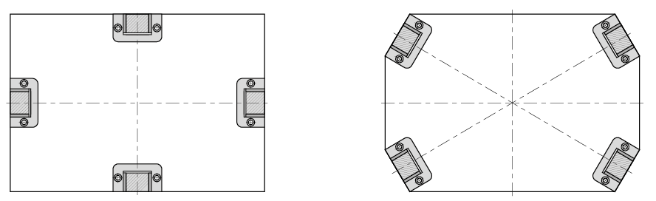 

The guides must not interfere with the removal of parts. This means that the flat guiding stock should be mounted in such a way that a gripper or robot arm, including their components, are not disturbed.

Oil grooves on the guiding surfaces are required for flat guiding units without self-lubrication.

|  |  |  |
| --- | --- | --- |
| Flat guiding unit | | |
|  |  | [E 1315](https://ecom.meusburger.com/e/index.asp?id=57) |
|  |  | [E 1320](https://ecom.meusburger.com/e/index.asp?id=60) |

|  |  |  |  |  |
| --- | --- | --- | --- | --- |
|  | Flat guiding rail | | Gliding plate | |
|  |  | [E 1323](https://ecom.meusburger.com/e/index.asp?id=63) |  | [E 1321](https://ecom.meusburger.com/e/index.asp?id=61) |
|  |  | [E 1323](https://ecom.meusburger.com/e/index.asp?id=63) |  | [E 13212](https://ecom.meusburger.com/e/index.asp?id=1371) |
|  |  | [E 1323](https://ecom.meusburger.com/e/index.asp?id=63) |  | [E 1322](https://ecom.meusburger.com/e/index.asp?id=62) |

|  |  |  |  |  |
| --- | --- | --- | --- | --- |
|  | Flat guiding stock 3-plate mould | | Gliding plate | |
|  |  | [E 1324](https://ecom.meusburger.com/e/index.asp?id=1370) |  | [E 1321](https://ecom.meusburger.com/e/index.asp?id=61) |
|  |  | [E 1324](https://ecom.meusburger.com/e/index.asp?id=1370) |  | [E 13212](https://ecom.meusburger.com/e/index.asp?id=1371) |
|  |  | [E 1324](https://ecom.meusburger.com/e/index.asp?id=1370) |  | [E 1322](https://ecom.meusburger.com/e/index.asp?id=62) |

## Centring

If the contour does not permit sufficient spotting, centring elements or form-fit centring devices (catch cone) must be introduced in addition to the main centring. Pressure plates ([E 2680](https://ecom.meusburger.com/e/index.asp?id=328&eg=3), [E 2682](https://ecom.meusburger.com/e/index.asp?id=329), [E 3174](https://ecom.meusburger.com/e/index.asp?id=2119&eg=12)) for the mould centring are to be provided with criss-cross oil grooves.

Depending on the mould size, additional pressure plates are to be introduced for easier alignment in the split line face.

### Top and side locks

Top and side locks are required in the manufacture of high-precision components.

Depending on space requirements top locks for vertical installation or side locks for horizontal installation can be used.

|  |  |  |  |  |  |  |
| --- | --- | --- | --- | --- | --- | --- |
| Top lock | | |  | Side lock | | |
|  |  | [E 1304](https://ecom.meusburger.com/e/index.asp?id=51&rnd=72384) |  |  |  | [E 1308](https://ecom.meusburger.com/e/index.asp?id=53) |
|  |  | [E 13045](https://ecom.meusburger.com/e/index.asp?id=1840) |  |  |  |  |

### Fine centring unit

|  |  |  |
| --- | --- | --- |
|  |  | [E 1306](https://ecom.meusburger.com/e/index.asp?id=52) |
|  |  | [E 1311](https://ecom.meusburger.com/e/index.asp?id=1039) |
|  |  | [E 13070](https://ecom.meusburger.com/e/index.asp?id=1850) |
|  |  | [E 13076](https://ecom.meusburger.com/e/index.asp?id=1851) |

### Centring unit

|  |  |  |
| --- | --- | --- |
|  |  | [E 1310](https://ecom.meusburger.com/e/index.asp?id=54) |
|  |  | [E 1352](https://ecom.meusburger.com/e/index.asp?id=1576) |

# Sprues

## Sprue type

The sprue type is determined in the mould specification. Alternatives are to be presented and justified.

## Sprue design

The sprue design is to be submitted to company XY when the designs are complete. If company XY carries out tests (filling simulations), the mould supplier must comply to them. Results of the filling simulations as well as a specification of the hot runner or cold runner manifold design are provided to the mould supplier after consultation at the start of the design phase.

### Sprue bush

|  |  |
| --- | --- |
| **Diameter** | **Length** |
| Ø XY | XY |

|  |  |  |  |  |  |  |  |  |  |  |
| --- | --- | --- | --- | --- | --- | --- | --- | --- | --- | --- |
| Sprue bush with radius 0 | | |  | Sprue bush with radius 15.5 | | |  | Sprue bush with radius 40 | | |
|  | 1° | [E 1600](https://ecom.meusburger.com/e/index.asp?id=129&rnd=44293) |  |  | 1° | [E 1605](https://ecom.meusburger.com/e/index.asp?id=130) |  |  | 1° | [E 1610](https://ecom.meusburger.com/e/index.asp?id=131) |
|  | 0.5° | [E 1620](https://ecom.meusburger.com/e/index.asp?id=132) |  |  | 0.5° | [E 1625](https://ecom.meusburger.com/e/index.asp?id=133) |  |  | 0.5° | [E 1630](https://ecom.meusburger.com/e/index.asp?id=134) |
|  | Starting hole | [E 1601](https://ecom.meusburger.com/e/index.asp?id=1964) |  |  |  |  |  |  |  |  |

### Sprue retainer

|  |  |
| --- | --- |
| **Diameter** | **Length** |
| Ø XY | XY |

|  |  |  |  |  |  |  |
| --- | --- | --- | --- | --- | --- | --- |
| Sprue retainer | | |  | Sprue retainer without undercut | | |
|  |  | [E 1660](https://ecom.meusburger.com/e/index.asp?id=135&rnd=2389) |  |  |  | [E 1663](https://ecom.meusburger.com/e/index.asp?id=137) |
|  | long guiding | [E 1662](https://ecom.meusburger.com/e/index.asp?id=136) |  |  | long guiding | [E 1664](https://ecom.meusburger.com/e/index.asp?id=138) |

### Sprue cone

To guarantee a safe removal, a sprue cone is needed. The length should be twice, maximum triple the average diameter. At the end of the sprue cone towards the sprue channels, a radius is required to guarantee a gentle material deflection. A collection bag for the cold drops is to be attached opposite the gating point.

### Sprue channel

|  |  |  |
| --- | --- | --- |
|  | **Type** | **Dimensions** |
|  | Fully round | Ø XY |
|  | Half round | Ø XY |
|  | Trapezoidal | cid:image001.png@01D76670.10913100  A =  B =  C =  R = |

The size of the sprue channel depends on the maximum part wall thickness and should be designed so that the filling of the component is guaranteed and the sprue channel does not determine the cycle time.

Sufficient fillets are to be made in the transition to the sprue tunnel.

### Sprue tunnel

The sprue tunnels are generally to be provided with a dead-end recess. The angle to the item should be between 25° and 35°. The angle is to be given special consideration for fibre-reinforced materials.

The sprue tunnel is to be designed for the plastic to be processed and the component to be injected. A jet must be avoided. Standard parts are to be used in the gate area.

|  |  |  |  |  |  |  |  |  |  |  |
| --- | --- | --- | --- | --- | --- | --- | --- | --- | --- | --- |
| Tunnel gate insert, round | | |  | Tunnel gate insert, rectangular | | |  | Contour tunnel gate insert | | |
|  |  | [E 1680](https://ecom.meusburger.com/e/index.asp?id=141&rnd=98939) |  |  |  | [E 1685](https://ecom.meusburger.com/e/index.asp?id=143) |  |  | 60 HRC | [E 1690](https://ecom.meusburger.com/e/index.asp?id=145) |
|  |  | [E 1682](https://ecom.meusburger.com/e/index.asp?id=142) |  |  |  | [E 1687](https://ecom.meusburger.com/e/index.asp?id=144) |  |  | 40 HRC | [E 1692](https://ecom.meusburger.com/e/index.asp?id=146) |
|  |  |  |  |  |  |  |  |  |  | [E 1693](https://ecom.meusburger.com/e/index.asp?id=1573) |
|  |  |  |  |  |  |  |  |  |  | [E 16935](https://ecom.meusburger.com/e/index.asp?id=2060) |
|  |  |  |  |  |  |  |  |  |  | [E 1694](https://ecom.meusburger.com/e/index.asp?id=1574) |
|  |  |  |  |  |  |  |  |  |  | [E 1695](https://ecom.meusburger.com/e/index.asp?id=147) |
|  |  |  |  |  |  |  |  |  |  | [E 1696](https://ecom.meusburger.com/e/index.asp?id=1343) |

### Sprue adjusters

Sprue adjusters should be used according to the sprue channel layout for quick shutting off or adjusting of unnecessary or damaged cavities.

|  |  |  |  |
| --- | --- | --- | --- |
|  |  | [E 1675](https://ecom.meusburger.com/e/index.asp?id=2092) | Without ejector bore |
|  |  | [E 1676](https://ecom.meusburger.com/e/index.asp?id=2093) | With ejector bore |

# Hot runner system

Meusburger Deutschland is the preferred supplier for the hot runner system. A standardised hot runner system is preferably used ([E 4500](https://ecom.meusburger.com/fh_menu/index.asp?rnd=65664)).

Company XY must be informed in the case of custom productions.

## General information

|  |  |  |  |
| --- | --- | --- | --- |
|  | **Type** | **Actuation** | **Radius of the sprue bush** |
|  | Valve gate | Individually actuated; actuation via lifting plate  Hydraulic, pneumatic, electric | XY |
|  | Open | - | XY |

## Hot runner design

If necessary, the hot runner supplier is to be included in the design. The filling simulations provided by company XY should also be submitted to the hot runner supplier.

The hot runner is to be insulated from the mould plates as best as possible, but supported so that no displacement can occur via the plastification unit.

The design designation, including the parts list of the system supplier, is to be enclosed with the mould design.

## Hot runner label

The hot runner label with commission number must be attached to the cavity plate on the operator side of the mould. The pin assignment must also be on the label ([E 191..](https://ecom.meusburger.com/e/index.asp?id=187&rnd=30043)).

## Hot runner electrical system

### Placement of the connector housing

The connector housing for electrical components is generally to be attached to the top of the mould. The connector housing is to be positioned so that there is no impairment from mould attachments or parts of the injection moulding machine when connecting the hot runner cables. Furthermore, the assembly is to be positioned sufficiently distanced from the eye bolt thread holes of the mould plates. The fastening should only be made to one mould plate if possible.

### Plug assignment on the hot runner

|  |  |  |
| --- | --- | --- |
|  | Male insert | **Meusburger/PSG-Standard pin assignment**  6 zones per plug (24-pin)  Variable pin assignment for sensor (+/-) and heating (L/N)  Type of locking: dual locking latch |
|  | Male insert | **Pin assignment -121**  6 zones per plug (24-pin)  Variable pin assignment for sensor (+/-) and heating (L/N)  Type of locking: dual locking latch |
|  | Male insert Female insert | **Pin assignment -522**  12 zones per plug (24-pin)  Separate plug for heating (L/N) and sensor (+/-)  Type of locking: dual locking latch |
|  | Male insert Female insert | **Pin assignment -620– EUROMAP 14**  8 zones per plug (16-pin)  Separate plug for heating (L/N) and sensor (+/-)  Type of locking: single locking latch |

### Assignment sequence

Starting with plug 1 at the top left clockwise

* First all nozzles
* Then top left clockwise starting with all subsequent nozzle zones (nozzle shaft)
* Then top left clockwise starting with all manifolds
* Then sprue bush
* Then, if desired in the mould specification, thermocouples

**Example:**



**Plug 1**

Zone 1 = nozzle 1

Zone 2 = nozzle 2

Zone 3 = nozzle 3

Zone 4 = manifold 1

Zone 5 = manifold 2

Zone 6 = manifold 3

Zone 7 = sprue bush



**Overview of the plug, socket and cable housing to download and print**

# Slides

## Mechanically actuated slides

If several slides are used, they must be designed in such a way that it is impossible to mix them up. Slides actuated by inclined pins are secured with an end-positioning device (spring-loaded thrust pieces, slide clamp, roof catches, etc.) and secured with a stop screw.

Inclined pins should preferably be exchangeable from the split line face (e.g. [E 1034](https://ecom.meusburger.com/e/index.asp?id=6&eg=1)).

For slide guides, self-lubricating, preferably DLC coated standard parts are to be used.

Wear plates for slide blocking are to be provided with criss-cross oil grooves.

In case of a danger of collision, an electrical end position monitoring is to be incorporated.

### Standardised slide systems

Preferably, standardised slide systems should be used.



[**Overview of the slide systems to download and print**](https://ecom.meusburger.com/files/pdf/e/schieber_uebersicht.pdf)

[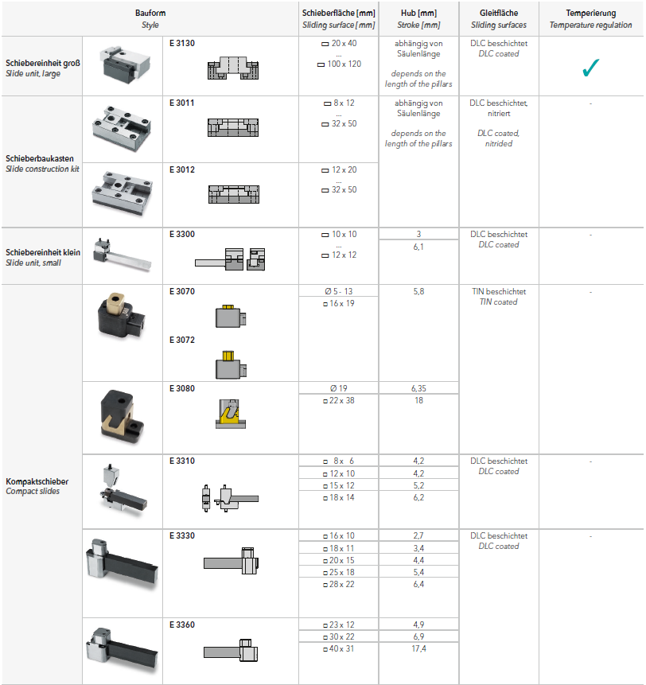](https://ecom.meusburger.com/e_menu/index.asp?set_gruppe=12)

## Hydraulically actuated slides

Hydraulic slides are equipped with end position monitoring for “**Core IN**” and “**Core OUT**”.

The setter must be able to see the position of the slide either by the operating rod (if mechanical limit switches are used) or by an optical device.

# Demoulding

## Ejectors

The mould supplier is responsible for demoulding that is appropriate for the item. The quantity and selection of demoulding elements are to be specified accordingly. If larger, contouring ejectors are used, these are to be cooled with a separate cooling circuit.

Contouring ejectors are to be secured against twisting. Ejectors with a steep contour on the front end must be provided with steps. Ejectors with DLC coating are preferably used.

In general, the ejector set compartment must be covered from above (e.g. with [E 1920](https://ecom.meusburger.com/e/index.asp?id=188&rnd=24763)).



[**Overview of the ejector pins to download and print**](https://ecom.meusburger.com/files/pdf/e/auswerfer_kernstifte_uebersicht_info_DLC.pdf)

|  |  |  |  |  |  |  |  |  |  |  |  |
| --- | --- | --- | --- | --- | --- | --- | --- | --- | --- | --- | --- |
|  |  |  |  |  |  |  |  |  |  |  |  |
|  |  | 1.2210 | 1.2210  DLC | 1.2343  non-nitrided | 1.2343  nitrided | 1.2343  nitrided/oxidised | 1.2344 | 1.3343 | 1.3343 DLC | 1.4112 | Copper |
|  | Ejector pin, straight | [E 171 0](https://ecom.meusburger.com/e/index.asp?id=151&rnd=21811) | [E 1710 DLC](https://ecom.meusburger.com/e/index.asp?id=149) |  | [E 1741](https://ecom.meusburger.com/e/index.asp?id=2323) | [E 1740](https://ecom.meusburger.com/e/index.asp?id=165) |  | [E 17103](https://ecom.meusburger.com/e/index.asp?id=1372) |  | [E 17109](https://ecom.meusburger.com/e/index.asp?id=2066) |  |
|  | Ejector pin straight with conical head | [E 1715](https://ecom.meusburger.com/e/index.asp?id=154) |  |  | [E 1745](https://ecom.meusburger.com/e/index.asp?id=166) |  |  |  |  |  |  |
|  | Ejector pin with anti-twist lock on one side | [E 1711](https://ecom.meusburger.com/e/index.asp?id=1965) |  |  |  |  |  |  |  |  |  |
|  | Ejector pin with anti-twist lock | [E 1712](https://ecom.meusburger.com/e/index.asp?id=153) |  |  |  |  |  |  |  |  |  |
|  | Ejector pin, offset | [E 1700](https://ecom.meusburger.com/e/index.asp?id=148) |  |  |  | [E 1730](https://ecom.meusburger.com/e/index.asp?id=164) |  | [E 17003](https://ecom.meusburger.com/e/index.asp?id=2201) | [E 1700 DLC](https://ecom.meusburger.com/e/index.asp?id=149) |  |  |
|  | Ejector pin, offset with anti-twist lock | [E 1702](https://ecom.meusburger.com/e/index.asp?id=150) |  |  |  |  |  |  |  |  |  |
|  | Ejector sleeve | [E 1720](https://ecom.meusburger.com/e/index.asp?id=155) |  |  | [E 1750](https://ecom.meusburger.com/e/index.asp?id=167) |  |  |  |  |  |  |
|  | Ejector sleeve, stepless | [E 1723](https://ecom.meusburger.com/e/index.asp?id=2200) |  |  |  |  |  |  |  |  |  |
|  | Blade ejector | [E 1725](https://ecom.meusburger.com/e/index.asp?id=156) |  |  |  | [E 1755](https://ecom.meusburger.com/e/index.asp?id=168&rnd=80594) |  |  |  |  |  |
|  | Blade ejector pin with  2 angle radii | [E 1727](https://ecom.meusburger.com/e/index.asp?id=160) | [E 1727 DLC](https://ecom.meusburger.com/e/index.asp?id=161) |  |  |  |  |  |  |  |  |
|  | Blade ejector pin with  4 angle radii | [E 1728](https://ecom.meusburger.com/e/index.asp?id=162) | [E 1728 DLC](https://ecom.meusburger.com/e/index.asp?id=163) |  |  |  |  |  |  |  |  |
|  | Blade ejector pin with extra long blade | [E 1726](https://ecom.meusburger.com/e/index.asp?id=1574) |  |  |  |  |  |  |  |  |  |
|  | Blade ejector pin with extra long blade, 2 angle radii | [E 17262](https://ecom.meusburger.com/e/index.asp?id=158) | [E 17262 DLC](https://ecom.meusburger.com/e/index.asp?id=1344) |  |  |  |  |  |  |  |  |
|  | Blade ejector pin with extra long blade, 4 angle radii | [E 17264](https://ecom.meusburger.com/e/index.asp?id=159) | [E 17264 DLC](https://ecom.meusburger.com/e/index.asp?id=1345) |  |  |  |  |  |  |  |  |
|  | Core pin |  |  | [E 1742](https://ecom.meusburger.com/e/index.asp?id=1651) |  |  |  |  |  |  | [E 1780](https://ecom.meusburger.com/e/index.asp?id=2059) |
|  | Contour core pin | [E 1786](https://ecom.meusburger.com/e/index.asp?id=169) |  |  |  |  | [E 1790](https://ecom.meusburger.com/e/index.asp?id=170) |  |  |  |  |
|  | Ejector pin for ventilation | [E 1770](https://ecom.meusburger.com/e/index.asp?id=2309) |  |  |  |  |  |  |  |  |  |

## Hydraulically operated ejector retaining plates

Plate length less than XY mm: 1 limit switch each for the end positions **“Core IN**” or “**Core OUT**”

Plate length more than XY mm: 2 limit switches each for the end positions **“Core IN**” or “**Core OUT**” diagonally opposite

The limit switches are to be arranged so that easy access and readjustment, if necessary, is possible.

## Thread insert and ejector rod

### Thread insert

|  |  |
| --- | --- |
| **Thread** | **Length** |
| XY | XY |

|  |  |  |
| --- | --- | --- |
|  |  | [E 1515](https://ecom.meusburger.com/e/index.asp?id=91&eg=8) |
|  |  | [E 1516](https://ecom.meusburger.com/e/index.asp?id=92) |

### Ejector rod

|  |  |
| --- | --- |
| **Diameter** | **Length** |
| XY | XY |

|  |  |  |
| --- | --- | --- |
|  |  | [E 1050](https://ecom.meusburger.com/e/index.asp?id=9&eg=1) |
|  |  | [E 1800](https://ecom.meusburger.com/e/index.asp?id=171&eg=8) |
|  |  | [E 1804](https://ecom.meusburger.com/e/index.asp?id=172) |

## Position monitoring and securing

### End position control

An end position monitoring is to be performed if there is a danger of collision between the ejector and other mould elements (slides) during the closing process, if front end position monitoring is required for the removal handling and if there are no push back pins. The position monitoring can be done using mechanical or inductive limit switches.



[**Overview of limit switches to download and print**](https://ecom.meusburger.com/files/pdf/e/Endschalter_info.pdf)

**Mechanical** **Inductive**

[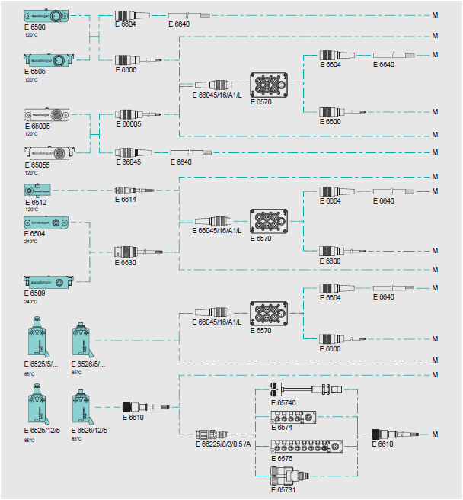](https://ecom.meusburger.com/index.asp?lang=1&k=f&ek=et&eg=21&eug=21020) [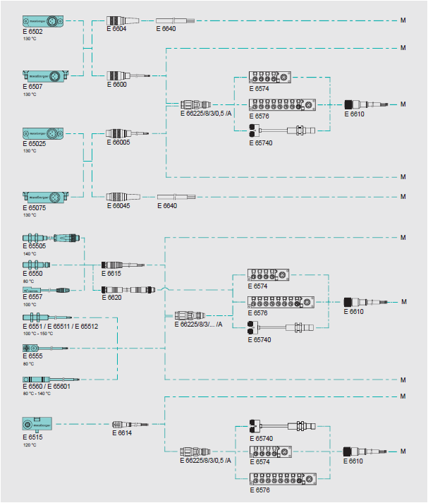](https://ecom.meusburger.com/index.asp?lang=1&k=f&ek=et&eg=21&eug=21020)

### Push back pins and push back unit

The rear end position of the ejector retaining plate is to be secured via push back pins when the mould is closed.

The front surface of the push back pins is to be provided with a chamfer or a radius. Alternatively, a push back unit ([E 1830](https://ecom.meusburger.com/e/index.asp?id=1672&rnd=5418)) can be installed.

### Ejector set lock

The [E 1940](https://ecom.meusburger.com/e/index.asp?id=193&eg=14) automatic ejector set lock is to be used to ensure a smooth transport, especially if ejectors are below slides. It can also be used in combination with the [E 1512](https://ecom.meusburger.com/e/index.asp?id=1655&eg=1) and [E 1513](https://ecom.meusburger.com/e/index.asp?id=89) support pillars for support.

## 3-plate moulds

The following components can be used according to the table to control tools with 3 plates. Pay attention if the floating plate has to be locked or if a back swinging is allowed.

|  |
| --- |
| **Locking** |
| Yes / No |

|  |  |  |  |
| --- | --- | --- | --- |
|  |  | **With locking** |  |
|  |  | No | [E 1807](https://ecom.meusburger.com/e/index.asp?id=173&rnd=59163) |
|  |  | No | [E 1808](https://ecom.meusburger.com/e/index.asp?id=174) |
|  |  | No | [E 1809](https://ecom.meusburger.com/e/index.asp?id=175) |
|  |  | No | [E 1817](https://ecom.meusburger.com/e/index.asp?id=2210) |
|  |  | Yes | [E 1820](https://ecom.meusburger.com/e/index.asp?id=177) |
|  |  | Yes | [E 1840](https://ecom.meusburger.com/e/index.asp?id=178) |
|  |  | Yes | [E 1845](https://ecom.meusburger.com/e/index.asp?id=1056) |

# Hydraulic system

## Hydraulic connectors

Uniform connection threads are to be incorporated on the mould.

|  |
| --- |
| **Connection thread** |
| XY |

The screw-in threads for the core puller connections on the mould plates are to be labelled with stamped numbers, engraving or marking chips [E 2030S](https://ecom.meusburger.com/e/index.asp?id=1842).

**Example:**

**Core 1 IN / core 1 OUT**

The core puller connections are to be arranged on the opposite of the operator side of the mould between the tie bars so they can be coupled. The screw sleeve and screw plug are to be attached via a deflection block if they cannot be attached recessed on the mould.

In general, the supply lines are to be realised through holes in the cavity plate. If this is not possible, hosing or piping is to be preferably used (ensure the same supply line length).

Pay attention to collisions of moving parts with machine parts (e.g. tie bars, connections).

## Hydraulic cylinders

The operating pressure of the hydraulic cylinder must be at least 160 bar. Preferably, standard sizes should be used.

The ventilation is ensured via the system. The arrangement should be such that no leak oil can get into the mould. When defining the bending radii of the hydraulic hoses, make sure they do not kink. The hoses must be long enough so that they do not kink in the mounts.

HLP 46 hydraulic oil (ISO viscosity grade VG 46) according to DIN 51524 is to be used.



[**Overview of the hydraulic cylinders to download and print**](https://ecom.meusburger.com/files/pdf/e/E70xx_Uebersicht.pdf)

[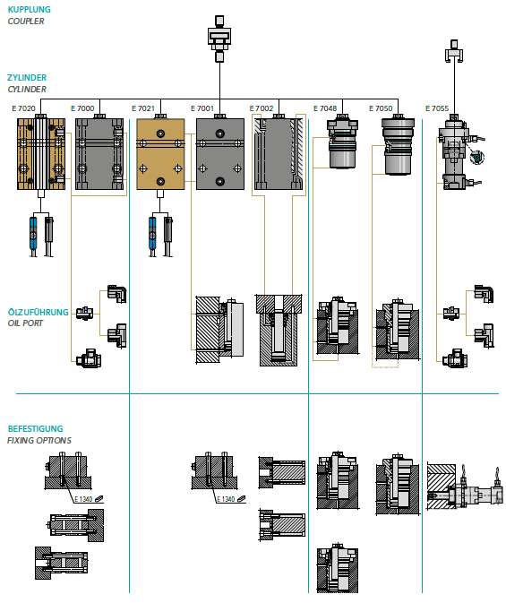](https://ecom.meusburger.com/e_menu/index.asp?set_gruppe=31)

# Temperature regulation components

## Layout of the cooling circuits

Connections for the cooling circuits are generally to be arranged opposite of operator side between the machine tie bars, provided the design permits this. If a hosing of the mould is required in the mould specification, cooling circuits can also be led out below and on the operating sides.

### Diameter of the cooling circuits

|  |
| --- |
| **Diameter of the cooling hole** |
| Ø XY |

When designing the cooling channels, the mould designer shall ensure that the distance to the cavity is maintained in relation to the cooling hole diameter to avoid an inhomogeneous temperature at the cavity surface. Uniform cross sections within the cooling circuits are to be ensured.

### Spacing of the cooling circuits to each other

The cooling holes are to be kept at a minimum distance to each other (at least the counterbore diameter d3) to ensure a flawless connection of the couplers.

### Marking the cooling circuits

Each cooling circuit is to be assigned a consecutive number and **IN** or **OUT**, which are incorporated in the mould plate in the form of marking chips [E 2030](https://ecom.meusburger.com/e/index.asp?id=202&eg=9).

**Example:**



## Adapting the cooling circuits

### Water coolant

If water is used as coolant, an open fitting is to be used.

The ratio of the inner fitting diameter to the cooling hole interior diameter is to be noted.

### Heat transfer oil coolant

If heat transfer oil is used, a sealing fitting is to be used.

### Core cooling

If possible, standard parts are to be used for the core cooling.

### Fittings



[**Overview of the coupling systems to download and print**](https://ecom.meusburger.com/files/pdf/e/Uebersicht_Kupplungssystem.pdf)

|  |  |  |  |  |
| --- | --- | --- | --- | --- |
| **Nominal size d2** | **Fitting** | **Coolant** | **Temperature** | **Pressure** |
| Ø XY | XY | XY | XY | XY |

|  |  |  |  |  |  |  |  |  |  |  |
| --- | --- | --- | --- | --- | --- | --- | --- | --- | --- | --- |
| EU system | | |  | USA system | | |  | System RPL-Stäubli | | |
|  |  | [E 2000](https://ecom.meusburger.com/e/index.asp?id=194&eg=9) |  |  |  | [E 2300](https://ecom.meusburger.com/e/index.asp?id=273) |  |  |  | [E 2800](https://ecom.meusburger.com/e/index.asp?id=1149&rnd=19738) |
|  |  | [E 2000 D](https://ecom.meusburger.com/e/index.asp?id=1847) |  |  |  | [E 2301](https://ecom.meusburger.com/e/index.asp?id=274) |  |  | | |
| Push-in fittings | | |
|  |  | [E 20004](https://ecom.meusburger.com/e/index.asp?id=2305) |  |  |  | [E 2320](https://ecom.meusburger.com/e/index.asp?id=277) |  |  |  | [E 7400](https://ecom.meusburger.com/e/index.asp?id=1024&rnd=66607) |
|  |  | [E 20009](https://ecom.meusburger.com/e/index.asp?id=195) |  |  |  | [E 2321](https://ecom.meusburger.com/e/index.asp?id=278) |  |  |  | [E 7405](https://ecom.meusburger.com/e/index.asp?id=1025) |
|  |  | [E 2002](https://ecom.meusburger.com/e/index.asp?id=1968) |  |  |  |  |  |  | | |
| Low-leakage | | |
|  |  | [E 2020](https://ecom.meusburger.com/e/index.asp?id=200) |  |  |  |  |  |  |  | [E 2500](https://ecom.meusburger.com/e/index.asp?id=2510&rnd=85411) |
|  |  | [E 2020 D](https://ecom.meusburger.com/e/index.asp?id=1848) |  |  |  |  |  |  |  | [E 2500 HT](https://ecom.meusburger.com/e/index.asp?id=2511) |
|  |  | [E 20209](https://ecom.meusburger.com/e/index.asp?id=946) |  |  |  |  |  |  |  |  |

### Temperature regulation pipe extension

Slide devices must be provided with corresponding piping where there is no danger of collision with the temperature regulation connections in case of movement. If necessary, the slide cooling is to be guaranteed via a hose connection.

|  |  |  |  |  |  |  |  |  |
| --- | --- | --- | --- | --- | --- | --- | --- | --- |
| EU system | | |  | USA system | | | | |
|  |  | [E 2016](https://ecom.meusburger.com/e/index.asp?id=2105&rnd=59509) |  |  |  | | | [E 2318](https://ecom.meusburger.com/e/index.asp?id=276&rnd=54071) |
|  |  | [E 2017](https://ecom.meusburger.com/e/index.asp?id=1144) |  |  | |  |  | |
| System RPL-Stäubli | | | | |
|  |  | [E 2018](https://ecom.meusburger.com/e/index.asp?id=198) |  |  |  | | | [E 2810](https://ecom.meusburger.com/e/index.asp?id=1150&rnd=25521) |
|  |  | [E 20189](https://ecom.meusburger.com/e/index.asp?id=2094) |  |  |  | | | [E 2811](https://ecom.meusburger.com/e/index.asp?id=1151) |
|  |  | [E 2019](https://ecom.meusburger.com/e/index.asp?id=199) |  |  |  | | |  |

## Mould hosing

If hosing is required in the mould specification, this is to be complied with as per the specified standard of company XY.

### **Couplers**

The couplers are to be selected according to the fittings (system and nominal size).

**EU system**

|  |  |  |  |  |  |  |  |  |  |  |
| --- | --- | --- | --- | --- | --- | --- | --- | --- | --- | --- |
| Standard | | |  | Quick-fit nozzle | | |  | Safety coupler | | |
|  |  | [E 2200](https://ecom.meusburger.com/e/index.asp?id=255&rnd=33061)  [E 2202](https://ecom.meusburger.com/e/index.asp?id=257)  [E 2204](https://ecom.meusburger.com/e/index.asp?id=258) |  |  |  | [E 22005](https://ecom.meusburger.com/e/index.asp?id=1326)  [E 22025](https://ecom.meusburger.com/e/index.asp?id=1327)  [E 22045](https://ecom.meusburger.com/e/index.asp?id=1328) |  |  |  | [E 22006](https://ecom.meusburger.com/e/index.asp?id=1356)  [E 22026](https://ecom.meusburger.com/e/index.asp?id=1357)  [E 22046](https://ecom.meusburger.com/e/index.asp?id=1358) |
|  |  | [E 2210](https://ecom.meusburger.com/e/index.asp?id=259)  [E 2212](https://ecom.meusburger.com/e/index.asp?id=261)  [E 2214](https://ecom.meusburger.com/e/index.asp?id=262) |  |  |  | [E 22105](https://ecom.meusburger.com/e/index.asp?id=1329)  [E 22125](https://ecom.meusburger.com/e/index.asp?id=1330)  [E 22145](https://ecom.meusburger.com/e/index.asp?id=1331) |  |  |  | [E 22106](https://ecom.meusburger.com/e/index.asp?id=1359)  [E 22126](https://ecom.meusburger.com/e/index.asp?id=1360)  [E 22146](https://ecom.meusburger.com/e/index.asp?id=1361) |
|  |  | [E 22009](https://ecom.meusburger.com/e/index.asp?id=256)  [E 22049](https://ecom.meusburger.com/e/index.asp?id=2098) |  |  |  |  |  |  |  | [E 22008](https://ecom.meusburger.com/e/index.asp?id=2100) |
|  |  | [E 22109](https://ecom.meusburger.com/e/index.asp?id=260)  [E 22149](https://ecom.meusburger.com/e/index.asp?id=2099) |  |  |  |  |  |  |  | [E 22108](https://ecom.meusburger.com/e/index.asp?id=2101) |
|  |  | [E 2220](https://ecom.meusburger.com/e/index.asp?id=263)  [E 2222](https://ecom.meusburger.com/e/index.asp?id=264)  [E 2224](https://ecom.meusburger.com/e/index.asp?id=265) |  |  |  |  |  |  |  | [E 22206](https://ecom.meusburger.com/e/index.asp?id=1362)  [E 22226](https://ecom.meusburger.com/e/index.asp?id=1363)  [E 22246](https://ecom.meusburger.com/e/index.asp?id=1364) |
|  |  | [E 2230](https://ecom.meusburger.com/e/index.asp?id=266)  [E 2232](https://ecom.meusburger.com/e/index.asp?id=267)  [E 2234](https://ecom.meusburger.com/e/index.asp?id=268) |  |  |  |  |  |  |  | [E 22306](https://ecom.meusburger.com/e/index.asp?id=1365)  [E 22326](https://ecom.meusburger.com/e/index.asp?id=1366)  [E 22346](https://ecom.meusburger.com/e/index.asp?id=1367) |
|  |  |  |  |  |  |  |  |  |  | [E 22208](https://ecom.meusburger.com/e/index.asp?id=2102) |
|  |  |  |  |  |  |  |  |  |  | [E 22308](https://ecom.meusburger.com/e/index.asp?id=2103) |

**USA system**

|  |  |  |  |  |  |  |  |  |  |  |
| --- | --- | --- | --- | --- | --- | --- | --- | --- | --- | --- |
| Standard | | |  | Quick-fit nozzle | | |  | Safety coupler | | |
|  |  | [E 2350](https://ecom.meusburger.com/e/index.asp?id=280&eg=9)  [E 2352](https://ecom.meusburger.com/e/index.asp?id=281)  [E 2354](https://ecom.meusburger.com/e/index.asp?id=283) |  |  |  | [E 23505](https://ecom.meusburger.com/e/index.asp?id=2109)  [E 23525](https://ecom.meusburger.com/e/index.asp?id=2110)  [E 23545](https://ecom.meusburger.com/e/index.asp?id=2111) |  |  |  | [E 23506](https://ecom.meusburger.com/e/index.asp?id=2115) |
|  |  | [E 2360](https://ecom.meusburger.com/e/index.asp?id=284)  [E 2362](https://ecom.meusburger.com/e/index.asp?id=285)  [E 2364](https://ecom.meusburger.com/e/index.asp?id=286) |  |  |  | [E 23605](https://ecom.meusburger.com/e/index.asp?id=2112)  [E 23625](https://ecom.meusburger.com/e/index.asp?id=2113)  [E 23645](https://ecom.meusburger.com/e/index.asp?id=2114) |  |  |  | [E 23606](https://ecom.meusburger.com/e/index.asp?id=2116) |
|  |  | [E 2370](https://ecom.meusburger.com/e/index.asp?id=287) |  |  |  |  |  |  |  | [E 23706](https://ecom.meusburger.com/e/index.asp?id=2117) |
|  |  | [E 2380](https://ecom.meusburger.com/e/index.asp?id=288) |  |  |  |  |  |  |  | [E 23086](https://ecom.meusburger.com/e/index.asp?id=2118) |

**System RPL-Stäubli**

|  |  |  |  |  |  |  |
| --- | --- | --- | --- | --- | --- | --- |
| Standard | | |  | Quick-fit nozzle | | |
|  |  | [E 2820](https://ecom.meusburger.com/e/index.asp?id=1153)  [E 2822](https://ecom.meusburger.com/e/index.asp?id=1155)  [E 2821](https://ecom.meusburger.com/e/index.asp?id=1154) |  |  |  | [E 28205](https://ecom.meusburger.com/e/index.asp?id=1332)  [E 28225](https://ecom.meusburger.com/e/index.asp?id=1334)  [E 28215](https://ecom.meusburger.com/e/index.asp?id=1333) |

**Low-leakage**

|  |  |  |  |  |  |  |  |  |  |  |
| --- | --- | --- | --- | --- | --- | --- | --- | --- | --- | --- |
| Standard | | |  | Quick-fit nozzle | | |  | Thread | | |
|  |  | [E 2510](https://ecom.meusburger.com/e/index.asp?id=2512) |  |  |  | [E 2515](https://ecom.meusburger.com/e/index.asp?id=2513) |  |  |  | [E 2520](https://ecom.meusburger.com/e/index.asp?id=2514)  [E 2522](https://ecom.meusburger.com/e/index.asp?id=2516) |
|  |  |  |  |  |  |  |  |  |  |  |
|  |  |  |  |  |  |  |  | With thread, high-temperature | | |
|  |  |  |  |  |  |  |  |  |  | [E 2520 HT](https://ecom.meusburger.com/e/index.asp?id=2515)  [E 2522 HT](https://ecom.meusburger.com/e/index.asp?id=2517) |

### Coolant hoses

[**Overview of the coolant hoses to download and print**](https://ecom.meusburger.com/files/pdf/e/Uebersicht-TEMP-Schlauch.pdf)

[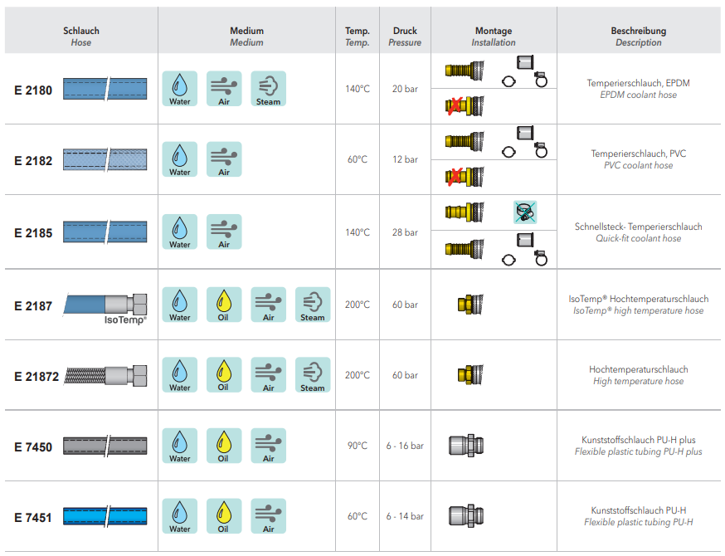](https://ecom.meusburger.com/e_menu/index.asp?set_gruppe=9)

### Manifolds

The manifolds are to be attached opposite of operator side between the machine tie bars.

The inlets and outlets of the manifolds are to be differentiated with colours (IN: blue; OUT: red).

|  |
| --- |
| **Number of outlets** |
| XY |

|  |  |  |  |
| --- | --- | --- | --- |
|  |  | [E 2165/../B](https://ecom.meusburger.com/e/index.asp?id=1157&eg=9) | 4-8 outlets |
|  |  | [E 2165/../R](https://ecom.meusburger.com/e/index.asp?id=1157&eg=9) | 4-8 outlets |

Each manifold is provided for one cooling circuit. Hose bridges may only be used in consultation with company XY. When attaching the coolant hoses, it may be necessary to provide a locking device on the mould plates. If there is hosing over the outside corners of the mould plate, a corner angle is to be used.

## Sealing plugs and screw plugs

|  |  |
| --- | --- |
| **Diameter** | **Thread** |
| XY | XY |

|  |  |  |  |
| --- | --- | --- | --- |
| Plugs | | | |
|  |  | [E 2071](https://ecom.meusburger.com/e/index.asp?id=214&eg=9) | Max. p = 40 bar  Mat.: steel |
|  |  | [E 20719](https://ecom.meusburger.com/e/index.asp?id=2097) | Max. p = 40 bar  Mat.: stainless steel |
|  |  | [E 2072](https://ecom.meusburger.com/e/index.asp?id=215) | Max. p = 10 bar  Mat.: Cu |
|  |  | [E 20725](https://ecom.meusburger.com/e/index.asp?id=216) | Max. p = 20 bar  Mat.: Cu |
|  |  | [E 2078](https://ecom.meusburger.com/e/index.asp?id=223) | Max. p = 20 bar |
|  |  | [E 2079](https://ecom.meusburger.com/e/index.asp?id=224) | Max. p = 10 bar |

|  |  |  |  |
| --- | --- | --- | --- |
| Screw plugs | | | |
|  |  | [E 2074](https://ecom.meusburger.com/e/index.asp?id=218) | Mat.: CuZn |
|  |  | [E 2074 D](https://ecom.meusburger.com/e/index.asp?id=1849) | Mat.: CuZn, with sealant |
|  |  | [E 20749](https://ecom.meusburger.com/e/index.asp?id=1658) | Mat.: stainless steel |
|  |  | [E 2075](https://ecom.meusburger.com/e/index.asp?id=219) | Max. temp. = 160°C  Mat.: CuZn, with sealant |
|  |  | [E 2080](https://ecom.meusburger.com/e/index.asp?id=225) | Mat.: CuZn |
|  |  | [E 20809](https://ecom.meusburger.com/e/index.asp?id=2196) | Mat.: stainless steel |
|  |  | [E 2076](https://ecom.meusburger.com/e/index.asp?id=220) | Mat.: CuZn |
|  |  | [E 20760](https://ecom.meusburger.com/e/index.asp?id=2520&eg=9) | p max = 10 bar, t max = 95°C  Mat.: PA |
|  |  | [E 20767](https://ecom.meusburger.com/e/index.asp?id=1659) | Mat.: steel |
|  |  | [E 20769](https://ecom.meusburger.com/e/index.asp?id=2519) | Mat.: stainless steel |
|  |  | [E 7140](https://ecom.meusburger.com/e/index.asp?id=322) | Mat.: steel |

## O-rings

O-rings are to be chosen depending on the temperature of the coolant.

|  |  |  |  |
| --- | --- | --- | --- |
|  |  | [E 2130](https://ecom.meusburger.com/e/index.asp?id=243) | Mat.: FKM  t max = 100°C water / 180°C oil |
|  |  | [E 21311](https://ecom.meusburger.com/e/index.asp?id=1990) | Mat.: FKM plus  t max = 180°C water / 180°C oil |

The hole should be designed as a ring groove if possible. If there is limited space available, a circular pocket is also an option.

|  |  |  |  |
| --- | --- | --- | --- |
| **Outer diameter** | **Thickness** | **Inner diameter** | **Design of the hole** |
| Ø XY | XY | XY | Ring groove / circular pocket |



[**Overview of the O-ring counterbores to download and print**](https://ecom.meusburger.com/files/pdf/e/O-Ring_Nutenempfelung.pdf)

# Process monitoring

## Cycle counter

In each series mould, a cycle counter is to be installed in the mould split line on the operator side to document the quantity already produced.

The cycle counter is not added or installed until the final delivery of the mould.

|  |  |  |  |
| --- | --- | --- | --- |
|  |  | [E 2480](https://ecom.meusburger.com/e/index.asp?id=319&eg=14) | Up to 120°C |
|  |  | [E 24805](https://ecom.meusburger.com/e/index.asp?id=1987) | Up to 160°C |
|  |  | E 24807 | Up to 200°C |
|  |  | [E 24830](https://ecom.meusburger.com/e/index.asp?id=2306) | Up to 120°C |
|  |  | [E 2484](https://ecom.meusburger.com/e/index.asp?id=325) | Up to 120°C |
|  |  | [E 2485](https://ecom.meusburger.com/e/index.asp?id=326) | Up to 120°C |

## Cavity pressure sensors

The quantity and positioning of the sensors is specified by company XY. The installation conditions in the installation instructions must be followed to avoid malfunctions.

The connections of cavity pressure sensors are usually to be attached on the top or side of the mould. Other positions are possible in consultation with company XY. When using several cavity pressure sensors, use a multi-channel connector.

|  |  |  |
| --- | --- | --- |
| **Cavity pressure sensor** | **Placement** | **Assignment** |
| Sensor 1 | XY | Multi-channel connector 1  Slot XY |
| Sensor 2 | XY | Multi-channel connector 1  Slot XY |
| Sensor 3 | XY | Multi-channel connector 1  Slot XY |

|  |  |  |  |
| --- | --- | --- | --- |
| Direct measurement | | | |
|  |  | [E 6740/2,5](https://ecom.meusburger.com/e/index.asp?id=2203&eg=21) | d= 2.5 mm  Nominal sensitivity: -2.0 pC/bar |
|  |  | [E 6740/4,0](https://ecom.meusburger.com/e/index.asp?id=2203&eg=21) | d= 4.0 mm  Nominal sensitivity: -5.0 pC/bar |

|  |  |  |  |
| --- | --- | --- | --- |
| Indirect measurement | | | |
|  |  | [E 6750/3,5/600](https://ecom.meusburger.com/e/index.asp?id=2204) | d= 3.5 mm  Nominal sensitivity: -12 pC/N |
|  |  | [E 6750/6,0](https://ecom.meusburger.com/e/index.asp?id=2204) | d= 6.0 mm  Nominal sensitivity: -4.5 pC/N |

|  |  |  |  |
| --- | --- | --- | --- |
| Sensor cable | | | |
|  |  | [E 6756](https://ecom.meusburger.com/e/index.asp?id=2205)  [E 6757](https://ecom.meusburger.com/e/index.asp?id=2328) | Mini coaxial |
|  |  | [E 6760](https://ecom.meusburger.com/e/index.asp?id=2329) | Single wire |
|  |  | [E 6763](https://ecom.meusburger.com/e/index.asp?id=2330&rnd=89996) | Multi-channel connector |



[**Overview of the cavity pressure sensors to download and print**](https://ecom.meusburger.com/files/pdf/e/WERKZEUGINNENDRUCKSENSOREN_ueberblick.pdf)

## Thermocouples

If there are several thermocouples, they should be connected in the same order as on the hot runner. A mould temperature sensor must be provided for each mould half.

company XY specifies the position of the sensors.

|  |  |  |
| --- | --- | --- |
|  |  | [E 6700](https://ecom.meusburger.com/e/index.asp?id=1221&rnd=67889) |
|  |  | [E 6702](https://ecom.meusburger.com/e/index.asp?id=1222) |
|  |  | [E 6704](https://ecom.meusburger.com/e/index.asp?id=1223) |

## Logic distributors

When merging several sensor signals, corresponding logic distributors are to be used.

|  |  |
| --- | --- |
| **Manifold** | **Combined sensors** |
| Manifold 1 | XY |
| Manifold 2 | XY |
| Manifold 3 | XY |

|  |  |  |  |
| --- | --- | --- | --- |
| Single AND/OR | | | |
|  |  | [E 65740](https://ecom.meusburger.com/e/index.asp?id=2331&eg=21) | Number of terminals: 1x2 |
|  |  | [E 6574/8/3/1x4](https://ecom.meusburger.com/e/index.asp?id=1352&eg=21) | Number of terminals: 1x4 |
|  |  | [E 6574/8/3/1x8](https://ecom.meusburger.com/e/index.asp?id=1352&eg=21) | Number of terminals: 1x8 |

|  |  |  |  |
| --- | --- | --- | --- |
| Double AND | | | |
|  |  | [E 6576/8/3/2x2](https://ecom.meusburger.com/e/index.asp?id=1353&rnd=11651) | Number of terminals: 2x2 |
|  |  | [E 6576/8/3/2x4](https://ecom.meusburger.com/e/index.asp?id=1353&rnd=11651) | Number of terminals: 2x4 |

## Electrical connections

Ensure state-of-the-art equipment is used and regulations are adhered to for the electrical connections (plugs and connection cables).



[**Overview of connection options to download and print**](https://ecom.meusburger.com/files/pdf/e/Anschlussmoeglichkeiten-gesamt.pdf)

# Mould specifications

## Dimensions and weight

Mould dimensions:

|  |  |  |
| --- | --- | --- |
| **Width** | **Height** | **Installation height** |
| XY  mm | XY  mm | XY  mm |

Mould weight:

|  |  |  |
| --- | --- | --- |
| **Fixed half (FH)** | **Moving half (MH)** | **Total** |
| XY  kg | XY  kg | XY  kg |

## Mould centre of gravity

The mould centre of gravity must be minimally inclined towards the moving half so that easy centring is possible when installing the mould on the fixed half. Eye bolt threads for separate clamping of the fixed and moving half must be in the centre of gravity.

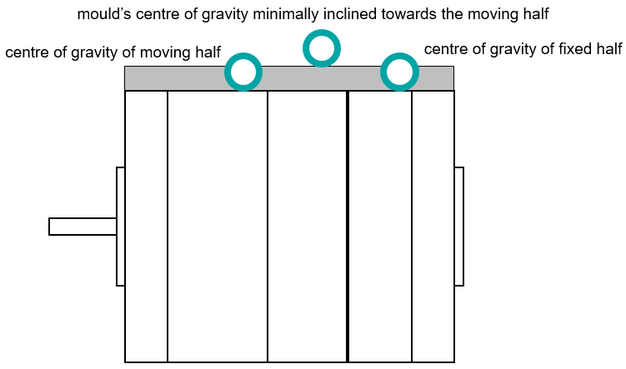

Generally 2, if possible 4, threaded holes are to be incorporated on the top side of the mould while taking the mould centre of gravity and the mould weight into consideration.

The thread depth must be sufficient so that eye bolts can be screwed in all the way.

## Securing the mould

The mould supplier must request the machine clamping plans for the respective project from company XY. The clamping surfaces as well as the strength are to be assigned to the respective machine group.

### Screw holes

**In case of sufficient spacing to the tie bars:**

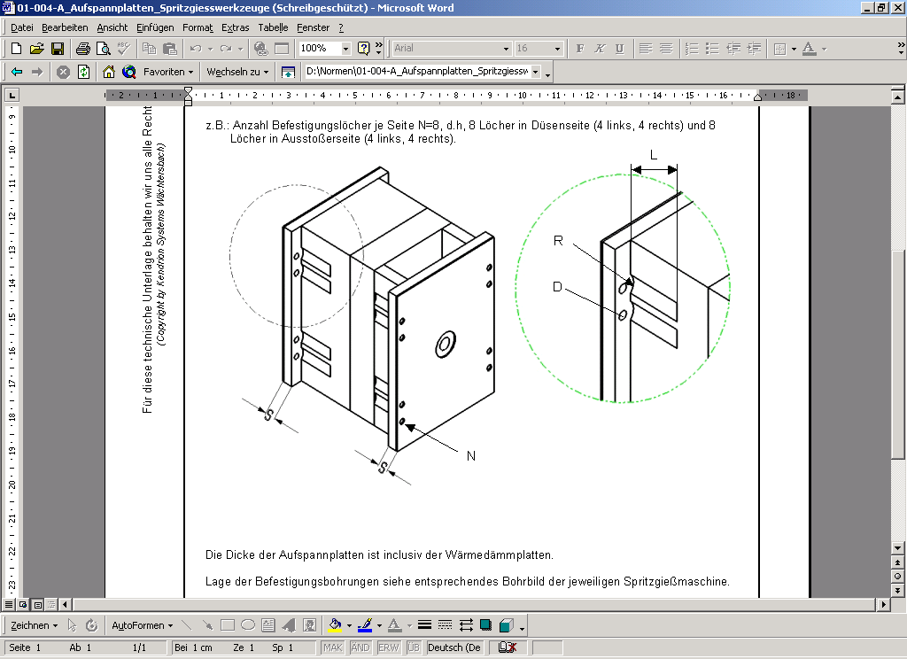

The clamping plates are to be provided with screw holes.

|  |  |  |
| --- | --- | --- |
| **L** | **R** | **D** |
| XY | XY | XY |

**In case of insufficient spacing to the tie bars:**

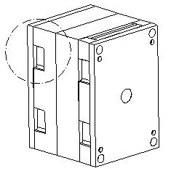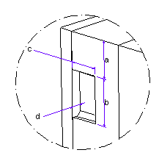

The dimensions of the recess depend on the mould and machine. The recess may also pass through.

|  |  |  |  |
| --- | --- | --- | --- |
| **a** | **b** | **c** | **d** |
| XY | XY | XY | XY |

ompany XY provides clamping plans for the injection moulding machine.

### Insulation boards

Insulation boards are to be made 2-3 mm (Meusburger standard) smaller than the clamping plate.

Insulation boards are generally to be attached on the moving half, as well as on the fixed half.

The insulation board is to be secured with a maximum of 8 hexagon socket countersunk head screws.

As a standard, drilled insulation boards are preferably used.

|  |  |
| --- | --- |
| **Required compressive strength** | **with mounting holes** |
| XY | Yes/No |

Compressive strength at 23°C min. 330 N/mm2 (e.g. Meusburger [E 140..](https://ecom.meusburger.com/e_menu/index.asp?set_gruppe=5))

Compressive strength at 23°C min. 600 N/mm2 (e.g. Meusburger [E 142..](https://ecom.meusburger.com/e_menu/index.asp?set_gruppe=5))

When processing thermoplastics and elastomers, lattice pattern insulation boards are to be used ([E 1450](https://ecom.meusburger.com/e/index.asp?id=1158&eg=5)).



[**Overview of the insulation boards to download and print**](https://ecom.meusburger.com/files/pdf/e/waermeschutz_tech.pdf)

## Required mould opening strokes



E = Required opening stroke* F = Part height G = Handling arm H = Handling

|  |  |  |  |
| --- | --- | --- | --- |
| **E** | **F** | **G** | **H** |
| XY | XY | XY | XY |

* The required opening stroke must be determined by the production team on-site.

## Mould centring

The mould must be provided with a locating ring on the fixed half, as well as the moving half.

The locating ring diameters are defined in the mould specification.

A chamber is to be applied to the locating ring (depends on the planned machine / see machine data sheet). If necessary, adapter rings are to be made for a different machine selection.

The locating rings are to be provided with 2 holes and 2 screws so they can be screwed to the mould.

Preferably, standardised locating rings with fixing holes from Meusburger should be used ([E 13….](https://ecom.meusburger.com/e_menu/index.asp?set_gruppe=4)).

## Mould transport and securing

### Mould support rails

Mould support rails are only to be attached in case of protruding clamping plates, extending slides, protruding fittings, etc. It may be necessary to incorporate a centred recess for water hoses. It is important that both mould halves can be placed separately and stably on an even surface. Spacers or support bolts are to be used for this purpose.

|  |  |  |
| --- | --- | --- |
|  |  | [E 1927](https://ecom.meusburger.com/e/index.asp?id=189) |
|  |  | [E 1928](https://ecom.meusburger.com/e/index.asp?id=190) |

### Transport lock

Appropriate standard parts are to be used for safe transport.

|  |  |  |
| --- | --- | --- |
|  |  | [E 1930](https://ecom.meusburger.com/e/index.asp?id=191&rnd=43162) |
|  |  | [E 1936](https://ecom.meusburger.com/e/index.asp?id=192) |

Appropriate threaded holes must be provided to reposition the mould or mould half.

### Lifting points

Connection threads for eye bolts are to be incorporated according to the design calculation, but no smaller than M12, in each cavity plate on all sides.

A transport safety bar is to be attached to the mould with a safety eye bolt (such as [E 1274 M](https://ecom.meusburger.com/e/index.asp?id=2147)) in the installation position, on the cavity plates via the split line.

The transport lock may not protrude beyond the clamping surfaces (installation height calculation without insulation board).

All connection threads must be in accordance with the DIN standard (fine threads are not permitted).

|  |  |
| --- | --- |
| **Lifting point** | **Thread size** |
| XY | XY |



[**Overview of the lifting points to download and print**](https://ecom.meusburger.com/files/pdf/e/anschlagpunkte_uebersicht.pdf)

## Mould labelling

### Label

company XY will provide a label that is to be attached on the operator side by the mould supplier.

The label contains the following information:

Mould number / part designation / drawing number / year of manufacture / owner / customer mould number / mould manufacturer number. In addition, a label showing the cooling circuits should be attached.

|  |  |
| --- | --- |
| **Material** | **Width x length** |
| Aluminium / PA 6.6 | XY |

|  |  |  |
| --- | --- | --- |
|  |  | [E 191..](https://ecom.meusburger.com/e/index.asp?id=187) |

### Status indicator plate

A status indicator plate is to be attached to the operator side of the mould to clearly identify the mould status.

|  |  |  |
| --- | --- | --- |
|  |  | [E 1917](https://ecom.meusburger.com/e/index.asp?id=1845) |
|  |  | [E 19180](https://ecom.meusburger.com/e/index.asp?id=2521) |