Meusburger Georg GmbH & Co KG
Kesselstr. 42, 6960 Wolfurt, Austria

NEW from Meusburger: flat-face centring unit with round fitting

Since October Meusburger offers a flat-face centring unit with round fitting. This innovative product in the range of Meusburger locks offers an additional option for a reliable and exact final centring of the mould at the split line face. Due to its geometry the new centring unit is optimal for moulds with unequal thermal expansion.

The easy introduction and positioning of the new E 1352 centring unit enables highest centring accuracy. Best sliding properties and high wear resistance are achieved through the DLC coating. It can be fixed from the split line face or the back side, therefore a flexible installation is possible. The centring unit is kept in the right position by means of the dowel pins provided either at the side or on the front end. Due to the identical fitting dimensions the flat-faced centring unit with round fitting is interchangeable with the Meusburger E 1310 centring unit. This offers the advantage that the centring unit can be replaced simply and easily in the event of unequal thermal expansion within the mould. The new component is available in the diameters of 16 to 42 mm and as always with Meusburger, can be supplied from stock.

Picture credits: Photo (Meusburger)
Caption: NEW from Meusburger: flat-face centring unit with round fitting

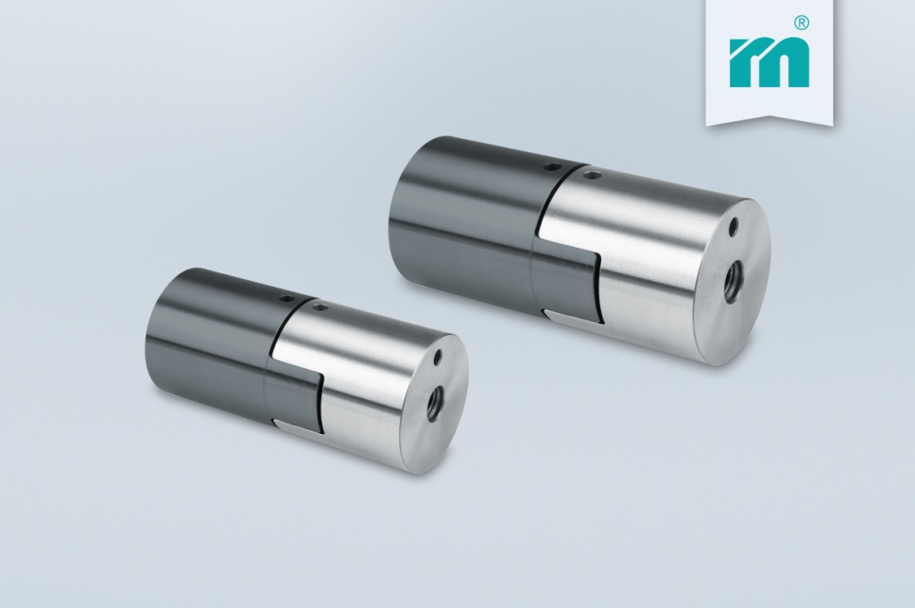

Meusburger – Setting Standards
Meusburger is the leading manufacturer of high-precision standard parts. More than 17,000 customers all over the world make use of the numerous advantages of standardisation and benefit from the company's over 50 years of experience in working with steel. Offering an extensive range of standard parts, combined with high-grade products in the field of workshop equipment, Meusburger is the reliable global partner for making dies, moulds, jigs and fixtures.

Further information:
Meusburger Georg GmbH & Co KG
Communication / Public relations
Phone: 0043 (0) 5574 6706-0
Email address: press@meusburger.com
www.meusburger.com

