Meusburger Georg GmbH & Co KG
Kesselstr. 42, 6960 Wolfurt, Austria

New cutting tools at Meusburger: indexable insert tools

The vast range of indexable inserts and tool carriers on the market make it difficult for users to make the right choice. Meusburger has created a range of indexable insert tools which are perfectly coordinated to the needs of die and mould makers. The simple ordering process saves time and money.

Indexable insert shoulder milling cutters 90°, high-feed and round insert milling cutters
A soft cut and low vibration is reached with the indexable shoulder milling cutters 90°. The extremely positive position of the indexable insert provides for a reduced cutting force, an improved chip flow and a high surface quality. The indexable high-feed milling cutters are suitable for the highest feed rates and maximum metal removal rates. Excellent chip removal is reached by optimised chip spaces. The indexable round insert cutters offer maximum stability at high feed rates. All of these milling cutters are available as shell-type, with steel shank or with screw-in thread.

Indexable 3D full-radius and torus milling cutters
Meusburger offers indexable 3D full-radius and torus milling cutters which are especially suitable for complex geometries. These fulfil high requirement such as: maximum stiffness and vibration dampening as well as high concentricity, balance quality, and high-precision insert seat. Depending on the tool holder costumers can choose between three versions: with carbide shank, steel shank, or screw-in thread.

Indexable insert solid drills
The indexable insert solid drills from Meusburger are characterised by high feed rates and high process reliability. They have 4 cutting edges per indexable insert which enable a good drilling behaviour. Two different lengths with 3xd and 5xd are offered.

Easy ordering
In the first step, the tool system is selected depending on the applications. Then the tool carrier with the diameter appropriate to the tool holder is chosen. The size of the inserts can now be easily determined as a function of the tool carrier in the table. With the help of the overview table, the optimal indexable insert is easily selected based on the machining type and the material to be machined.

As always with Meusburger, the recommended reference values for cutting speed, feed and offset for different materials and indexable inserts are given for all cutting tools. The high-quality indexable insert tools are as usual immediately available from stock.

Picture credits: Photo (Meusburger)
Caption: New cutting tools at Meusburger: indexable insert tools

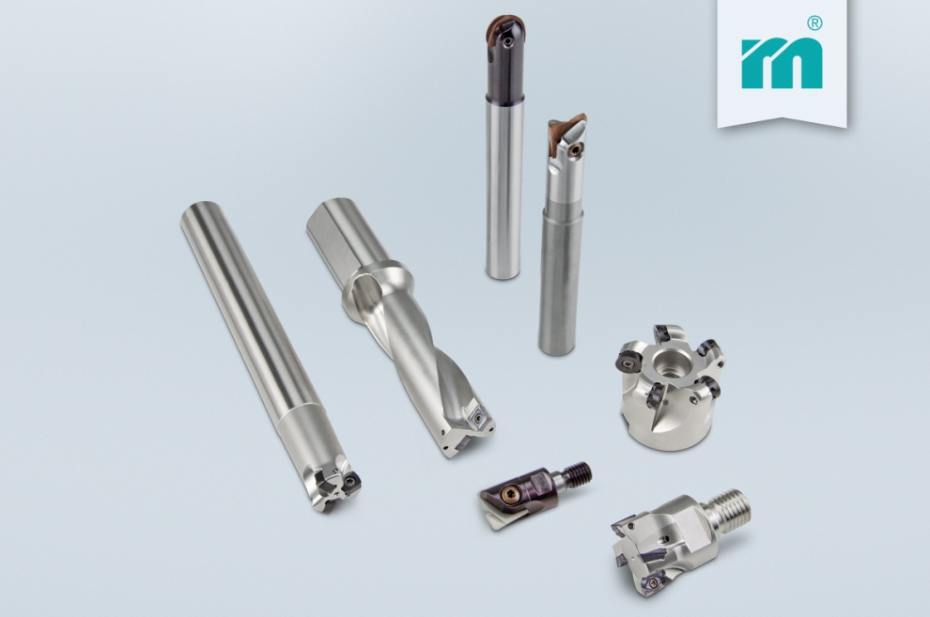

Meusburger – Setting Standards
Meusburger is the leading manufacturer of high-precision standard parts. More than 17,000 customers all over the world make use of the numerous advantages of standardisation and benefit from the company's over 50 years of experience in working with steel. Offering an extensive range of standard parts, combined with high-grade products in the field of workshop equipment, Meusburger is the reliable global partner for making dies, moulds, jigs and fixtures.

Further information:
Meusburger Georg GmbH & Co KG
Communication / Public relations
Phone: 0043 (0) 5574 6706-0
Email: presse@meusburger.com
www.meusburger.com/press-releases

