PRESS RELEASE
Wolfurt, 11 January 2022

Innovations in workshop equipment from Meusburger

Meusburger once again expanded its workshop equipment product range with innovations in almost all product groups in autumn 2021. In particular, the assembly equipment, consumables and EDM accessories product ranges were expanded.

Assembly made easy
With the new E 21990 hose assembly device straight, 45° and 90° couplers and nozzles can be mounted into the coolant hoses (E 2180 and E 2185) much easier. The compact design also allows mobile use by clamping in a vice or via the fixing holes. Depending on which area the device is to be used, there are three different set variants to choose from.
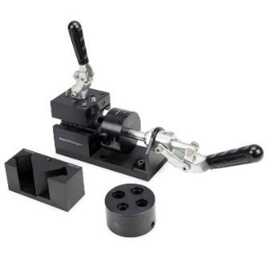
Image source: Meusburger publication free of charge
Caption: Set: Hose assembly device

Biodegradable foam cleaner for cavities
With the new VCF 18 foam cleaner for cavities, Meusburger presents a biodegradable alternative to the high-end VCC 30 cleaner. For the most part, this cleaner does not contain conventional solvents and therefore does not produce any aerosol mist containing solvents. It easily removes residues from release agents, anticorrosives and lubricants. It can also be used to efficiently remove light plastic deposits and burnt-on residues from injection moulds.

New in EDM accessories
Workpieces for wire EDM can be precisely clamped and adjusted in three axes with the new HER 6115 rotatable pendulum vice with jaw. A clamping range between 0 and 100 mm and an angle adjustment of 360° are possible. A further innovation is the HER 6120 V-block holder ITS-50. The V-block holder enables the clamping of round and square workpieces such as ejector pins or cutting punches.

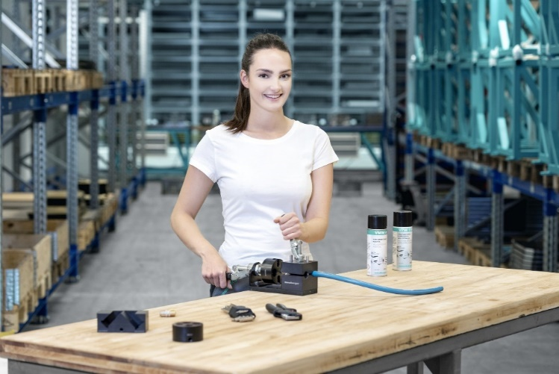
Image source: Meusburger publication free of charge
Caption: Innovations in workshop equipment at Meusburger

Meusburger – Setting Standards.

Meusburger is the market leader in the field of high-precision standard parts. Customers all over the world make use of the advantages of standardisation and benefit from the company’s over 55 years of experience in working with steel. The product portfolio ranges from high-precision standard parts and selected products in the field of workshop equipment to hot runner and control systems, the WBI Knowledge Management Method and solutions for efficient corporate management in the ERP/PPS software area. This makes Meusburger the reliable global partner for making moulds, dies, jigs and fixtures.

Press contact

Meusburger Georg GmbH & Co KG
Communication / Public relations
Phone: +43 5574 6706-0
Email: press@meusburger.com
www.meusburger.com

