Press Release
Wolfurt, on 16.07.2019

Meusburger presents innovations in the field of workshop equipment

In the middle of June, Meusburger expanded its workshop equipment product range with numerous innovations and additions in the machining, EDM accessories and clamping equipment product groups. Meusburger also has new products for measuring, lifting, and surface finishing.

High-performance reamer up to 65 HRC
The new high-performance reamer from carbide (VHM) with TiAlN multi-layer coating ensures maximum performance and process reliability during machining. Thanks to the best cutting data, the machining times are significantly reduced which leads to a reduction in processing costs. The high-performance reamers are suitable for soft and hardened steels up to 65 HRC. The cooling channels on the shank ensure perfect cooling during machining, especially for through holes. The new reamers are available for through holes H7 (WZR 102520) as well as finished size (WZR 102522) with the hundredth graduations X.98 to X.02 in diameter range 3 to 12 mm.

WZF 126688 High-performance milling cutter with chip breaker and reinforced core
The high-performance milling cutter for HPC machining with non-uniform pitch and centre cut is characterised especially by the so-called ‘chip breaker’. The interruption at the cutting edge ensures that short chips are produced and thus better chip removal is guaranteed. The result is a significant increase in process reliability due to the lower risk of chips getting jammed. In addition, the milling cutters with a diameter from 6 mm have a reinforced core. This creates optimised chip space. The milling cutter has a larger chip space in the front cutting area which gets smaller and smaller towards the shank. This leads to both better chip removal and more stability in the core of the milling cutter. The new milling cutter is suitable for all steels, including stainless steels. Meusburger offers the WZF 126688 in a diameter range from 3 to 16 mm in the cutting lengths 4dx, available from stock.

HWS 510 Precision vice
Our new precision vice, which is precision-ground to exact angles on all sides and has knife-edge accuracy, is ideal for horizontal, vertical and lateral milling, grinding, inspection and EDM work. The angle accuracy and parallelism is 0.003/100 mm. Thanks to the pull-down effect, lifting of the workpiece is prevented – so no knocking down is necessary. The operation is carried out by means of an Allen key and the quick adjustment via stub shaft. The HWS 510 Precision vice is available in jaw widths 60, 75, 100 and 125 mm.

Quick-action clamping chuck with threaded coupling for system ITS
With the new quick-action clamping chucks HER 3012 for ITS-50 and HER 3032 for ITS-50/ITS-100, electrode holders can be clamped quickly and reliably using the threaded coupling. They are ideally suited for electrode machining.

Additions to electrodes
With around 100 new sizes, Meusburger has expanded its range of electrodes with system and multi-hole patterns made of copper and graphite. In addition, the graphite cut to customised dimensions are now also available in the grades Q70 (V 92221), Q60 (V 92224) and Q40 (V 92227) and in the thicknesses 90, 100, 120 and 150 mm.

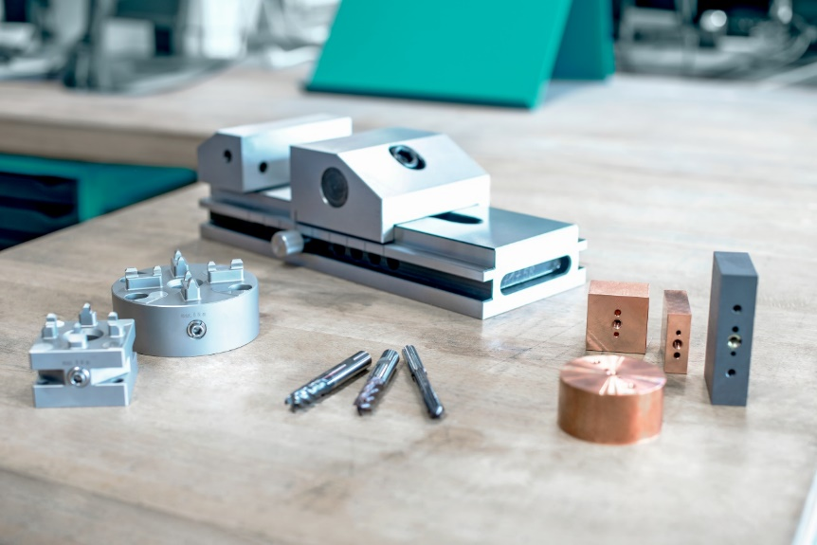

Image source: Meusburger publication free of charge
Caption: Meusburger innovations in workshop equipment

Meusburger – Setting Standards.

As a part of the Meusburger Group, the Meusburger company is the market leader in the field of high-precision standard parts. 21,000 customers all over the world make use of the advantages of standardisation and benefit from the company's over 50 years of experience in working with steel. Offering an extensive range of standard parts, combined with selected products in the field of workshop equipment, Meusburger is the reliable global partner for making moulds, dies, jigs and fixtures.

Press contact

Meusburger Georg GmbH & Co KG
Communication / Public relations
Phone: +43 5574 6706-0
Email: press@meusburger.com
www.meusburger.com

