PRESS RELEASE
Wolfurt, on 24.07.2020

TT slide unit now available in two new sizes

In addition to the existing sizes with slide surfaces of 12 x 10 mm and 15 x 12 mm, the tried and trusted E 3310 TT slide unit from Meusburger has been expanded with two new sizes with slide surfaces of 8 x 6 mm and 18 x 14 mm. The ready-to-use slide unit reduces overall costs during design and mould manufacturing. In addition, daily work is facilitated through the compatibility of the components and the direct download of CAD data including installation spaces. Small slide units are in particular demand for complex moulds.

With its compact design, the new TT slide unit offers minimum installation spaces. The term ‘TT’ comes from the T-guides in the slide and cotter. This type of guide guarantees optimal force transmission at high injection pressures. The DLC coated slide – out of steel grade 1.2343 with 52 HRC – not only offers a high wear resistance but also best sliding properties. Due to the ESR grade the slides are excellent for mirror polishing. The supplied buffer stops the small slide safely and precisely, even with the highest dynamics. This function can also be implemented directly in the insert or in the cavity plate to save space, which makes previously unrealisable projects such as slides in change moulds possible. In addition, the slide and guide can be installed and removed together.
The CAD data is immediately available for download and additional installation spaces can be generated: www.meusburger.com/tt-slide-unit.

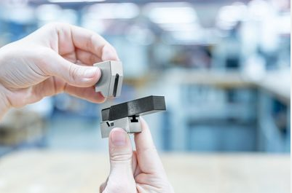
Image source: Meusburger
Caption: E 3310 TT slide unit from Meusburger now available in two new sizes

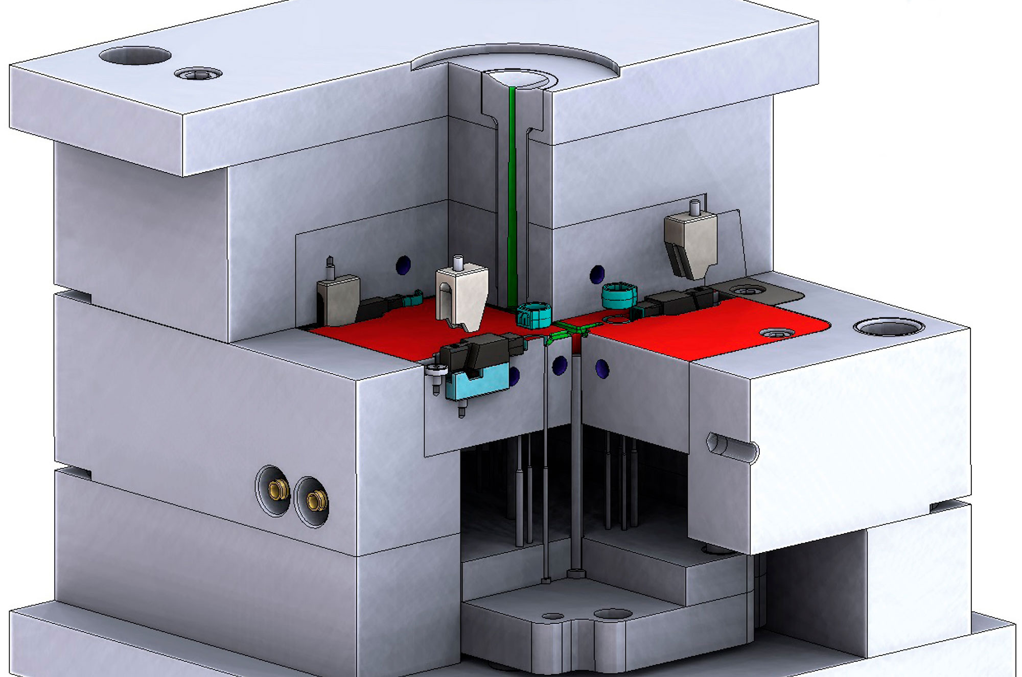
Image source: Meusburger
Caption: Installation example of the new TT slide unit in the FW change mould

Meusburger – Setting Standards.

Meusburger is the market leader in the field of high-precision standard parts. Customers all over the world make use of the advantages of standardisation and benefit from the company’s over 55 years of experience in working with steel. The product portfolio ranges from high-precision standard parts and selected products in the field of workshop equipment to hot runner and control systems, the WBI Knowledge Management Method and solutions for efficient corporate management in the ERP/PPS software area. This makes Meusburger the reliable global partner for making moulds, dies, jigs and fixtures.

Press contact

Meusburger Georg GmbH & Co KG
Communication / Public relations
Phone: +43 5574 6706-0
Email: press@meusburger.com
www.meusburger.com

