Meusburger Georg GmbH & Co KG
Kesselstr. 42, 6960 Wolfurt, Austria

New cutting punches and contour bases at Meusburger

Meusburger has expanded their range adding three new cutting punches. Furthermore, Meusburger now offers additional contours, for maximum flexibility in the configuration of cutting punches.

E 55405 Cutting punch with tight-tolerance cylindrical head
The new E 55405 Cutting punch features a cylindrical head with tolerance +0/-0.02 mm. Because of this tight tolerance, the cutting punch is ready-to-use and adjustment time is reduced to a minimum. This means savings in time and cost during the installation.

E 5531 Cutting punch with bottle-neck, with ejector
The ejector guarantees reliable removal of the stamping waste and therefore ensures the highest process reliability in the stamping process. Thanks to its bottle-neck geometry, the new cutting punch is suitable for high stamping and retracting forces.

E 55402 Cutting punch with cylindrical head from 1.3344 PM (PM 23)
The powder metallurgical steel 1.3344 PM (PM 23) features highest adhesive and abrasive wear resistance through its homogeneous carbide structure. In addition, it is characterised by excellent compressive strength and toughness.

New contours for the existing cutting punches range
In addition to the offset contours round, oblong hole, and rectangle, Meusburger now also offers a freely configurable hexagon contour as well as a round contour with flattening on both sides. These can be selected quickly and easily using the cutting punches configurator in the digital catalogues. The configurable cutting punches are available within 3 working days.

Picture credits: Photo (Meusburger)
Caption: Increased process reliability in the stamping process with precision control devices
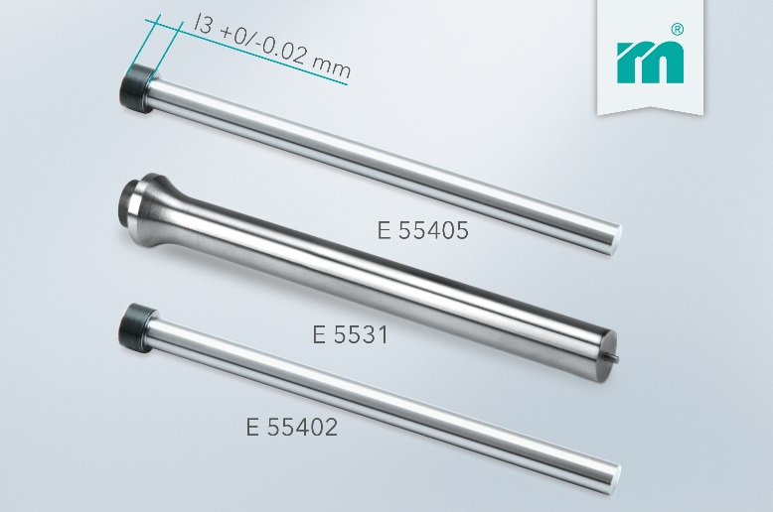

Meusburger Group – Setting Standards

The Meusburger Group is the leading international manufacturer of high-quality standard parts, hot runner and control systems and selected items in workshop equipment. More than 18,500 customers all over the world make use of the numerous advantages of standardisation and benefit from the company's over 50 years of experience in working with steel. The permanent availability of products makes the Meusburger Group the reliable and global partner for die, mould, and jigs and fixtures construction.

Further information:
Meusburger Georg GmbH & Co KG
Communication / Public relations
Lia Klimmer
Phone: + 43 5574 6706-1446
Email: press@meusburger.compresse@meusburger.com
http://www.meusburger.com/en/press/press.html

