Meusburger Georg GmbH & Co KG
Kesselstr. 42, 6960 Wolfurt, Austria

New catalogue for machine and jig construction

The hot off the presses Meusburger catalogue ‘Machine and Jig Construction 2019/2020’ is now available with numerous innovations. Customers will find the expanded product range on over 400 pages with 37,000 items clearly presented. The standardised and quickly available plates and bars are available in 29 different materials. And there is also a completely new product group: the components, which are specially tailored to the requirements of jig construction.

Competitive advantages through standardisation
The trend towards standardisation is gaining ground in machine and jig construction as increasingly shorter project lead times and efficiency improvements are required to survive on the market. Particularly when it comes to jigs and fixtures, where each machine is different, standardisation can bring a decisive competitive advantage. Complex systems can be assembled in a cost-effective way from standard parts. This eliminates costly machining times and shortens lead times. In addition, the workforce is freed up, allowing manufacturers to concentrate on their core competences.

Standard range in the new catalogue
The Meusburger product range for machine and jig construction offers quickly available standard plates with standardised dimensions as well as bars in various versions and a variety of dimensions available from stock. The new product group of components includes jigs, clamping elements and fasteners as well as operating elements which are especially designed for use in jig construction.

Individual solutions by customer request
In addition to the standard plates range, Meusburger offers special plates in eight different versions – from sawn cuts to high-precision plates with precision grinding in the usual high quality. All plates are heat-treated for stress relief and available upon request with eye bolt threads and deep hole drilling. Whether flame cutting, sawing, deep hole drilling, milling, grinding or turning - Meusburger offers a complete service as well as prompt quotations and short lead times!

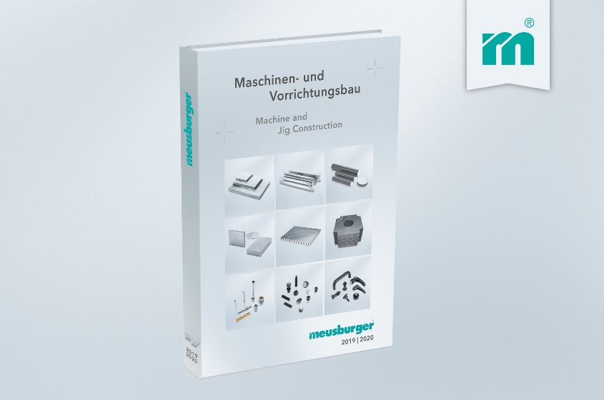

Picture credits: Photo (Meusburger)
Caption: The new Meusburger catalogue for machine and jig construction

Meusburger – Setting Standards

As a part of the Meusburger Group, the Meusburger company is the market leader in the field of high-precision standard parts. Customers all over the world make use of the advantages of standardisation and benefit from the company's over 50 years of experience in working with steel. Offering an extensive range of standard parts, combined with selected products in the field of workshop equipment, Meusburger is the reliable global partner for making dies, moulds, jigs and fixtures.

Further information:
Meusburger Georg GmbH & Co KG
Communication / Public relations
Lia Klimmer
Phone: + 43 5574 6706-1446
Email: press@meusburger.compresse@meusburger.com
http://www.meusburger.com/en/press/press.html

