Meusburger Georg GmbH & Co KG
Kesselstr. 42, 6960 Wolfurt, Austria

NEW from Meusburger – Compact slide units for smallest installation spaces

With the new compact slide units Meusburger offers a slim slide option especially for small installation spaces. In addition to their size the ready-to-use versions also convince by their quality. High wear resistance and best sliding properties are possible through the DLC coated slides. Furthermore highest precision in the design and the production of the new slide units guarantee maximum process reliability in the injection moulding process.

Slide units with small fitting dimensions are especially required in complex moulds. Particularly for this purpose Meusburger offers the new, high-precision and ready-to-use compact slide units in extremely slim designs. The large angle radii of the rectangular compact slide units enable a secure and simple installation. Providing a laborious anti-rotation blocking is therefore not necessary. The DLC coated slides – out of steel grade 1.2343 with 54 HRC – not only offer a high wear resistance but also best sliding properties. Due to the ESR grade the slides are excellent for mirror polishing. An additional adjustment of the slide preload is easily possible by means of a provided shim. There are two versions of compact slide units with 3 variations each to select from: the E 3360 version can be installed easily and quickly from the split line face or from the back side. For use in very tight spaces Meusburger offers the E 3330 Compact slide unit. For some variations an installation rotated at 180° is also possible. Thus additional space is created for the hot runner nozzles or the cooling holes. As usual with Meusburger, the new compact slide units are available from stock.

Picture credits: Photo (Meusburger)
Caption: NEW from Meusburger – Compact slide units for smallest installation spaces

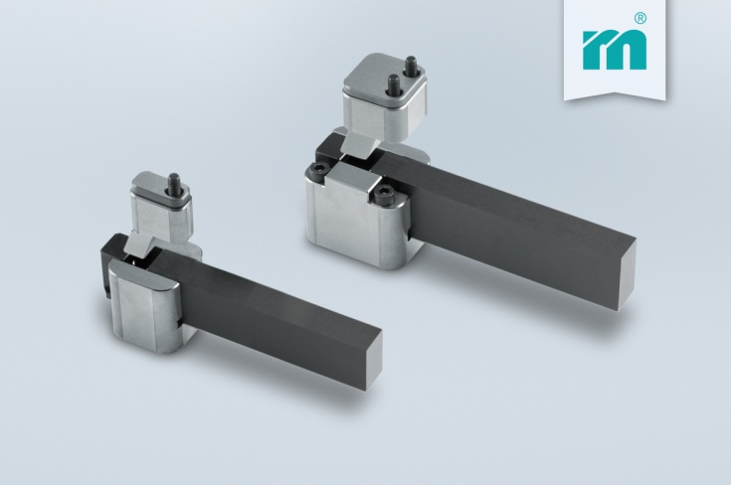

Meusburger – Setting Standards
Meusburger is the leading manufacturer of high-precision standard parts. More than 17,000 customers all over the world make use of the numerous advantages of standardisation and benefit from the company's over 50 years of experience in working with steel. Offering an extensive range of standard parts, combined with high-grade products in the field of workshop equipment, Meusburger is the reliable global partner for making dies, moulds, jigs and fixtures.

Further information:
Meusburger Georg GmbH & Co KG
Communication / Public relations
Phone: 0043 (0) 5574 6706-0
Email address: presse@meusburger.com
www.meusburger.com/press-releases

