Meusburger Georg GmbH & Co KG
Kesselstr. 42, 6960 Wolfurt, Austria

NEW from Meusburger: E 7048 Build-in cylinder with flange

Ideal for the smallest installation spaces, Meusburger now exclusively offers the compact build-in cylinder with flange. Thanks to an uncomplicated incorporation and the supplied screws, it can be installed in no time at all. In addition, the two-step installation hole protects the sealing during installation.

The compact and intelligent design of the new build-in cylinder with flange from Meusburger enables its installation in the smallest spaces and thus maximum mould design freedom. Surface or flush installation can be selected. A two-step hole provided in the plate facilitates the installation and helps prevent damage to the O-ring seal from the transverse hole. Double sealed piston rods with additional rod wipers ensure a clean operation whereby the standard FKM (Viton®) seals enable an operation temperature of up to 180°C. The hardened and ground piston rod offers optimal protection and therefore a long service life. The cylinder can be removed quickly and easily by means of a pull-off thread. The new E 7048 Build-in cylinder with flange is available in 4 different sizes with 3 different strokes each. The CAD data is available for download with just a few clicks in the Meusburger digital catalogues. >>meusburger.com/build-in-cylinder-E7048

Picture credits: Photo (Meusburger)
Caption: NEW from Meusburger: E 7048 Build-in cylinder with flange

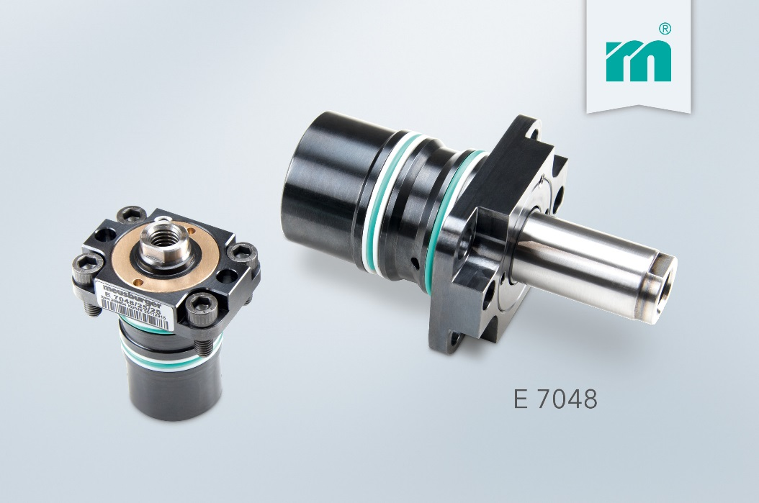

Meusburger Group – Setting Standards

As a part of the Meusburger Group, the Meusburger company is the market leader in the field of high-precision standard parts. Customers all over the world make use of the advantages of standardisation and benefit from the company's over 50 years of experience in working with steel. Offering an extensive range of standard parts, combined with selected products in the field of workshop equipment, Meusburger is the reliable global partner for making dies, moulds, jigs and fixtures.

Further information:
Meusburger Georg GmbH & Co KG
Communication / Public relations
Lia Klimmer
Phone: + 43 5574 6706-1446
Email: press@meusburger.com
http://www.meusburger.com/en/press/press.html

