Press Release
Wolfurt, on 24.09.2019

Meusburger presents their brand new stamping and forming die set at the Blechexpo 2019

At this year’s Blechexpo in Stuttgart (5-8 November), the Meusburger stand (hall 6, stand 6107) will feature the brand new standardised stamping and forming die set from Meusburger and Bihler. The companies WBI and Segoni will also offer a glimpse into their product range.

A special highlight at this year’s Blechexpo will be the standardised stamping and forming die set, which is the first of its kind and was developed in cooperation with Bihler for the Bihler NC presses. The new die sets in types ‘tunnel cut’ or ‘spring-loaded guiding plate’ are available for stamping presses with forces up to 400 kN and promise to bring enormous savings in time and cost for Meusburger and Bihler customers in future.

From small batches to large quantities
The newly developed SB stamping and forming die sets are offered for Bihler NC presses with stamping forces of 200kN, 300kN and 400kN. The die sets are available in lengths up to 596 mm and in the types ‘SBH tunnel cut’ or ‘SBP spring-loaded guiding plate’. While the tunnel cut version is primarily used for prototypes and small batches, the version with spring-loaded guiding plate is ideally suited for producing high precision parts and large quantities.

Benefits for customers
The standardisation of stamping and forming die sets has great advantages: they are significantly more cost-effective, and they are available from stock. The die sets themselves also offer many product advantages – such as: precision alignment edges and practical anti-rotation protection, as well as helpful mounting threads in the plates for pull handles, eye bolts and spacer discs, and useful vent holes.

Everything from a single source
In addition to Meusburger, the associated companies WBI and Segoni will also be presenting their range of products for mould and die makers to the trade fair visitors. WBI Knowledge Management will introduce their software specially developed for the knowledge management method. With this software, the resource of knowledge can be collected, shared, further developed and saved thus preventing the loss of important know-how.
Segoni in turn will offer a live presentation of the latest version of their software which enables efficient production planning and focuses on companies with individual production structures active in the fields of mould, die, and jigs and fixtures construction. They will also provide information for visitors on the use and capabilities of the system.

Further information: www.meusburger.com

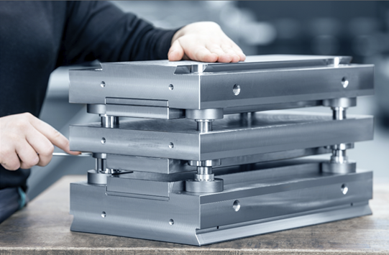

Image source: Meusburger, publication free of charge publication free of charge
Caption: The SBP stamping and forming die set with spring-loaded guiding plate from Meusburger

Meusburger – Setting Standards.

As a part of the Meusburger Group, the Meusburger company is the market leader in the field of high-precision standard parts. 21,000 customers all over the world make use of the advantages of standardisation and benefit from the company's over 50 years of experience in working with steel. Offering an extensive range of standard parts, combined with selected products in the field of workshop equipment, Meusburger is the reliable global partner for making moulds, dies, jigs and fixtures.

Press contact

Meusburger Georg GmbH & Co KG
Communication / Public relations
Phone: +43 5574 6706-0
Email: press@meusburger.com
www.meusburger.com

