Successful standardisation begins in the design phase

The world is becoming smaller – both logistically and economically. Globalisation increases the competitive pressure on die and mould makers, but also offers the chance to profit from orders in fast-growing markets. At the same time the innovation wheel is turning ever faster, which requires adaptability and flexibility from companies. The high cost and time pressure forces companies to constantly improve their efficiency. A high degree of standardisation along the entire process chain offers an excellent opportunity to drastically reduce costs and project lead times.
In the product life cycle of a die, it is important to take a holistic view of the costs. At the beginning of a project, possible savings should already be considered. The use of standard parts has a positive effect on the overall cost. Helpful questions are for example: are there die components which can be standardised? If so, what possibilities are there to fall back on for internally standardised parts or die set concepts? Could these be bought from an external standard parts manufacturer? There is a lot of savings potential here to gain clear competitive advantages.
The design phase is decisive
The costs of a die can be greatly influenced during the development phase, whereas towards the end of the process, in the series productions stage, it is almost impossible to reduce costs. The designer determines the machining sequence in the die. He or she decides how the individual machining stations or the feed are designed. In this phase, the production parameters with which the die will later work in the stamping workshop are set. In addition, the designer decides whether the die set is to be constructed from standard plates in stock or from order-specific special plates. The more standard parts used, the higher the percentage of fixed calculable costs.
Reach your goal quickly with digital wizards
The use of standard parts results in savings in all areas. This starts with the fast and reliable pre-calculation by means of the Meusburger die set wizards. With these tools, all necessary components for a project can be assembled quickly and easily and saved for later use. CAD data of complete die sets can be exported from the Meusburger web shop or offline shop to all common CAD systems with just a few clicks. This gives the designer more time to concentrate on the actual ‘critical points’ of a die.
Over 40,000 items to guarantee success
In the area of die making, Meusburger offers over 40,000 items, which are specially tailored to customer requirements. The low deformation material itself has a big influence on the manufacturing and maintenance costs of the die: thanks to the high-grade steel, which is heat-treated for stress relief, as well as exact form and position tolerances, subsequent costs can be reduced. Also the built-in components - such as active parts - perform important functions in the die. Buying these from external suppliers, rather than producing them in-house, offers significant additional savings and therefore long-term competitive advantages. The best time for putting this into practice is quite simply - now! Times of economic boom are exactly the right time to prepare for the future.

TIPS & TRICKS FOR STANDARDISATION
- Create quality standards through low deformation plates
- Develop design guidelines
- Reduce the variety of components used
- Use standardised components and lower manufacturing costs
- Create machining guidelines, such as predefined tolerances or dimensions
- Create standardised processes

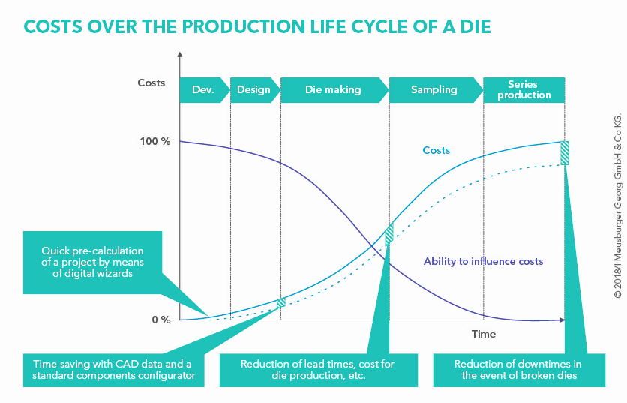
Picture credits: Graphics department (Meusburger)
Caption: How the use of standard parts influences product costs

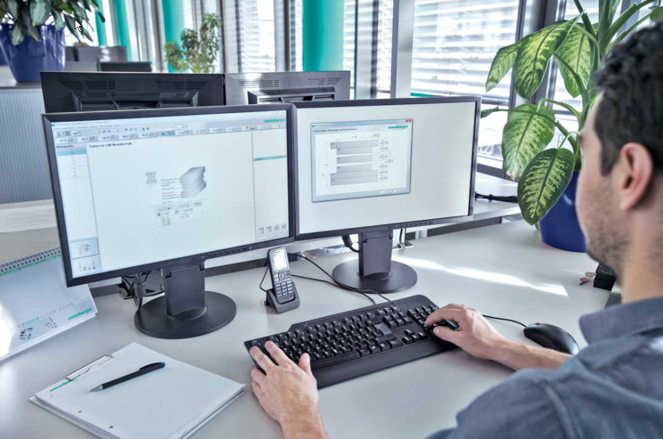
Picture credits: Photo (Meusburger)
Caption: CAD data of complete die sets can be exported from the Meusburger web shop or offline shop to all common CAD systems with just a few clicks.

Meusburger – Setting Standards

As a part of the Meusburger Group, the Meusburger company is the market leader in the field of high-precision standard parts. Customers all over the world make use of the advantages of standardisation and benefit from the company's over 50 years of experience in working with steel. Offering an extensive range of standard parts, combined with selected products in the field of workshop equipment, Meusburger is the reliable global partner for making moulds, dies, jigs and fixtures.

Further information:
Meusburger Georg GmbH & Co KG
Communication / Public relations
Phone: + 43 5574 6706-0
Email: press@meusburger.compresse@meusburger.com
http://www.meusburger.com/en/press/press.html

