Meusburger Georg GmbH & Co KG
Kesselstr. 42, 6960 Wolfurt, Austria

H 3000 - The innovative clamping system for die making

The tried, trusted and advanced clamping system from Meusburger is now also available for die making. With the H 3000 you will not only work quickly and effectively but also with absolute precision and repeatable accuracy. The die set plates are aligned and clamped where it is important for the die set function, i.e. in the guide holes.

Competitive advantages due to the zero clamping systems
Zero clamping systems help reduce set-up times since they enable quick and precise positioning, fixing and clamping of workpieces in one work step. This is especially important if there is a high number of variants or a large number of die set plates.
Based on the tried and trusted H 1000 Clamping system for mould making a new, innovative clamping system for die making was developed – the H 3000. This results in short set-up times during the machining of die set plates. Due to a dimensionally perfect stamping die, the stamped parts comply with the highest quality guidelines.
Once aligned and fixed to the machine, the die set plates can be clamped quickly and effectively on the H 3000 with absolute precision and with repeatable accuracy.
The clamping without interfering contours by means of expansion rings in the guiding holes simplifies the programming and minimises the risk of collision.

H 3000 clamping options
In addition to die set plates for the SV-Standard die set and the SH and SD Two-pillar die sets, the NP-Precision bars, which serve as functional plates in the stamping die, can also be clamped on the H 3000. Pallets for vices or electrode holders can be attached as well.

H 3000 Wizard – for simplified configuration
With the H 3000 Wizard in the web shop and CD catalogue, an individual H 3000 Clamping system can be quickly and easily configured. First you can choose from two different plate sizes which can then be equipped with the respective clamping devices. The fully automatic calculation of the clamping accessories ensures that the clamping system exactly meets your requirements.

Picture credits: Photo (Meusburger)
Caption: H 3000 - The innovative clamping system for die making

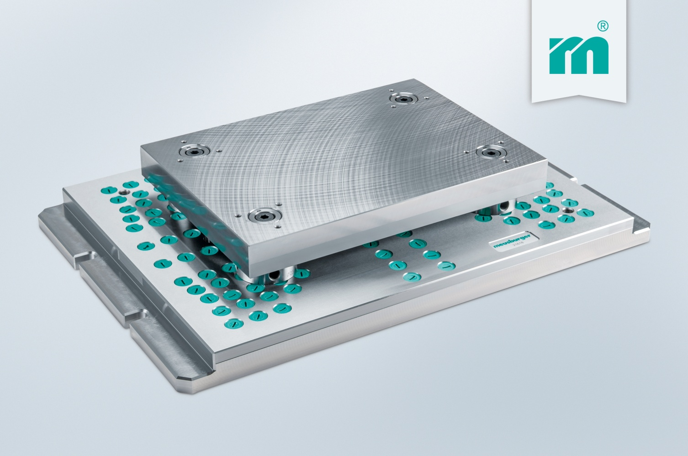
Meusburger Group – Setting Standards

The Meusburger Group is the leading international manufacturer of high-quality standard parts, hot runner and control systems and selected items in workshop equipment. More than 17,500 customers all over the world make use of the numerous advantages of standardisation and benefit from the company's over 50 years of experience in working with steel. The permanent availability of products makes the Meusburger Group the reliable and global partner for die, mould, and jigs and fixtures construction.

Further information:
Meusburger Georg GmbH & Co KG
Communication / Public relations
Lia Klimmer
Phone: + 43 5574 6706-1446
Email: press@meusburger.compresse@meusburger.com
http://www.meusburger.com/en/press/press.html

