**PRESS RELEASE**

Wolfurt, on 28.01.2020

**Standardised components for strip guiding**

**Many stamping die components such as strip guiding are usually produced in small quantities, which is quite expensive and time-consuming. That is why using standardised components is a good option. Advantages include immediate availability, the combination possibilities of the different types of strip guiding within the stamping die, and the provided CAD data for the design. The following takes a closer look at the strip guiding solutions available at Meusburger.**

**E 5632 Spring-loaded strip guiding pin, round**

The spring-loaded strip guiding pin with collar can be used for different strip thicknesses and is optimally protected against wear thanks to the hardened design. For dies with small installation space, the spring can be built into the bore in a space-saving manner from a diameter of 10 mm.

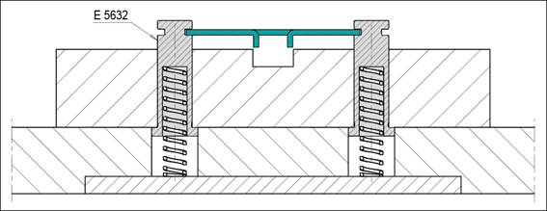

**~~Image source~~**: Meusburger, ~~publication free of charge~~

**~~Caption:~~** Installation example of spring-loaded strip guiding pin, round

**E 5634 Spring-loaded strip guide, block-shaped**

The block-shaped strip guide is mainly used when there are side cut-outs and therefore too little contact surface available. Due to the intelligent design, it is possible to mount this strip guide directly from the working plane. Thanks to the centrally positioned shoulder screw, only a small amount of installation space is required within the stamping die. The length of the shoulder screw also determines the spring displacement of the strip guide. The symmetrical design allows the block-shaped strip guide to be used on both sides.

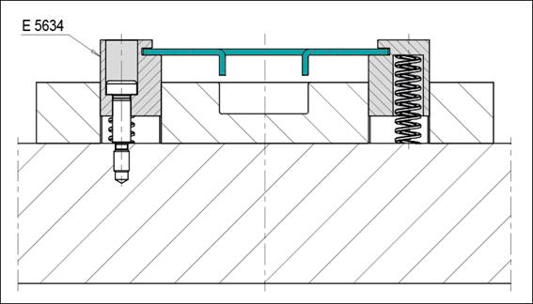

**~~Image source~~**~~:~~ Meusburger, ~~publication free of charge~~

**~~Caption:~~** Installation example of spring-loaded strip guide, block-shaped

The following installation example shows that the block-shaped strip guide is optimally suited for side cut-outs. In addition, a further advantage of using standardised components is demonstrated: the different strip guides are optimally matched to each other and can therefore be combined as required within the stamping dies.

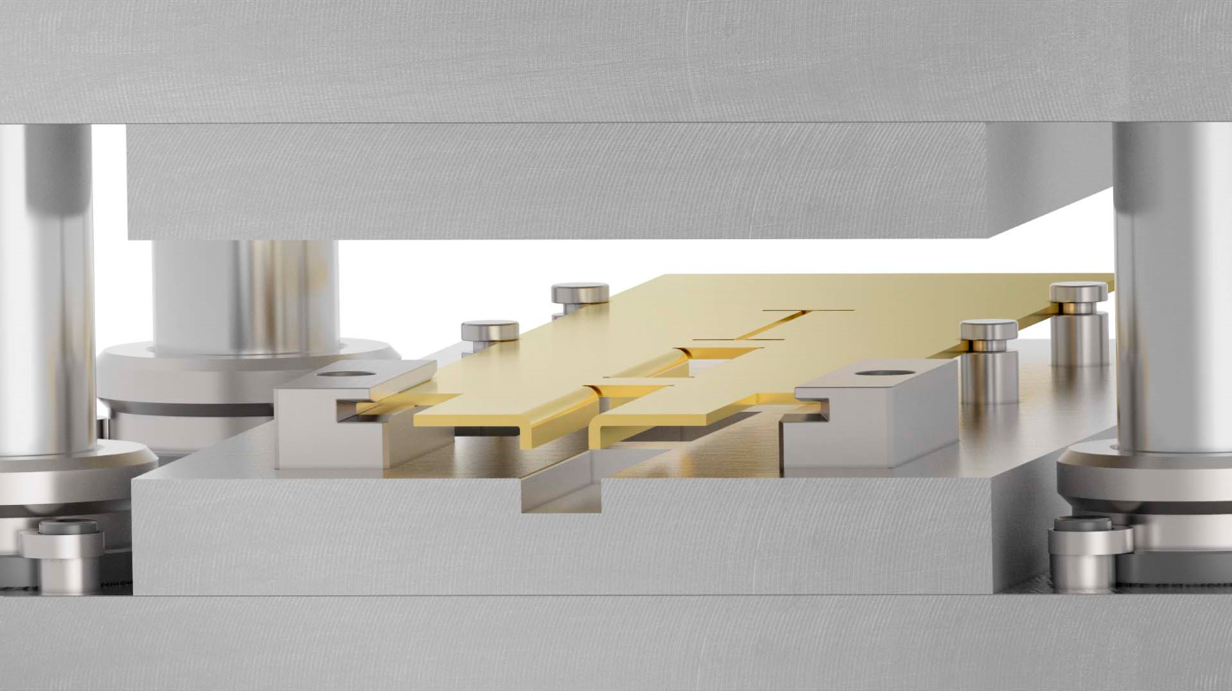

**~~Image source~~**~~:~~ Meusburger, ~~publication free of charge~~

**~~Caption:~~** Optimal for strips with side cut-outs

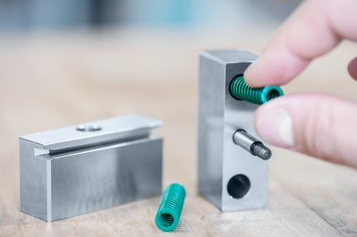

**~~Image source~~**~~:~~ Meusburger, ~~publication free of charge~~

**~~Caption:~~** Spring-loaded strip guide, block-shaped

**E 5636 Strip guiding rail**

The strip guiding rail is always used in combination with a strip lifter. Thanks to the screw connection on the top, it can be directly installed from the working plane. The hardened design ensures the best wear protection and the integrated infeed chamfers allow safe insertion of the punching strip. In addition, it can be used on both sides thanks to the symmetrical design.

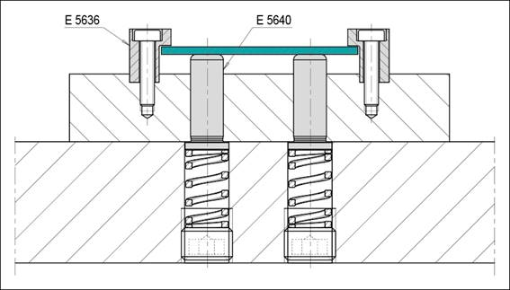

**~~Image source~~**~~:~~ Meusburger, ~~publication free of charge~~

**~~Caption:~~** E 5636 Strip guiding rail with E 5640 Strip lifter, round

**E 5640 Strip lifter, round**

The small diameter versions are suitable for dies with limited installation space. The integrated initial bore enables the introduction of a clearance hole for a pilot pin. In addition, the lengths of the strip lifter with collar are matched to the strip guiding pin with collar - which makes it easy to combine these two elements.

**E 5644 Strip lifter, block-shaped**

The large contact surface of the block-shaped strip lifter guarantees reliable lifting and forward pushing of the metal strip, even for large cut-outs. The E 5644 also has an integrated initial bore for the introduction of a clearance hole for pilot pin, and all functional dimensions are matched to the respective plate thicknesses. All items are available from stock. For more information, please visit www.meusburger.com.

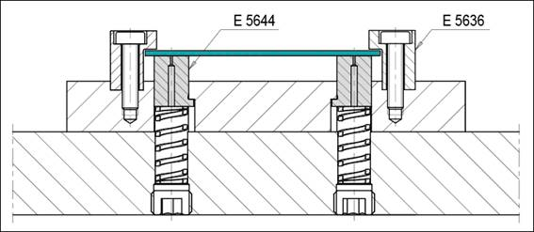

**~~Image source~~**~~:~~ Meusburger, ~~publication free of charge~~

**~~Caption:~~** Block-shaped strip lifter



**Meusburger – Setting Standards.**

**Meusburger is the market leader** in the field of **high-precision standard parts**. Customers all over the world make use of the **advantages of standardisatio**n and benefit from the company’s over **50 years of experience** in working with steel. The product portfolio ranges from **high-precision standard parts** and selected products in the field of workshop equipment to **hot runner and control systems**, the **WBI Knowledge Management Method** and solutions for efficient corporate management in the **ERP/PPS software area**. This makes Meusburger the **reliable global partner** for **making moulds, dies, jigs and fixtures**.

**Press contact**

Meusburger Georg GmbH & Co KG

Communication / Public relations

Phone: +43 5574 6706-0

Email: press@meusburger.com

www.meusburger.com