Meusburger Georg GmbH & Co KG
Kesselstr. 42, 6960 Wolfurt, Austria

Exclusive guide for inclined pin from Meusburger

The exclusive E 3064 Guide for inclined pin stands out due to optimal surface contact with the inclined pin and best material pairings. This results in a high force absorption. The machining of the pocket in the slide is possible without inclining. In addition the slide stroke can be adjusted subsequently by customising, or adjusting the position of the guide for inclined pin.

During the entry of the inclined pin as well as when the mould is opening, the highest forces act on the surface between the inclined pin and the slide. In addition the inclined surface machining of the guiding hole in the slide is often very laborious. That is why Meusburger developed the E 3064 Guide for inclined pin. This is inserted in the slide and forms the contact surface for the inclined pin. Due to the special geometry in the hole, full-surface contact between the inclined pin and the guiding is created. Combined with the best material pairings, this leads to a higher force absorption. The introduction of the guide for the inclined pin is simple: you just cut a rectangular pocket with a threaded hole in the slide and then provide the required clearance for the inclined pin. Thus the machining can also be carried out on a conventional 3 axle machine and before the hardening. Furthermore it is possible to execute the installation conveniently from the split line face. The E 3064 Guide for inclined pin is available from stock for inclined pins with diameters of 12-30 mm. The CAD data including installation spaces is readily and easily available in our web shop.

Picture credits: Photo (Meusburger)
Caption: Exclusive guide for inclined pin from Meusburger

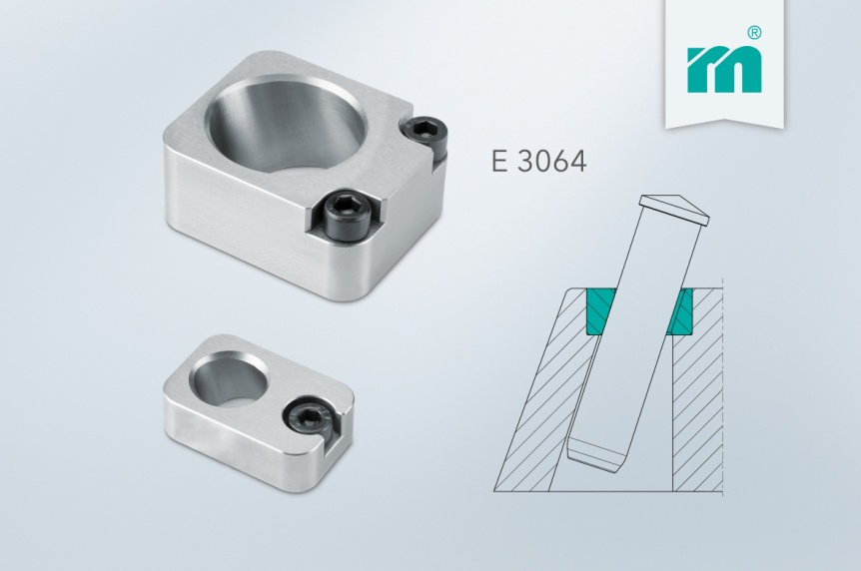

Meusburger Group – Setting Standards

The Meusburger Group is the leading international manufacturer of high-quality standard parts, hot runner and control systems and selected items in workshop equipment. More than 17,500 customers all over the world make use of the numerous advantages of standardisation and benefit from the company's over 50 years of experience in working with steel. The permanent availability of products makes the Meusburger Group the reliable and global partner for die, mould, jigs and fixtures construction.

Further information:
Meusburger Georg GmbH & Co KG
Communication / Public relations
Lia Klimmer
Phone: + 43 5574 6706-1446
Email: presse@meusburger.compresse@meusburger.com
http://www.meusburger.com/en/press/press.html

