**Press Release**

Wolfurt, on 17.12.2019

**Precise control of heating processes made easy**

**Meusburger presents two new products in the area of control systems. The T7 offers a compact operating and display unit for the sysTemp® and flexotemp® controllers, as well as the MPI 02 and MPI 05 components. The THYPO power controller is the new control unit for all industrial segments where precise switching of resistive loads is required.**

The T7 is a compact operating and display unit with a 7" multitouch screen for parameterisation and visualisation of the various Meusburger controllers. Depending on the controller series, the T7 is connected to the devices via CAN or Ethernet. This means the operating and display unit can be positioned freely. Several controllers, even from different series, can be connected to a T7 at the same time and you have an overview at all times. The clear and intuitive operating concept ensures a transparent display of all process data in various display formats and on all configuration parameters. Access to all functions and parameters is defined via the three-level user administration. The option to change languages makes the T7 suitable for worldwide use.

**Precise control of heating elements with THYPO power controllers**

With THYPO, Meusburger offers a modular multi loop power controller for switching and controlling heating elements and heating fields. THYPO can be used in a variety of industries and applications. Some examples include drying paints and coatings, and moulding plastics and lightweight materials, as well as plastic welding and film extrusion. The control unit is robust, incredibly compact, and very easy to install. Simply mount, connect the supply voltage and heaters, assign heating outputs, and off you go. With the three TP output modules in different power levels, the multi loop power controller can be easily adapted to different applications. A THYPO system can be made up of a maximum of 63 TP output modules. With up to 1512 outlets at 1.84 kW per outlet, it can control very large heating fields while needing very little space. With a maximum output of 7.6 kW per outlet, 567 outlets are available per system.

Communication with the controller is via Profinet IO, or optionally also via Modbus TCP/IP or CANopen. Further interfaces such as EtherCAT or Powerlink will soon be available so THYPO can be used with any make of controller. Innovative functions ensure increased process reliability. Detailed diagnostic functions provide support in case of errors in the heating process and help to solve the errors quickly. With the help of the reaction-free current measurement it is possible, for example, to detect which heater is defective, whether a fuse has tripped or whether the mains voltage or frequency is outside the tolerance. In addition, current measurement to compensate for mains voltage fluctuations is integrated as standard. The diagnostic data is transferred via the interfaces to the central system control. Using the convenient web interface, access to the web browser is possible. THYPO can also be used as an output module for heaters in the flexotemp® controller series (PCU and PCU PNIO), as an alternative to use on a controller.



**~~Caption:~~** The T7 is used for parameterisation and visualisation of the temperature controllers.

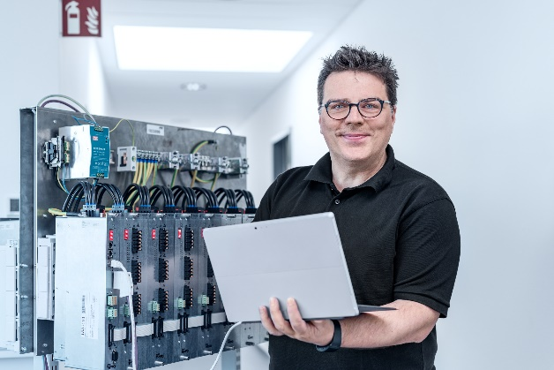

**~~Caption:~~** The THYPO multi loop power controller is an impressive compact unit.

**~~Image source~~**~~:~~ Meusburger ~~publication free of charge~~



**Press contact**

Meusburger Georg GmbH & Co KG

Communication / Public relations

Phone: +43 5574 6706-0

Email: press@meusburger.com

www.meusburger.com