Meusburger Georg GmbH & Co KG
Kesselstr. 42, 6960 Wolfurt, Austria

Innovations for the modular concept

Meusburger presents exclusive and groundbreaking innovations for the modular concept at the Stanztec trade fair

The E 5076 and E 5078 Module guides are now available in configurable lengths. This offers the customer maximum flexibility during the design of die modules. The slide-in aid reduces the processing costs and set-up times to a minimum. With the modular design wizard, the time-consuming and difficult selection of individual plates is a thing of the past.

Configurable lengths
Limited availability of space during the installation of springs is not uncommon, especially when working with die modules. That’s why the springs are often integrated in the guiding unit. For optimum adjustment, the l4 length of the guide pillars must be adapted. This is now freely selectable for the E 5076 and E 5078 Guide pillars for the modular concept from Meusburger. To ensure that the tolerances of all guide pillars used in a module are exactly consistent, they are produced in one work step. After cutting to length the tolerance is +0/-0.02 mm. The l4 length can be adjusted in the hundredth of millimetre range. The CAD data of the configured guide pillar is then ready for export.

E 6045 Slide-in aid for modules
When changing the modules, several components must be removed so that the modules can be disassembled and reinstalled. The expensive and time-consuming introduction of T-slots in the die plates is often necessary, especially for the fixing of the spacers. These problems are a thing of the past with the hardened and ground slide-in aid from Meusburger. With the already integrated T-slot according to DIN 508, the installation and removal of spacers is very simple. The thickness of the slide-in aid is optimally adjusted to the thickness of the Meusburger plates and can be selected individually. In addition, damage to the base set is almost impossible due to the hardened slide-in aids. Ergonomics during die module changes are positively influenced. As usual, the slide-in aid for modules is available from stock.

Complete die modules with just a few clicks
In order to assemble a module, a lot of time must be invested to individually and manually select a large number of plates. Then, the appropriate base set must also be selected. This is where the new wizard for the modular concept from Meusburger comes into play. It enables quick and easy configuration of die modules in just four steps. A variety of plates can be selected with just a few clicks. The individual lengths of the modules ensure maximum flexibility in the total length of the modular die set. After selecting the individual modules, the appropriate SH Two-pillar die set is automatically suggested. Finally, thanks to the direct interfaces to all common CAD systems, the 3D data can be exported as usual.

Picture credits: Photo (Meusburger)
Caption: Innovations for the modular concept

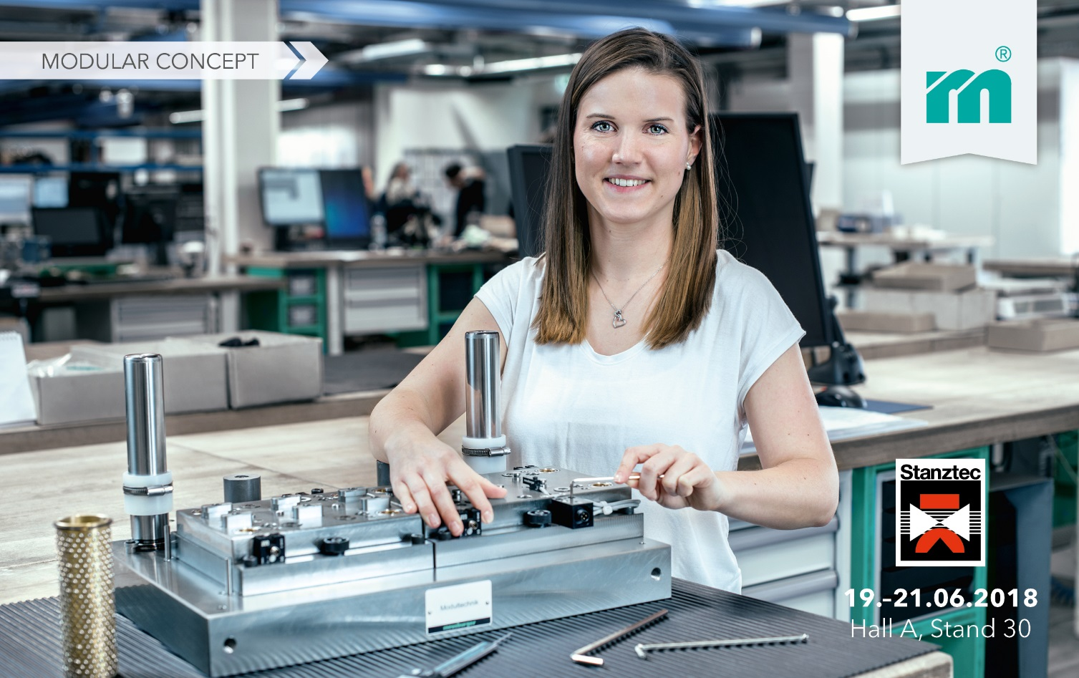

Meusburger Group – Setting Standards

As a part of the Meusburger Group, the Meusburger company is the market leader in the field of high-precision standard parts. Customers all over the world make use of the advantages of standardisation and benefit from the company's over 50 years of experience in working with steel. Offering an extensive range of standard parts, combined with selected products in the field of workshop equipment, Meusburger is the reliable global partner for making dies, moulds, jigs and fixtures.

Further information:
Meusburger Georg GmbH & Co KG
Communication / Public relations
Lia Klimmer
Phone: + 43 5574 6706-1446
Email: press@meusburger.com
http://www.meusburger.com/en/press/press.html

