Meusburger Georg GmbH & Co KG
Kesselstr. 42, 6960 Wolfurt, Austria

NEW from Meusburger: magnetic proximity sensor and magnetic cable retainer

The standard parts manufacturer Meusburger expands its product range in the area of electrical components. The E 65620 Magnetic proximity sensor for T-slots with reliable and precise switching point is ideally suited for use as a cylinder sensor. For easy and secure fixing of cables within the moulds, Meusburger now also offers the universally usable E 2766 Magnetic cable retainer.

Reliable and precise
The new E 65620 Magnetic proximity sensor from Meusburger is equipped with a new setting aid: the flashing signal threshold alarm and continuous light in the optimal switching range guarantee an exact and simple adjustment. Also the existing E 6562 Magnetic proximity sensor which in addition is equipped with a connector was upgraded with this new function. Both sensors from Meusburger are ideally suited for the position sensing of hydraulic cylinders. The fixing of the magnetic proximity sensors takes place in the T-groove. Both variants are coordinated to the tried and trusted Meusburger E 7020 Compact cylinder and guarantee even higher process reliability.

Easy and secure cable holding
The E 2766 Magnetic cable retainer is the optimal solution for easy and secure fixing of the connecting leads inside the cable slot. For incorporating the cable retainer only a milling cutter with a diameter of 12 mm is required. Thus the user is spared the time-consuming task of introducing a threaded hole. The retainer is fixed by means of a strong Neodymium magnet. This helps save time and costs during the mould assembly. Due to their temperature resistance of up to 150°C the magnetic cable retainers can also be used for hot runner systems.

The magnetic proximity sensors and cable retainers are, as is usual with Meusburger, available from stock.

Picture credits: Photo (Meusburger)
Caption: NEW from Meusburger: magnetic proximity sensor and magnetic cable retainer

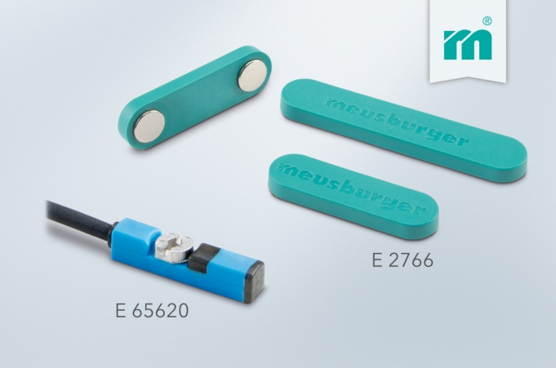

Meusburger – Setting Standards
Meusburger is the leading manufacturer of high-precision standard parts. More than 17,000 customers all over the world make use of the numerous advantages of standardisation and benefit from the company's over 50 years of experience in working with steel. Offering an extensive range of standard parts, combined with high-grade products in the field of workshop equipment, Meusburger is the reliable global partner for making dies, moulds, jigs and fixtures.

Further information:
Meusburger Georg GmbH & Co KG
Communication / Public relations
Lia Klimmer
Phone: + 43 5574 6706-1446
Email: presse@meusburger.compresse@meusburger.com
www.meusburger.com/ press-releases

