Meusburger Georg GmbH & Co KG
Kesselstr. 42, 6960 Wolfurt, Austria

Meusburger expands their range in control systems

With the newest product additions Meusburger is expanding their control systems range in the area of workshop equipment. Three new pin assignments have been added for the tried and trusted hot runner controller profiTEMP+, which are now available at Meusburger directly from stock.

Everything from a single source
Since the merger of Meusburger and PSG under the umbrella of the Meusburger Group, both companies have been working hand in hand to expand the product range and offer the customers unique added value through the resulting synergy. This means that tried and trusted PSG products are now also available from stock at Meusburger.

profiTEMP+ Hot runner controller
With both innovative technology and space-saving design, the profiTEMP+ Hot runner controller from PSG is sure to impress. In addition to new intelligent functions like Smart Power Limitation (SPL) and MoldCheck, the tried and trusted features are further developed in the new hot runner controller. Due to the clearly designed 7“ multi-touch screen, easy and intuitive operation is guaranteed.

New pin assignments
PSG’s versatile standard pin assignment represents one of the most important standards in the hot runner sector, but many other versions and standards are also represented on the market.
In order to offer customers maximum flexibility for their existing systems, Meusburger has expanded their control systems range with three additional pin assignments, which are now available directly from stock.

The new pin assignments differ as follows:

- Assignment 121: 24-pin, variable pin assignment
The assignment 121 efficiently combines thermocouple and heating cables in one cable. The construction is therefore comparable to the PSG standard assignment, however the arrangement of the individual zones differs.
- Assignment 522: 24-pin, separate thermocouple and heating cables
In the assignment 522 the thermocouple and heating cables are connected to the control unit and hot runner with separate cables.
- Assignment 620:- 16-pin, separate thermocouple and heating cables
The assignment 620 is also constructed with separate thermocouple and heating cables, but has 16 pins and corresponds to the EUROMAP 14” specifications.

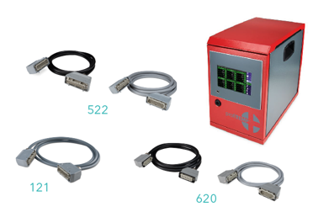
Picture credits: Photo (Meusburger)
Caption: Three new pin assignments available from stock at Meusburger

Meusburger – Setting Standards.

As a part of the Meusburger Group, the Meusburger company is the market leader in the field of high-precision standard parts. Customers all over the world make use of the advantages of standardisation and benefit from the company's over 50 years of experience in working with steel. Offering an extensive range of standard parts, combined with selected products in the field of workshop equipment, Meusburger is the reliable global partner for making moulds, dies, jigs and fixtures.

Further information:
Meusburger Georg GmbH & Co KG
Communication / Public relations
Phone: + 43 5574 6706-0
Email: press@meusburger.compresse@meusburger.com
http://www.meusburger.com/en/press/press.html

