PRESS RELEASE
Wolfurt, on 17.04.2020

Material grade 1.2738 TSHH now available from stock

Reducing processing time and optimising costs is especially important for injection moulds with moderate shot weights. In addition, flawless surface quality is often required for injection moulded parts. 1.2738 TSHH steel has long been established on the market for this purpose. This steel is especially useful in the automotive industry, but also for consumer goods. Meusburger now offers cavity plates and standard plates in the material grade 1.2738 TSHH available from stock.

Characteristics and use

Generally, the steel for injection moulds is designed for the cavity that comes in contact with the plastics. But the steel properties important for the mould design are often not considered.
The material grade 1.2738 TSHH is a modified, hardened and tempered steel for injection moulds which meets all requirements: it offers both excellent polishability and grainability as well as high thermal conductivity and high wear resistance. It is especially suited for cavity plates without dimension restrictions, with deep cavities and high core loads.

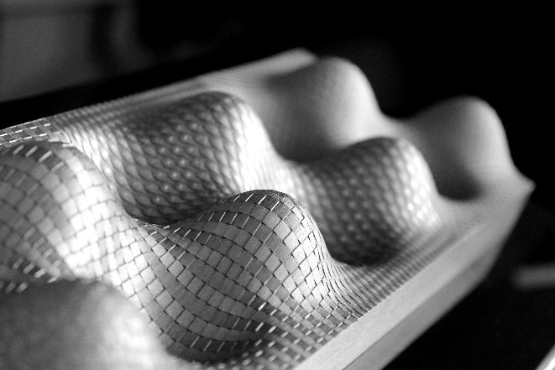
Image source: Reichle Technologiezentrum GmbH
Caption: The figure shows an example of a plate in the material grade 1.2738 TSHH with a deep laser texturing.

In direct comparison to material grades 1.2311 and 1.2738, 1.2738 TSHH features the following characteristics:

- High hardness over the entire cross section, also for thick plates
- Grainability, even for delicate surfaces
- Excellent for polishing
- High thermal conductivity
- Improved weldability

The steel is already supplied hardened and tempered with a strength of 1,200 N/mm² (≈ 38 HRC), so no further heat treatment is necessary. Therefore time and costs can be saved during machining and production.

Now available from stock at Meusburger

The standard parts manufacturer, Meusburger offers a comprehensive range of cavity plates and P standard plates in sizes from 156 246 to 496 996 and in the thicknesses from 56 to 136 mm, all available from stock.

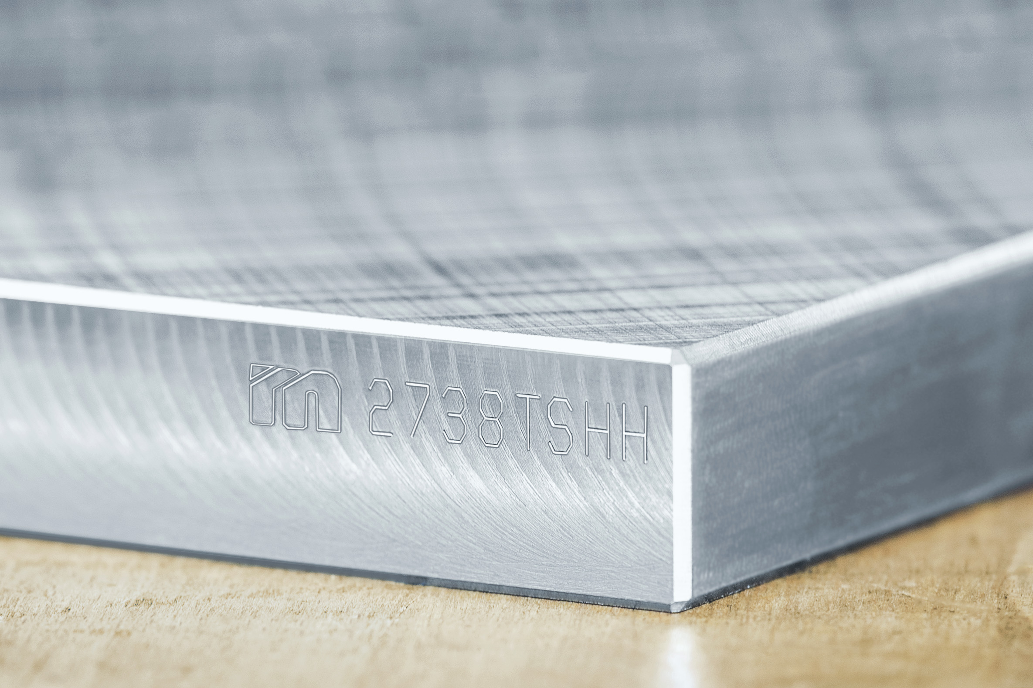
Image source: Meusburger publication free of charge
Caption: At Meusburger, the material 1.2738 TSHH is available from stock.

Meusburger – Setting Standards.

Meusburger is the market leader in the field of high-precision standard parts. Customers all over the world make use of the advantages of standardisation and benefit from the company’s over 55 years of experience in working with steel. The product portfolio ranges from high-precision standard parts and selected products in the field of workshop equipment to hot runner and control systems, the WBI Knowledge Management Method and solutions for efficient corporate management in the ERP/PPS software area. This makes Meusburger the reliable global partner for making moulds, dies, jigs and fixtures.

Press contact

Meusburger Georg GmbH & Co KG
Communication / Public relations
Phone: +43 5574 6706-0
Email: press@meusburger.com
www.meusburger.com

