Meusburger Georg GmbH & Co KG
Kesselstr. 42, 6960 Wolfurt, Austria

Meusburger standard components for the modular concept

Meusburger's convenient and cost-effective standard components guarantee an easy installation of die modules. Key advantages when using modules are quick tool changes and therefore reduced downtimes. The Austrian standard parts manufacturer offers users the possibility to use these advantages with its extensive range of products for the modular concept. Various elements are available for guiding in the module. In addition the range contains different items for positioning and fixing which are required for a precise assembly of modules with repeatable accuracy. These are suitable for every area of application and available from stock in high quality. All components for the modular concept and further Meusburger products can be ordered quickly and easily in the online shop.

www.meusburger.com

Picture credits: Photo (Meusburger)
Captions: Meusburger standard components for the modular concept

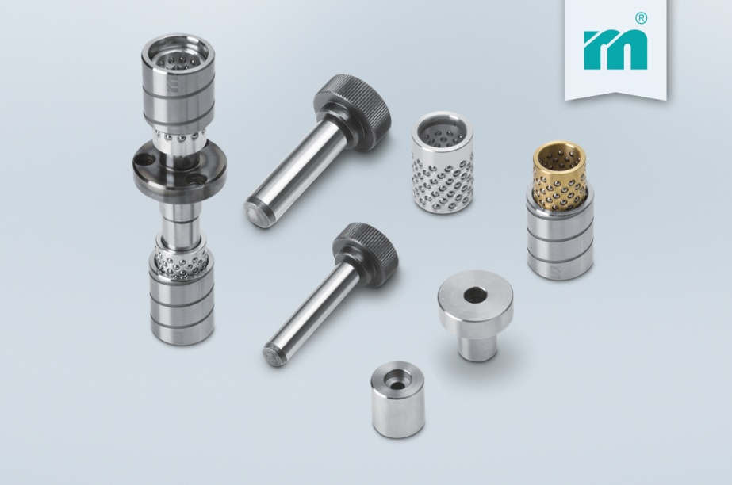

Meusburger – Setting Standards
Meusburger is the leading manufacturer of high-precision standard parts. More than 17,000 customers all over the world make use of the numerous advantages of standardisation and benefit from the company's over 50 years of experience in working with steel. Offering an extensive range of standard parts, combined with high-grade products in the field of workshop equipment, Meusburger is the reliable global partner for making dies, moulds, jigs and fixtures.

Further information:
Meusburger Georg GmbH & Co KG
Communication / Public relations
Phone: 0043 (0) 5574 6706-0
Email: presse@meusburger.com
www.meusburger.com/press-releases

