PRESS RELEASE
Wolfurt, on 03.03.2020

Top reliability when operating 3-plate moulds

Latch locks are used to control moulds with 2 split lines, often referred to as 3-plate moulds. With the new E 1817 latch lock, Meusburger has created an exclusive and cost-effective alternative to existing products on the market, such as round or flat latch locks. Thanks to its simple mechanical functional principle, the new latch lock offers maximum reliability in the control of 3-plate moulds. In addition, it features a compact design as well as low machining effort prior to its installation.

The functional principle in detail

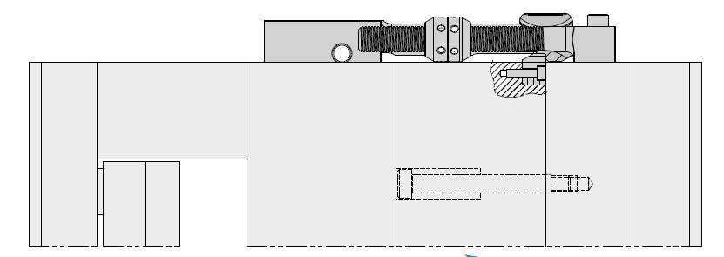

The mould is initially closed. Then it is opened at the first split line, with a maximum permissible pulling force of 14 kN per latch lock. The puller inserted in the plate pulls the floating plate to the desired stroke. This is determined by the position of the cam, which can be easily and precisely adjusted on the spindle within a range from 6 to 165 mm. The position is fixed by locking the two cam halves, thus eliminating the play of the spindle.
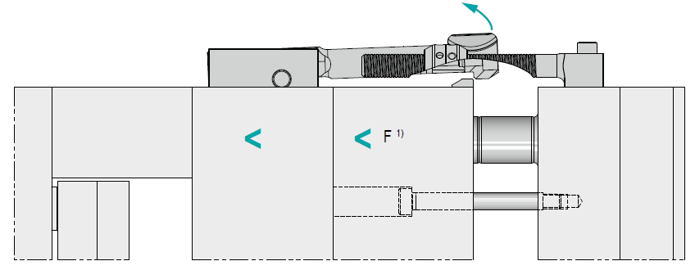

As soon as the rocker lever makes contact with the cams, the latch arm is steered over the puller and the second split line face is released and can be opened. The rocker lever is DLC coated and therefore extremely wear-resistant.

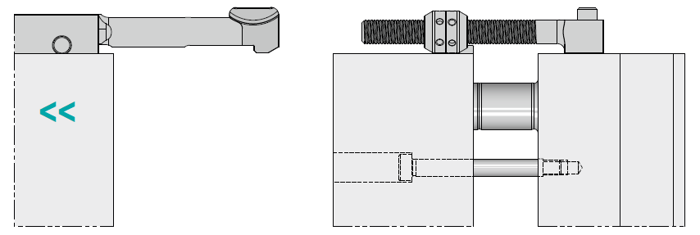

Thanks to the integrated system compression spring in the latch arm, the lever is brought to the neutral position after each operation.

Meusburger created an animation of the E 1817 latch lock to show the individual steps in detail – just click here to watch.

As usual at Meusburger, the CAD data is also available for download in the shops. The E 1817 latch lock from Meusburger is available from stock. Find further information at www.meusburger.com

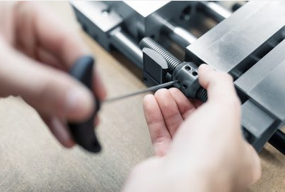
Image source: Meusburger publication free of charge
Caption: E 1817 Latch lock

Meusburger – Setting Standards.

Meusburger is the market leader in the field of high-precision standard parts. Customers all over the world make use of the advantages of standardisation and benefit from the company’s over 55 years of experience in working with steel. The product portfolio ranges from high-precision standard parts and selected products in the field of workshop equipment to hot runner and control systems, the WBI Knowledge Management Method and solutions for efficient corporate management in the ERP/PPS software area. This makes Meusburger the reliable global partner for making moulds, dies, jigs and fixtures.

Press contact

Meusburger Georg GmbH & Co KG
Communication / Public relations
Phone: +43 5574 6706-0
Email: press@meusburger.com
www.meusburger.com

