Meusburger Georg GmbH & Co KG
Kesselstr. 42, 6960 Wolfurt, Austria

Meusburger offers a comprehensive range of accessories for spring installation

In die making, springs are an essential part to every die set. As a competent partner for die makers Meusburger offers, in addition to springs with round or rectangular cross section and elastomer compression springs in diverse shore hardness, also the most extensive range of accessories for spring installation on the market.

A new and innovative solution from Meusburger is the E 1549 Spring cover. The simple through hole in combination with the spring cover replaces the laborious threading of a blind hole for spring installation. Moreover the entire spring force is absorbed by the spring cover. The sizes of the spring cover are adapted to the diameter of the system compression springs of 20-40 mm. Also new in range is the E 15481 Screw plug with collar. The collar allows a precise positioning of the screw plug and is therefore ideally suited for a comfortable and easy installation of the coil compression springs, at which the fine thread ensures low tightening torques. All new products and also the proven components like spring pre-loading unit, spacer unit, or shoulder screw are available from stock in high quality from Meusburger.

Picture credits: Photo (Meusburger)
Captions: Meusburger offers a comprehensive range of accessories for spring installation
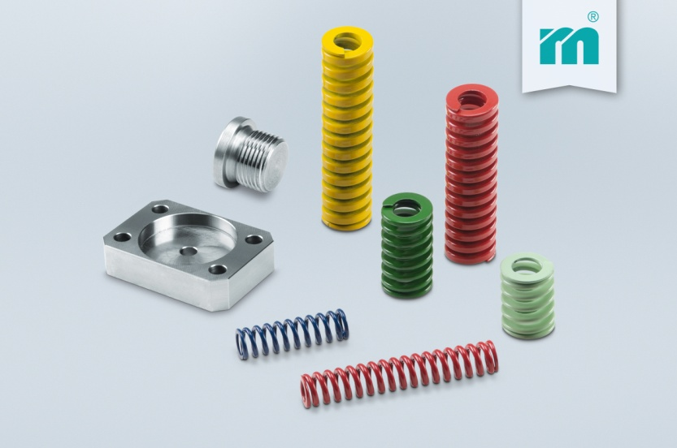

Meusburger – Setting Standards
Meusburger is the leading manufacturer of high-precision standard parts. More than 17,000 customers all over the world make use of the numerous advantages of standardisation and benefit from the company's over 50 years of experience in working with steel. Offering an extensive range of standard parts, combined with high-grade products in the field of workshop equipment, Meusburger is the reliable global partner for making dies, moulds, jigs and fixtures.

Further information:
Meusburger Georg GmbH & Co KG
Communication / Public relations
Phone: 0043 (0) 5574 6706-0
Email address: presse@meusburger.com
www.meusburger.com/press-releases

