Meusburger Georg GmbH & Co KG
Kesselstr. 42, 6960 Wolfurt, Austria

NEW from Meusburger – carbide blocks for eroding

With the new NE-Blocks for eroding from carbide Meusburger offers the ideal compromise between wear resistance and fracture toughness. Carbide blocks for eroding are therefore perfectly suited for universal uses in stamping, embossing, bending, and forming.

The high-quality CF-H40S+ carbide, with a hardness of 1400 HV10, ensures a long service life, with maximum wear resistance and excellent edge stability. The well-balanced fine/medium grit type of these blocks for eroding enables reliable machining of complex and filigree mould and die geometries. Their high corrosion resistance makes them ideal for wire EDM. Furthermore, they perfectly comply with the mechanical and physical requirements in mould and die making. The carbide blocks for eroding from Meusburger are available from stock in size 100x100 mm and in different thicknesses ranging from 10 to 60 mm.

Picture credits: Photo (Meusburger),
Captions: NEW from Meusburger – carbide blocks for eroding

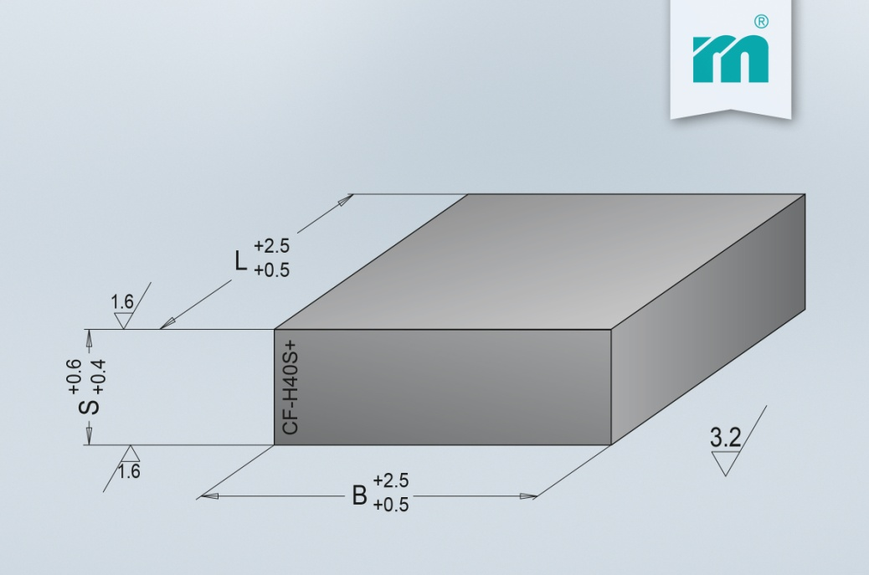

Meusburger – Setting Standards
Meusburger is the leading manufacturer of high-precision standard parts. More than 17,000 customers all over the world make use of the numerous advantages of standardisation and benefit from the company's over 50 years of experience in working with steel. Offering an extensive range of standard parts, combined with high-grade products in the field of workshop equipment, Meusburger is the reliable global partner for making dies, moulds, jigs and fixtures.

Further information:
Meusburger Georg GmbH & Co KG
Communication / Public relations
Phone: 0043 (0) 5574 6706-0
Email: presse@meusburger.com
www.meusburger.com/press-releases

