Meusburger Georg GmbH & Co KG
Kesselstr. 42, 6960 Wolfurt, Austria

Safety first! New product group 'Protective equipment' at Meusburger

The theme protective equipment accompanies die and mould makers in their daily working life. To function as a competent full-range supplier, Meusburger expands its range in the area of workshop equipment with the new product group protective equipment. The standard parts manufacturer exclusively relies on the high-quality products from UVEX. The pre-sorted product range enables an easy and time-saving selection of the required protective equipment and as always with Meusburger, is available from stock.

Safety glasses with optimal fit
All safety glasses offer perfect protection and a high level of comfort through individual adaptability. Different models and matching accessories are available just to name a few: the sporty ASA 1000 safety glasses, the ASA 1400 with flexible side arms, the ASA 3200 for an unrestricted peripheral vision and much more. All models have an anti-fog inner lens and a scratch-resistant outer lens with high light transmission and are equipped with UV protection. Therefore a clear view is guaranteed.

All ears when it comes to hearing protection
Too much or too little sound insulation can lead to communication problems or an increased risk of accidents. A residual sound level of 70-80 dB is ideal to the wearer's ear. The different hearing protection systems at Meusburger offer the optimal noise insulation for every area of application and volume. Ergonomically designed earplugs as disposable or reusable versions and earmuffs with a SNR attenuation of 27-36 dB guarantee not only noise protection but also maximum wearing comfort.

Hand protection for different areas of application
Meusburger offers a comprehensive range of hand protection equipment for different requirements. The suitable model can be quickly and easily determined by means of an overview diagram. Safety gloves for precision, all-round, or heavy duty tasks and different environmental conditions from dry to wet are available. There are a total of 12 different models to choose from which all fulfil the high requirements of die and mould makers. The ASH 1210 All-purpose glove is optimal for general work. Cut-resistant gloves are available in the categories Cut 3 and Cut 5. The Meusburger range also includes chemical-resistant gloves, which are suitable for working with dielectric materials, and disposable gloves with high resistance to grease and oil.

Breathe easy with respiratory protection from Meusburger
The Meusburger dusk masks are available in classes FFP1, FFP2, and FFP3. Exhalation valves provide for comfortable breathing. The practical selection guide helps to quickly find the right respiratory protection mask for every use.

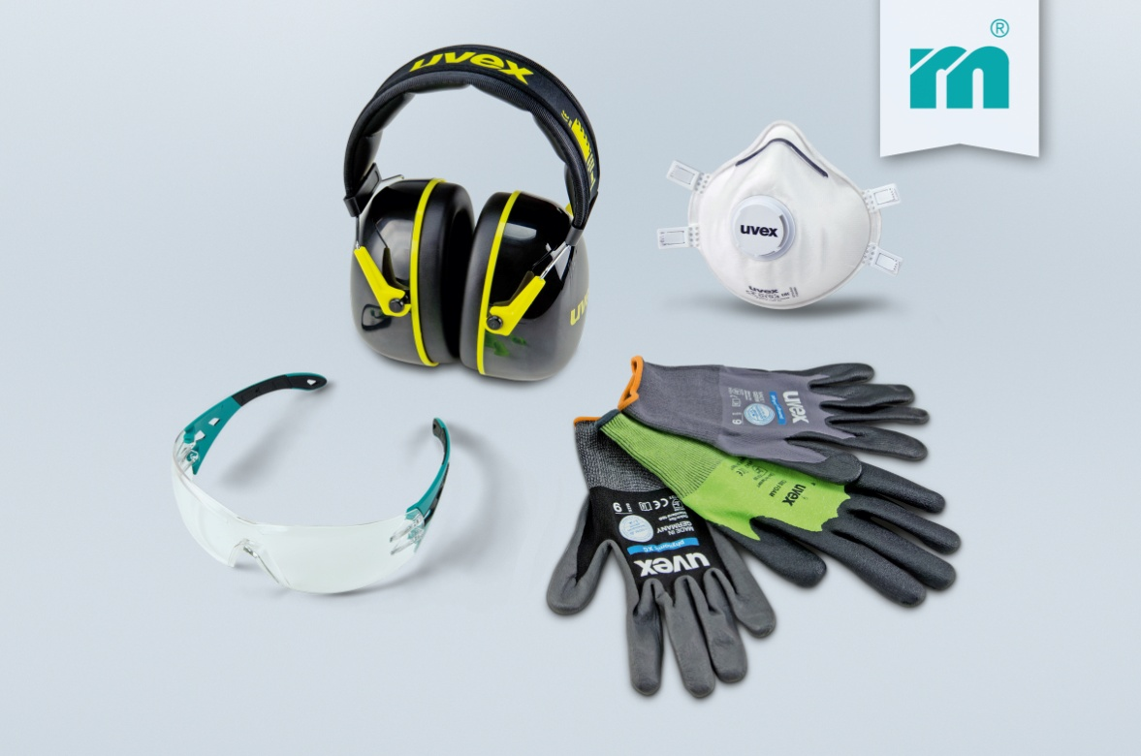

Picture credits: Photo (Meusburger)
Caption: New product group at Meusburger Protective equipment

Meusburger – Setting Standards
Meusburger is the leading manufacturer of high-precision standard parts. More than 17,000 customers all over the world make use of the numerous advantages of standardisation and benefit from the company's over 50 years of experience in working with steel. Offering an extensive range of standard parts, combined with high-grade products in the field of workshop equipment, Meusburger is the reliable global partner for making dies, moulds, jigs and fixtures.

Further information:
Meusburger Georg GmbH & Co KG
Communication / Public relations
Phone: 0043 (0) 5574 6706-0
Email address: presse@meusburger.com
www.meusburger.com/press-releases

