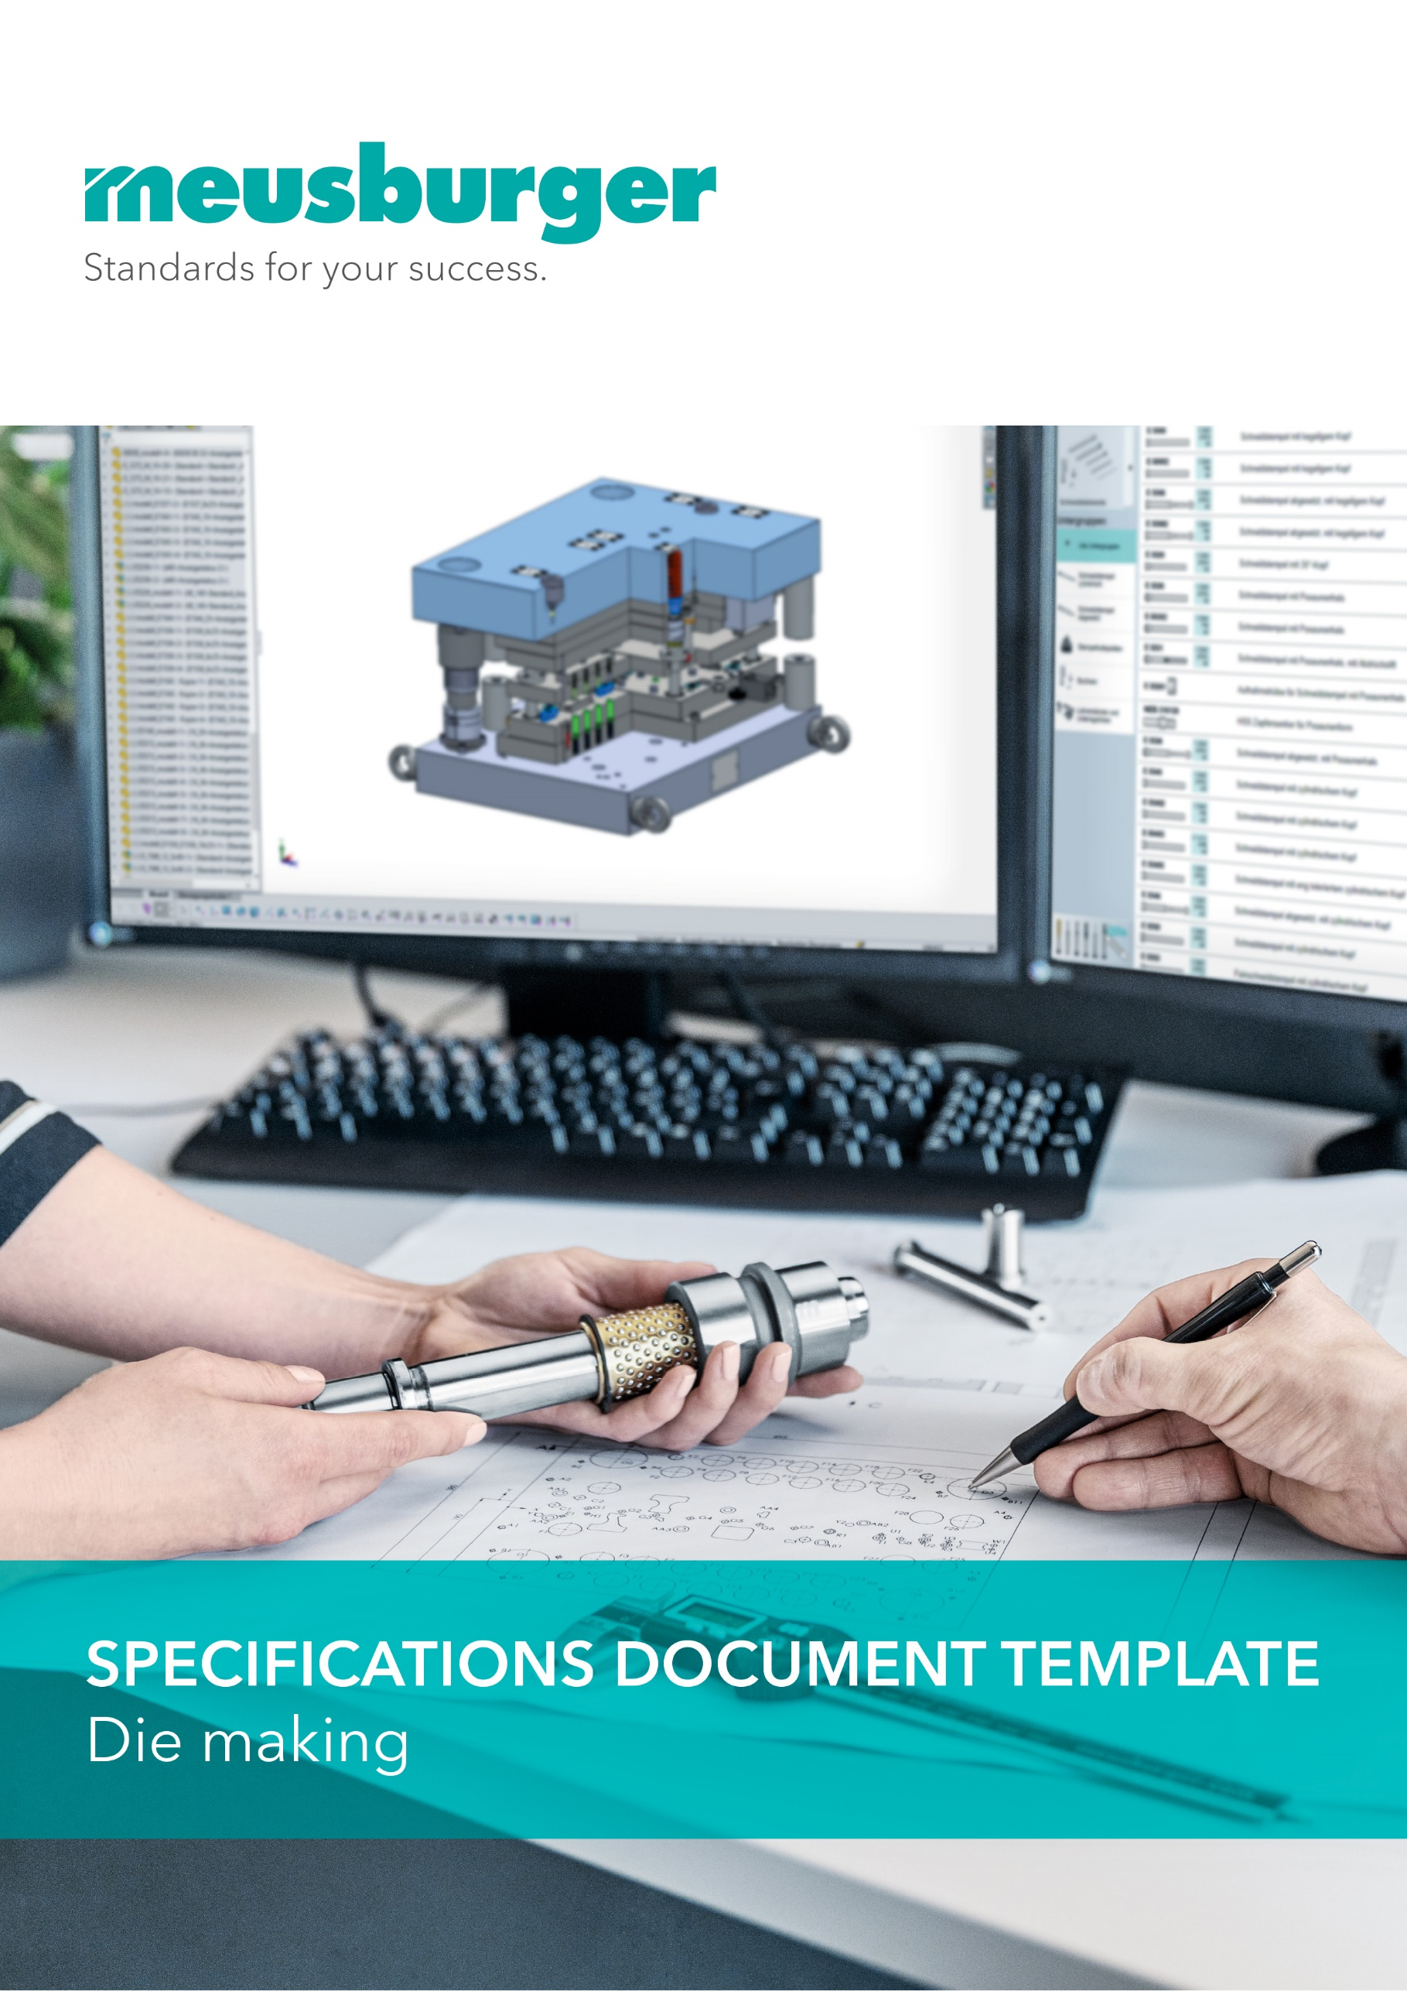

Version 1.0

Contents

1. Foreword 3

2. General information 4

2.1. Title 4

2.2. Customer 4

2.3. Contacts 4

2.4. Goal 4

2.4.1. Minimum die requirement 4

2.5. Liabilities 4

2.6. Delivery date / schedule 4

2.7. Deviations 4

2.8. Sampling 4

2.8.1. Die function test 4

2.8.2. Sampling 4

2.9. Die delivery 4

2.10. Die transport 4

2.10.1. Transport insurance 4

2.10.2. Delivery note 5

3. Die design 6

3.1. Design implementation 6

3.2. Design approval 6

3.3. Design documents 7

3.3.1. After completion of the design 7

3.3.2. Before delivery of the die 7

3.3.3. After completion of the project 7

3.3.4. Media for the data exchange 7

4. Die making 8

4.1. General information 8

4.1.1. Production area 8

4.1.2. Strip layout / process sequence 8

4.1.3. Usable width and total length 8

4.1.4. Standard die concepts 9

4.1.5. Press installation parameters 10

4.2. Material selection 10

5. Die sets 11

5.1. General information 11

5.1.1. Standard hole pattern/anti-rotation protection 11

5.1.2. Ventilation groove 11

5.1.3. Plates screw connection 12

5.1.4. Alignment edge 12

5.1.5. Optional fastening of guide pillars 13

5.2. SV-Standard die set 13

5.3. SH Two-pillar die set, back guiding 13

5.4. SD Two-pillar die set, diagonal guiding 14

5.5. SZ Two-pillar die set, central guiding 15

5.6. Tolerances SV, SH, SD, SZ 15

5.7. SP-Precision die set 15

5.8. SP tolerances 16

5.9. Hole tolerances 16

5.10. Modular concept 16

5.10.1. Base set 16

5.10.2. Module plates 17

5.10.3. Components for the modular concept 17

5.11. Design specifications 17

5.11.1. Eye bolt holes 17

6. Accessories (E-parts) 19

6.1. General information 19

6.2. Material selection 19

6.3. Guiding 19

6.4. Fasteners 21

6.5. Cutting elements 21

6.6. Active parts 22

6.7. Springs 23

6.7.1. System compression springs 23

6.7.2. Elastomer compression springs 24

6.8. Gas springs 24

6.9. Slide systems 25

6.10. Attachments 25

6.10.1. Lifting points 26

6.10.2. Label 26

6.10.3. Status indicator plate 26

6.11. Monitoring/process reliability 27

6.11.1. Sensors 27

6.11.2. Logic distributors 27

6.11.3. Electrical connections 28

7. Approved suppliers 28

# Foreword

This document is considered the basis for die design and production.

Passages marked in turquoise can be filled out accordingly.

In tables, the first column can be marked to indicate which product is used.

**Example:**

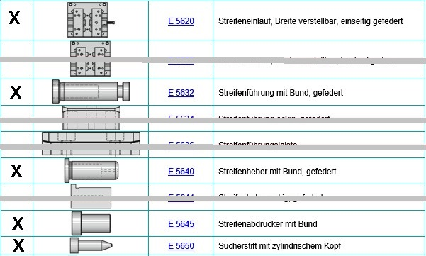

Passages and points that are not generally required can simply be deleted or supplemented.

The table of contents must be updated accordingly at the end.

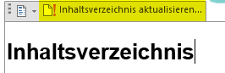



This symbol provides useful overviews about downloading and printing regarding the respective topic.

# General information

## Title

XY

## Customer

XY

## Contacts

XY

## Goal

### Minimum die requirement

* + - 1. Required number of strokes / minimum or total number of strokes – service life of the die
      2. Batch size up to maintenance interval / spare parts recommendation list

XY

## Liabilities

XY

## Delivery date / schedule

XY

## Deviations

XY

## Sampling

### Die function test

XY

### Sampling

XY

## Die delivery

XY

## Die transport

### Transport insurance

XY

### Delivery note

XY

# Die design

In general, the die design should be maintenance friendly.

Upon final payment, the customer obtains ownership to the design and intellectual property rights, provided these are not protected by patent.

The design approval is broken down into

* Pt. 1 Die pre-design/function (for steel approval/order)
* Pt. 2 Design approval of the complete 3D design

## Design implementation

* The drawings or data released by the customer for the individual project steps are considered the basis for the order. Associated 3D CAD item models may only be used while taking the dimensions and tolerances specified in the drawing into consideration.
* The authorised die maker is solely responsible for the data conversion in their CAD system. The die maker is liable for possible conversion errors.
* Subcontracting of the order to third parties is not permitted; only after consultation with and written approval from the company XY.
* The origin/basis of the entire die design is the 3D CAD die item model (file name). An up-to-date die model is always available during the project. Old versions are saved for documentation purposes.
* The entire die design is built using 3D CAD solid models based on the die item model.
* All die components exist as separate 3D CAD models.
* A detailed drawing is created of each component. The drawings correspond to the 3D CAD models so the drawings are automatically updated if there are model changes. Changes are documented in the title block by the change index and major changes are documented in a change data sheet.
* Alternatively, the 3D CAD models can be coloured in according to the standard colour codes.
* The old design status must be saved before making changes/adjustments.



[**CAD colour codes to download and print**](https://www.meusburger.com/DE/AT/media/DOC_PRO_FLY_CAD-Farbtabellenstandards_IN.pdf)

## Design approval

Before starting the construction, the customer must submit the die design. If the design is not yet complete, there has to be at least a preliminary draft which is approved in a design meeting with the company project manager XY.

The die design adopted by the XY company does not release the manufacturer from its responsibility to create a fully functional and production-ready die.

The design must be approved by the following parties:

|  |  |  |  |  |
| --- | --- | --- | --- | --- |
| **Department** | **Name** | **Function** | **Date** | **Signature** |
| Die manufacturer |  |  |  |  |
| Company XY Development/Sales |  | Project manager |  |  |
| Company XY Mould Technology |  | Die technology manager |  |  |
| Company XY Production |  | Production manager |  |  |
| XY |  |  |  |  |

## Design documents

The following documents are to be handed over to the customer in paper form and/or as a PDF format:

### After completion of the design

* Assembly drawings depicting the complete stamping die:
  + Top view of upper and lower part
  + Sectional views showing all relevant details
  + Exploded view (if available)
  + The drawings must include the dimensions, the die weight and the item numbers of the parts list
* The parts list includes all items and all steel grades with the material numbers, strength and hardness in HRC as well as the suppliers.

Upon the customer’s request, additional documents are to be provided at any point in the project.

### Before delivery of the die

* Complete set of drawings of all necessary individual parts used for die production.
* Parts list
* Electrical layout plan (if necessary)

### After completion of the project

The customer receives the complete design documents in paper form and as an electronic data set.

This includes:

* 3D CAD data in CAD format or STEP format specifying the software, software version and service pack.
  + - All item CAD data, which was used as the basis to implement the project
    - All die items
    - Upper and lower part issued as a separate assembly group

Base sheets: DXF data for the creation of the cutting die and the stamp bases

* + 2D CAD in DXF and PDF format
* Parts list
* Electrical layout plan (if necessary)

In general:

* + All 2D/3D CAD data must be clearly identified (e.g. cutting punch, cutting die, etc.)
  + All components have the die coordinate system as a reference
  + Current actual dimensions to guarantee a spare parts production without subsequent rework or press-in work

### Media for the data exchange

* USB flash drive or cloud

In general:

Labelling with the customer’s information: project no., commission no., die no., item description, item no., table of contents

# Die making

## General information

Die sets and standard parts from Meusburger + XY are to be used whenever possible.

### Production area

The production premises, machines, tonnages, work table lengths and item requirements must be checked by the customer in advance and the specifications adapted as closely as possible to the Meusburger standard.

### Strip layout / process sequence

The strip layout or process sequence is created in advance by the design department, taking into account all corresponding item requirements and overall process requirements. In particular, the stroke rate specification and whether single/multiple or pairs must be taken into account.

The resulting dimensions (usable width and total length) are therefore an important first step and must be effectively incorporated into a standard die set, preferably from Meusburger.

### Usable width and total length

Based on the strip layout or the process sequence, you define the die concept in width, height and total length.

The resulting usable width leads to filtering to the appropriate die set and the option to directly export CAD data and parts list.

In addition, the active plates are determined on the basis of the usable width and thus the standard thickness are selected via a grid. In addition, the NP precision bars determined from this are generated.

**Example:**



|  |  |
| --- | --- |
| **Usable width** | XY mm |
| **Total length** | XY mm |

### Standard die concepts

|  |  |  |  |  |  |  |  |  |  |
| --- | --- | --- | --- | --- | --- | --- | --- | --- | --- |
|  | **Die set version** | **Number of pillars** | **Backing plate** | **Material infeed** | | **Pillars retainer**  **Rolling guide/sliding guide** | | | **Dimensions**  **W x L**  **(from/to)** |
| **Usable width**  **(from/to)** | **Usable length**  **(from/to)** | **Top** | **Centre** | **Bottom** |
|  | SV-Standard die sets | 4 | Yes/no | 50 mm  -  450 mm | 156 mm  -  1396 mm | X |  | X | 156x156  -  696x1396 |
|  | SP-Precision die set | 4 | Yes | 90 mm  -  330 mm | 196 mm  -  696 mm |  | X |  | 196x196  -  496x696 |
|  | SH Two-pillar die set, back guiding | 2 | No | 70 mm  -  295 mm | 156 mm  -  696 mm | X |  | X | 126x156  -  396x696 |
|  | SD Two-pillar die set, diagonal guiding | 2 | Yes/no | 20 mm  -  230 mm | 29 mm  -  318 mm | X |  | X | 126x156  -  396x496 |
|  | SZ Two-pillar die set, central guiding | 2 | Yes/no | - | 50 mm  -  330 mm | X |  | X | 126x156  -  396x496 |
|  | SM  Modular concept | 2/4 | Yes | - | - |  | X |  |  |
|  | SBH-Stamping and forming die sets | 2 | No |  |  | X |  | X |  |
|  | SBP-Stamping and forming die sets | 4 | Yes |  |  |  | X |  |  |
|  | XY |  |  |  |  |  |  |  |  |

For details on the respective die set types, see from chapter 5.

### Press installation parameters

The machine list – as of xx.xx.20xx, which can be found in the appendix, applies here.



|  |  |
| --- | --- |
| **Active plates height** | XY mm |
| **Cutting height** | XY mm |
| **Belt infeed height** | XY mm |
| **Bottom clamping edge height** | XY mm |
| **Top clamping edge height** | XY mm |
| **Upper part centring to the punch press** | Clamping pivot/centring unit/fitting key |
| **Parts removal is carried out by** | Chute slide/conveyor belt |
| **Scrap removal is carried out by** | Chute slide/conveyor belt/down through the table opening |
| **Die locking device** | Ejection control/feed sensing/double sheet detection |
| **XY** |  |

## Material selection

The material to be used for the individual components can be taken from the following list. Further information on the materials can be found in the Meusburger material selection wizard. <http://material.meusburger.com/>

|  |  |  |  |  |
| --- | --- | --- | --- | --- |
| **Designation** | **Material** | **Heat treatment** | **Hardness in HRC or strength** | **Properties/standard** |
| Clamping plate, clamp risers |  |  |  |  |
| Pillars retainer |  |  |  |  |
| Bushes retainer |  |  |  |  |
| Wear plate |  |  |  |  |
| Retainer plate |  |  |  |  |
| Guiding plate |  |  |  |  |
| Active plate |  |  |  |  |
| Cutting die |  |  |  |  |
| Die 1 |  |  |  |  |
| Die 2 |  |  |  |  |
| XY |  |  |  |  |

# Die sets

## General information

All die sets are made of high-grade steel, heat-treated for stress relief and are in modular design.

The close-tolerance standard die sets guarantee easy interchangeability. In addition, the use of standard die sets results in further advantages in the machining and assembly of dies.

### Standard hole pattern/anti-rotation protection

The inside dimensions of all die plates are to be constructed according to the Meusburger principle:

* The ratio between the size of the guiding hole and the edge distance always remains the same
* Optimal space utilisation ➔ saves the designer from time-consuming changes.
* Two guiding holes are symmetrically offset to allow the die set to be used rotated (pillar installation)
* The offset guiding holes are marked by means of a milled recess, so they can be easily visually recognised.



[**Overview of the inside dimensions to download and print**](https://ecom.meusburger.com/files/info/bohrbild_S.pdf)

### Ventilation groove

Ventilation grooves must be provided in the clamping risers to guarantee the escape of air during the die closing action when using sliding guides.

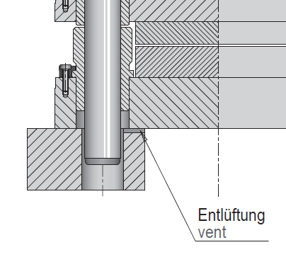

### Plates screw connection

The coordinates must be designed in such a way that it is possible to screw the corners of the plates. This means that the screw holes can be made in a space-saving manner without minimising the usable area on the die.

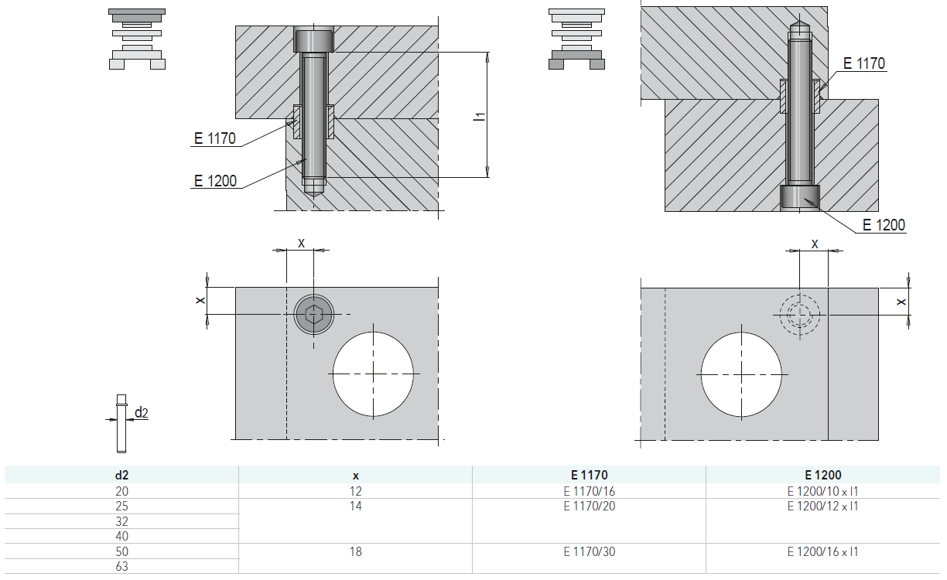

### Alignment edge

The alignment edge is a surface produced in a one clamping operation centrally relative to the guiding holes for the exact alignment of the die plates. It is located on the long side of all plates which includes holes for die guiding.

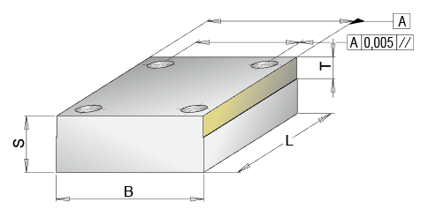

### Optional fastening of guide pillars

Retainer clips can always be used. A recess for the retainer washer is standard in the pillars retainers (SV 40), where fastening via these is possible (depending on plate thickness).

|  |  |
| --- | --- |
|  |  |
| S = XY | S = XY  T = XY - Standardised - depending on the pillar diameter |

## SV-Standard die set

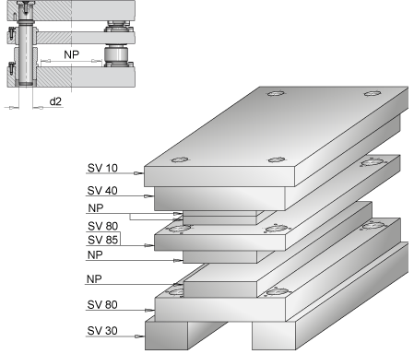

The [SV-standard die set](https://catalogue.meusburger.com/ausgaben/84Stanzgestelle/#76) is offered in dimensions 156 mm x 156 mm to 696 mm x 1396 mm.

The guide pillar fixing (top or bottom) as well as the complete set up are freely configurable. This also includes the option of selecting clamping plates at the top or bottom or clamp risers to correspond to the die. SV-standard die sets are predominately used for progressive dies and have 4 pillars built in.

## SH Two-pillar die set, back guiding

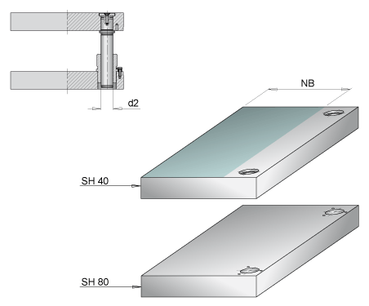

The [SH-two-pillar die set](https://ecom.meusburger.com/sh_menu/index.asp?rnd=87713) is offered in dimensions 126 mm x 156 mm to 496 mm x 996 mm.

It is used, for example, as a base set in the modular concept area, as an insert die or a blank cut for progressive die bending machines.

## SD Two-pillar die set, diagonal guiding

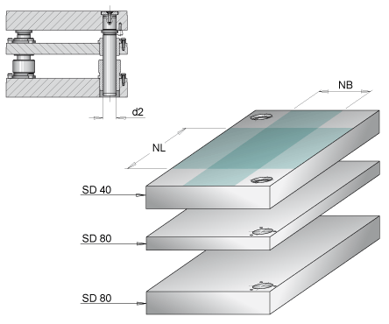

The [SD-two-pillar die set](https://ecom.meusburger.com/sd_menu/index.asp?rnd=82917) is offered in dimensions 126 mm x 156 mm to 396 mm x 496 mm.

The two guiding holes are placed diagonally. A backing plate as a guide plate or stripper plate and the usable width in length or width can be selected additionally. The SD two-pillar die set is used for example as a base set for the modular concept, insert dies, modular inserts or as a blank cut for progressive die bending machines.

## SZ Two-pillar die set, central guiding

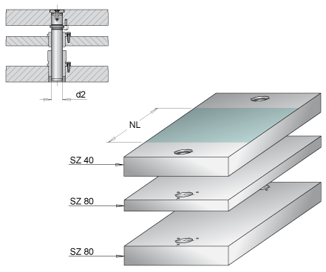

The [SZ-two-pillar die set](https://ecom.meusburger.com/sz_menu/index.asp?rnd=80872) is offered in dimensions from 126 mm x 156 mm to 396 mm x 496 mm.

A backing plate can also be selected as a guide or stripper plate. The SZ two-pillar die set is used, for example, as an insert die and module insert for base sets.

## Tolerances SV, SH, SD, SZ

The tolerances are coordinated with each other and can be taken from the following tables:



[**Overview of SV tolerances to download and print**](https://ecom.meusburger.com/files/info/tol_sv.pdf)



[**Overview of SH, SD and SZ tolerances to download and print**](https://ecom.meusburger.com/files/info/tol_sh.pdf)

## SP-Precision die set

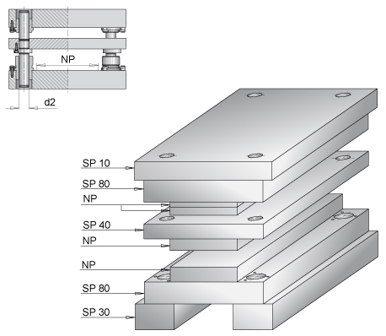

The [SP-precision die set](https://ecom.meusburger.com/sp_menu/index.asp?rnd=18859) is offered in dimensions from 196 mm x 196 mm to 496 mm x 696 mm.

It is used for very high and precise part requirements. The pillar deflection is minimised through the mounting of the pillars in the guiding plate. This means that items with the smallest tolerance can be punched.

## SP tolerances



[**Overview of SP tolerances to download and print**](https://ecom.meusburger.com/files/info/tol_sp.pdf)

## Hole tolerances

If no prefabricated standard die sets are used, the following tolerances must be selected for the bushes, or pillar holes to ensure simple and safe assembly of the guiding elements:

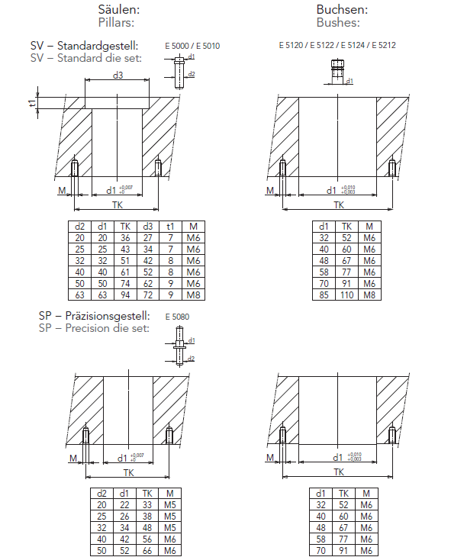

## Modular concept

### Base set

An SH two-pillar die set is usually used as the base set for a die in modular design.

This ensures one-side removal from the die. For larger modular concepts, die sets with more than two guide pillars can also be used.

**Example:**

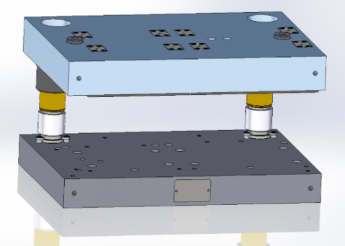

### Module plates

Since the individual modules in a die, apart from the length, always have the same parameters, these only have to be defined once. Plates combination, thickness of plates, stroke, clamping plate protrusions and the width of the active plates remain the same in individual modules. The length of the individual modules may vary. The Meusburger [modular design wizard](https://ecom.meusburger.com/sm_menu/index.asp?rnd=30369) can be used to configure a module die. With the wizard, up to five modules can be configured simultaneously in just a few steps.

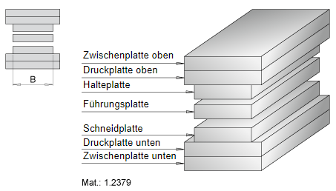

### Components for the modular concept

|  |  |  |  |
| --- | --- | --- | --- |
|  |  | [E 6030](https://ecom.meusburger.com/e/index.asp?id=443&eg=29) | Positioning unit |
|  |  | [E 6032](https://ecom.meusburger.com/e/index.asp?id=938) | Mushroom-shaped retaining piece |
|  |  | [E 6034](https://ecom.meusburger.com/e/index.asp?id=939) | Mushroom-shaped clamping piece |
|  |  | [E 6036](https://ecom.meusburger.com/e/index.asp?id=1137) | Retaining bar |
|  |  | [E 6038](https://ecom.meusburger.com/e/index.asp?id=1138) | Clamping bar |
|  |  | [E 6040](https://ecom.meusburger.com/e/index.asp?id=444) | Spring loaded pin |
|  |  | [E 6045](https://ecom.meusburger.com/e/index.asp?id=1966) | Slide-in aid for modules |
|  | XY |  |  |

## Design specifications

### Eye bolt holes

The following Meusburger standard applies here:

|  |  |  |  |  |  |
| --- | --- | --- | --- | --- | --- |
| E 1272 M | E 1272 | E 1274 M | E 1274 | E 1276 | E 1280 |
|  |  |  |  |  |  |

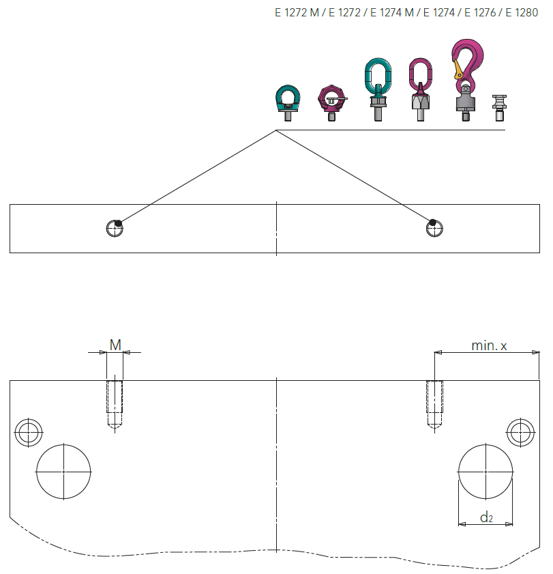

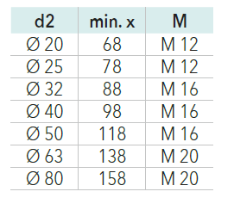

# Accessories (E-parts)

## General information

E-parts from Meusburger and XY must always be used as standard parts. These are all available for CAD data download and are immediately configurable and ready-to-use in the design.

## Material selection

|  |  |  |  |  |
| --- | --- | --- | --- | --- |
|  | **Standard** | **Manufacturer** | **Material** | **Hardness/coating** |
| Cutting elements |  |  |  |  |
| Cutting inserts |  |  |  |  |
| Bending punches |  |  |  |  |
| Deep drawing punch |  |  |  |  |
| Bending insert |  |  |  |  |
| Embossing stamp |  |  |  |  |
| Cross beams |  |  |  |  |
| Impact piece |  |  |  |  |
| Spacers |  |  |  |  |
| XY |  |  |  |  |

## Guiding

Guiding systems and matching standard parts from Meusburger must always be used.

Generally, there is the right combination of guiding elements for every application.

* **Standard guiding systems** are best suited for general applications such as progressive dies.
* **Compact guiding systems** are available especially for limited spaces from ø 4 mm to ø 19 mm.
* **Module guides** are specially designed for use in modular dies.
* **Guiding systems for large dies** are the suitable guide system for transfer and large dies.

|  |  |  |
| --- | --- | --- |
| Guiding system | | |
|  | Sliding guide |  |
|  | Ball guide |  |
|  | Roller guide |  |

Preferably, the following guiding system combinations should be used:

|  |  |  |  |  |
| --- | --- | --- | --- | --- |
|  | **Standard** | **Manufacturer** | **Order number** | **Retainer clip** |
| Guide pillar | ISO 9182 | Meusburger | E 5000 | E 5270 |
| Guide bush | ISO 9448 | Meusburger | E 5212 | E 5270 |
| Ball cage |  |  |  |  |
| Cage retainer |  |  |  |  |
| Assembly ring |  | Meusburger | E 5260 |  |
| XY |  |  |  |  |

[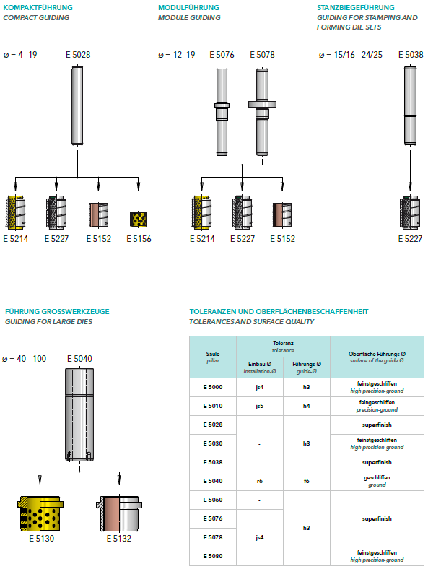](https://ecom.meusburger.com/e_menu/index.asp?set_gruppe=17) [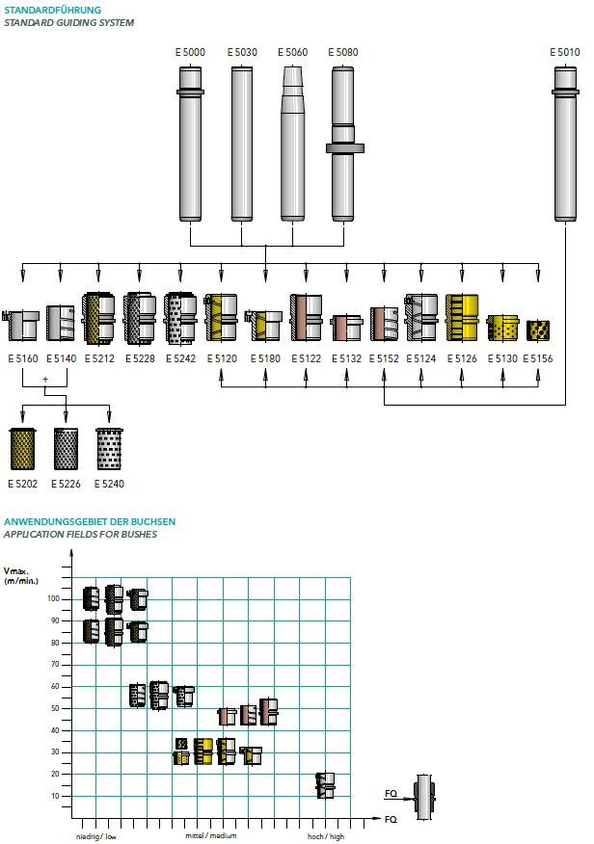](https://ecom.meusburger.com/e_menu/index.asp?set_gruppe=17)



[**Guide selection guide to download and print**](https://ecom.meusburger.com/files/pdf/e/stanz_auswahlhilfe.pdf)

## Fasteners

Make sure to use uniform fasteners such as screw connections, dowel pins, etc. when possible. In addition, their accessibility should be taken into account.  When fastening the contour punches, special attention must be paid to the correct layout regarding the retracting forces.

Generally, DIN screws with a strength of at least 10.9 are to be used.

Generally, cylindrical pins with internal threads are to be used and secured against falling with a pin retaining sleeve ([E 1296](https://ecom.meusburger.com/e/index.asp?id=1159&eg=2)) .

If there are space problems in the die, ([E 1170](https://ecom.meusburger.com/e/index.asp?id=27&eg=3)) a centring bush with one fitting diameter can be used to also position the plates directly when screwing.

## Cutting elements

The Meusburger [cutting punches configurator](https://ecom.meusburger.com/e/index.asp?id=2505&rnd=50389) can be used to select the suitable cutting punch. Here you can select the head shape, the material, the shape (continuous or offset), with/without ejector and the different coatings.

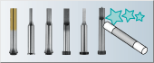

|  |  |  |  |  |  |
| --- | --- | --- | --- | --- | --- |
|  | **Head shape** |  | **Standard** | **Material** | **Coating** |
|  | Cutting punch with conical head |  | DIN 9861 |  |  |
|  | Cutting punch with 30° conical head |  |  |  |  |
|  | Cutting punch with  bottle-neck |  | DIN 5118 |  |  |
|  | Cutting punch with  cylindrical head |  | ISO 8020 |  |  |
|  | Cutting punch with  cylindrical head,  head height 4 mm |  | DIN 9844 |  |  |
|  | Fine blanking punch |  |  |  |  |
|  | Ball-lock  cutting punch |  | ISO 10071-2 |  |  |

## Active parts

Active parts include all components/standard parts for guiding, positioning and machining the punching strip.

|  |  |  |  |
| --- | --- | --- | --- |
|  |  | [E 5620](https://ecom.meusburger.com/e/index.asp?id=1051) | Infeed guide, adjustable width, spring-loaded on one side |
|  |  | [E 5622](https://ecom.meusburger.com/e/index.asp?id=1052) | Infeed guide, adjustable width, fixed on both sides |
|  |  | [E 5632](https://ecom.meusburger.com/e/index.asp?id=433) | Strip guiding pin with collar, spring-loaded |
|  |  | [E 5634](https://ecom.meusburger.com/e/index.asp?id=2220) | Block-shaped strip guide, spring-loaded |
|  |  | [E 5636](https://ecom.meusburger.com/e/index.asp?id=434) | Strip guiding rail |
|  |  | [E 5640](https://ecom.meusburger.com/e/index.asp?id=435) | Strip lifter with collar, spring-loaded |
|  |  | [E 5644](https://ecom.meusburger.com/e/index.asp?id=1670) | Block-shaped strip lifter, spring-loaded |
|  |  | [E 5645](https://ecom.meusburger.com/e/index.asp?id=2067) | Strip pusher with collar |
|  |  | [E 5650](https://ecom.meusburger.com/e/index.asp?id=436) | Pilot pin with cylindrical head |
|  |  | [E 5650 AlCrN](https://ecom.meusburger.com/e/index.asp?id=2225) | Pilot pin with cylindrical head, AlCrN coated |
|  |  | [E 5652](https://ecom.meusburger.com/e/index.asp?id=1841) | Pilot pin with conical head |
|  |  | [E 5654](https://ecom.meusburger.com/e/index.asp?id=2525) | Block-shaped strip positioner, spring-loaded |
|  |  | [E 5655](https://ecom.meusburger.com/e/index.asp?id=1591) | Pilot unit |
|  |  | [E 5660](https://ecom.meusburger.com/e/index.asp?id=1163) | Adjustment unit |
|  |  | [E 5665](https://ecom.meusburger.com/e/index.asp?id=1668) | Punch suspension piece with radius |
|  |  | [E 5690](https://ecom.meusburger.com/e/index.asp?id=1853) | Bending unit |
|  |  | [E 5692](https://ecom.meusburger.com/e/index.asp?id=1854) | Bending insert |
|  |  | [E 56703](https://ecom.meusburger.com/e/index.asp?id=2221&eg=34) | Embossing stamp |
|  | XY |  |  |

## Springs

If possible, in the layout spring compression springs should only be designed up to an average service life. The [Meusburger system compression springs selection guide](https://ecom.meusburger.com/e_menu/index.asp?set_gruppe=13) is ideal for finding the appropriate system compression spring.

**[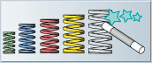](https://ecom.meusburger.com/e_menu/index.asp?set_gruppe=13)**

### System compression springs

When possible, use the [E 1549](https://ecom.meusburger.com/e/index.asp?id=1317) spring cover from Meusburger.

|  |  |  |  |  |
| --- | --- | --- | --- | --- |
|  | **Wire form** |  |  | **Diameter** |
|  |  |  | [E 1536 / E 1537](https://ecom.meusburger.com/e_menu/index.asp?set_gruppe=13)  [E 1538 / E 1539](https://ecom.meusburger.com/e_menu/index.asp?set_gruppe=13)  [E 15365 / E 15375](https://ecom.meusburger.com/e_menu/index.asp?set_gruppe=13)  [E 15385](https://ecom.meusburger.com/e_menu/index.asp?set_gruppe=13) | Ø 6 – Ø 8 mm  Ø 10 - Ø 16 mm |
|  |  |  | [E 1541 / E 1542 / E 1543](https://ecom.meusburger.com/e_menu/index.asp?set_gruppe=13)  [E 1544 / E 1545 / E 1546](https://ecom.meusburger.com/e_menu/index.asp?set_gruppe=13) | Ø 10 - Ø 63 mm |

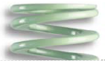Light green colour code: very light load

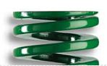Green colour code: light load

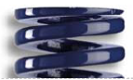Blue colour code: medium load

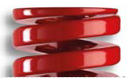Red colour code: heavy load

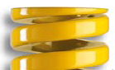Yellow colour code: very heavy load

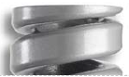Grey colour code: extremely high load



[**Overview of system compression springs to download and print**](https://www.meusburger.com/DE/AT/media/DOC_PRO_POS_Systemdruckfedern_IN)

### Elastomer compression springs

|  |  |  |  |
| --- | --- | --- | --- |
|  | **Type** |  | **Hardness** |
|  | Elastomer compression spring |  | 70 Shore A |
|  | Elastomer compression spring |  | 90 Shore A |

## Gas springs

Preference should be given to gas spring types that are standardised according to VDI or ISO. It is important to consider the respective installation or load situation depending on the type and not consider the preload.

The stroke of the gas spring must not exceed 90 % of the total stroke.

If necessary, oil drain holes must be provided so that they are not immersed in oil.

The [Meusburger gas spring selection guide](https://ecom.meusburger.com/e_menu/index.asp?set_gruppe=33) helps you to find the right gas spring for your application. With this, the ideal gas spring for the respective situation can be found with just a few clicks.

[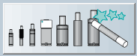](https://ecom.meusburger.com/e_menu/index.asp?set_gruppe=33)

|  |  |  |  |
| --- | --- | --- | --- |
|  | **Gas springs** |  | **Standard** |
|  | Spring-loaded thrust pieces |  | VDI |
|  | Mini |  | VDI / ISO |
|  | Standard |  | VDI / ISO |
|  | Force |  | VDI / ISO |
|  | Force extreme |  | - |
|  | Compact |  | - |



[**Overview of gas springs to download and print**](https://ecom.meusburger.com/files/pdf/e/gasdruck_anhang.pdf)

## Slide systems

Slide systems are all sliding guide elements that redirect a vertical movement/force into a horizontal one and primarily minimise friction. Here, attention must be paid to the appropriate pairing and, if necessary, to the load direction of the parts.

## Attachments

The attachments category includes all parts that are screwed to the die and usually the base plate and the head plate, such as lifting aids for transport, clamping or centring aids, labels, parts counters, etc.)

|  |  |  |
| --- | --- | --- |
|  |  | [E 5300](https://ecom.meusburger.com/e/index.asp?id=419&eg=14) |
|  |  | [E 5302](https://ecom.meusburger.com/e/index.asp?id=420&eg=29) |
|  |  | [E 5330](https://ecom.meusburger.com/e/index.asp?id=421&eg=14) |
|  |  | [E 5340](https://ecom.meusburger.com/e/index.asp?id=423&eg=14) |

### Lifting points

Connection threads for eye bolts are to be installed according to the calculation of the design, but at least M12 and exclusively according to DIN standard (fine threads are not permitted).

See point 5.11.1. – Eye bolt holes



[**Overview of the lifting points to download and print**](https://ecom.meusburger.com/files/pdf/e/anschlagpunkte_uebersicht.pdf)

### Label

Company XY will provide a label that is to be attached on the operator side by the die supplier.

The label contains the following information:

Die number / part designation / drawing number / year of manufacture / owner / customer die number / die manufacturer number.

|  |  |
| --- | --- |
| **Material** | **Width x length** |
| Aluminium / PA 6.6 | XY |

|  |  |  |
| --- | --- | --- |
|  |  | Click here for the online label generator [E 191..](https://ecom.meusburger.com/e/index.asp?id=187) |

### Status indicator plate

A status indicator plate must be attached to the operator side of the die to clearly identify the die status.

|  |  |  |
| --- | --- | --- |
|  |  | [E 1917](https://ecom.meusburger.com/e/index.asp?id=1845) |
|  | …with integrated label | [E 19180](https://ecom.meusburger.com/e/index.asp?id=2521) |

## Monitoring/process reliability

In order to scan parts, control feed rate, detect double sheets and enable ejection control in the dies, the following standardised electrical components with cable or plug are to be used.

### Sensors

|  |  |  |  |
| --- | --- | --- | --- |
|  |  | [E 6530](https://ecom.meusburger.com/e/index.asp?id=1232&rnd=91369) | Fork light barrier, infrared light |
|  |  | [E 6532](https://ecom.meusburger.com/e/index.asp?id=1233) | Fork light barrier, infrared light, side screws |
|  |  | [E 6534](https://ecom.meusburger.com/e/index.asp?id=1821) | Split light barrier, infrared |
|  |  | [E 6536](https://ecom.meusburger.com/e/index.asp?id=1234) | Fork light barrier, red light, side screws |
|  |  | [E 6538](https://ecom.meusburger.com/e/index.asp?id=1822) | Multibeam fork light barrier, infrared |
|  |  | [E 6542](https://ecom.meusburger.com/e/index.asp?id=1235) | Fork light barrier, infrared light for double sheet detection and tilt control |
|  |  | [E 6540](https://ecom.meusburger.com/e/index.asp?id=1823) | Analogue sensor, inductive |
|  | XY |  |  |

### Logic distributors

When merging several sensor signals, corresponding logic distributors must be used.

|  |  |
| --- | --- |
| **Manifold** | **Combined sensors** |
| Manifold 1 | XY |
| Manifold 2 | XY |
| Manifold 3 | XY |

|  |  |  |  |
| --- | --- | --- | --- |
| Single AND/OR | | | |
|  |  | [E 65740](https://ecom.meusburger.com/e/index.asp?id=2331&eg=21) | Number of terminals: 1x2 |
|  |  | [E 6574/8/3/1x4](https://ecom.meusburger.com/e/index.asp?id=1352&eg=21) | Number of terminals: 1x4 |
|  |  | [E 6574/8/3/1x8](https://ecom.meusburger.com/e/index.asp?id=1352&eg=21) | Number of terminals: 1x8 |

|  |  |  |  |
| --- | --- | --- | --- |
| Double AND | | | |
|  |  | [E 6576/8/3/2x2](https://ecom.meusburger.com/e/index.asp?id=1353&rnd=11651) | Number of terminals: 2x2 |
|  |  | [E 6576/8/3/2x4](https://ecom.meusburger.com/e/index.asp?id=1353&rnd=11651) | Number of terminals: 2x4 |

### Electrical connections

Make sure to use state-of-the-art equipment and to adhere to connection technology regulations (plug and connecting cables).



[**Overview of connection options to download and print (from page 4)**](https://ecom.meusburger.com/files/pdf/e/Lichtschranken_Anschluss.pdf)

# Approved suppliers

|  |  |  |
| --- | --- | --- |
| **Components** | **Supplier** | **Alternate supplier** |
| Cutting elements | Meusburger | XY |
| Guide pillars and bushes | Meusburger | XY |
| Helical springs | Meusburger | XY |
| Gas springs | Meusburger | XY |
| Lifting aids | Meusburger | XY |
| Electrical components/sensors | Meusburger | XY |
|  |  |  |
| **Plate materials** | Meusburger | XY |